

**La transición al español para el año 12.**

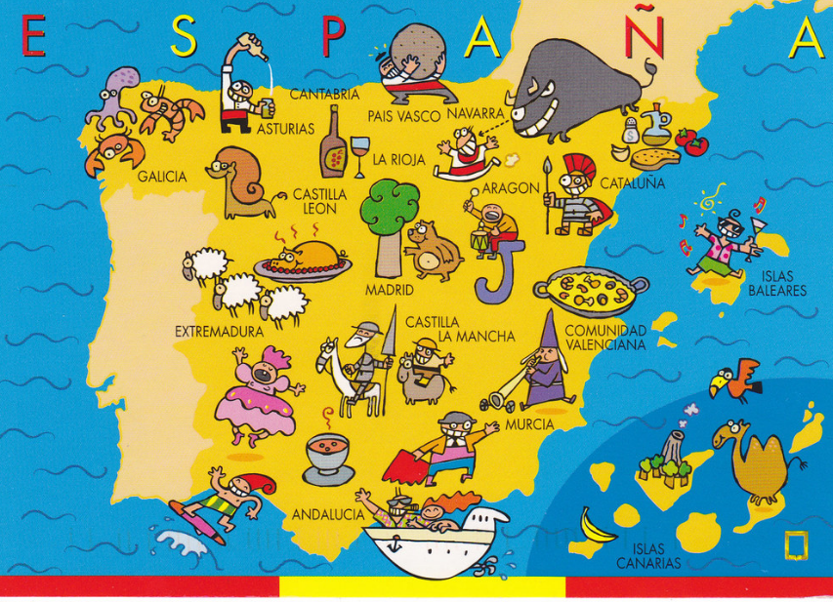

**¡Bienvenidos!**

**1. Why study Spanish?**

Congratulations on choosing to study Spanish A Level. You have opened the door of opportunity! Studying Spanish will enrich your life, giving you opportunities to travel abroad and to learn about different cultures and different ways of life. Studying a language will also enhance your life chances, as universities and employers tend to prefer candidates who can speak more than one language – you will be in an elite club of those who can!

Did you know that linguists are better communicators and writers and have a better understanding of their own language too? Students who study languages do better in tests, and learning a language will improve the functionality of your brain and improve your memory skills.

Spanish is the second-most widely spoken language in the world (after Mandarin Chinese), with 400 million native speakers, and official status in a staggering 21 countries, spanning South, Central and North America, as well as Africa and Europe.

Studying A Level Spanish will enable you to learn the Spanish language and will also help you to gain an in-depth insight into the cultural, social, political and artistic aspects of the Spanish speaking country/countries you will study.

This booklet will help you prepare for A-Level in Spanish.

¡Buena suerte!



“he (she) who does not know foreign languages does not know anything about his (her) own”

*Johann Wolfgang von Goethe, German writer*

**Course content at A-Level**

Year 12 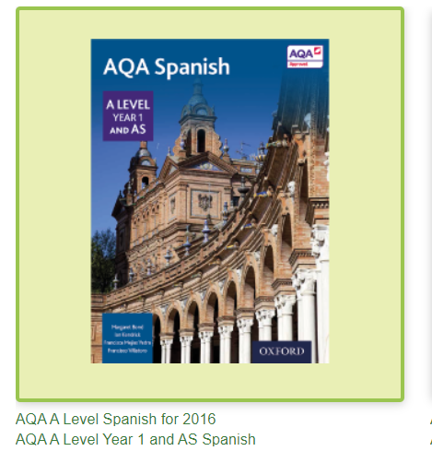

**A) Aspects of Hispanic society**

1. Los valores tradicionales y modernos

2. El ciberespacio

3. La igualdad de los sexos

**B) Artistic culture in the Hispanic world**

4. La influencia de los ídolos

5. La identidad regional en España

6. El patrimonio cultural

**Film** *El Laberinto del Fauno*

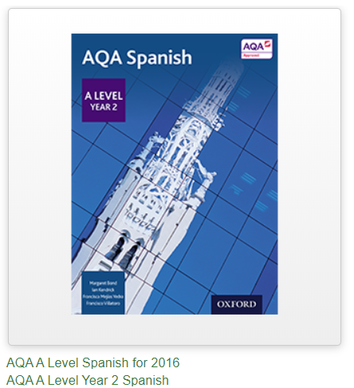

Year 13

**A) Multiculturalism in Hispanic society**

1. La inmigración

2. El racismo

3. La convivencia

**B) Aspects of political life in the Hispanic world**

4. Jóvenes de hoy, ciudadanos del mañana

5. Monarquías y dictaduras

6. Movimientos populares

**Book**  *La Casa de Bernarda Alba* by Federico García Lorca

**Themes and sub-themes will be assessed in paper 1 & 3.**

**Film and text will be assessed in paper 2.**

Paper 1: Listening, reading and writing (including translations Spanish to English and English to Spanish)

Paper 2: Writing - One text and one film or two texts from the list set in the specification & Grammar

Paper 3: Speaking -Discussion of a sub-theme with the discussion based on a stimulus card (5 – 6 minutes) You will study the card for 5 minutes at the start of the test. Presentation (2 minutes) and discussion (9 – 10 minutes) of individual research project.

The choice of works (literary texts and films) offers opportunities to link with the themes.

**What makes a successful language student?**

**Have opinions:** Look at the topic areas and maybe just jot down in Spanish or even English how you feel about the major issues arising from each one of them. Watch the news or read a national broadsheet newspaper. Above all **be interested and be informed.**

**Practise grammar all the time** Use the booklet provided and the grammar appendix 1. Remember we recap all grammar from GCSE at A-Level.

**Be resilient:** You’re great at English because of the amount of time you’ve spent practising it, so don’t give up when you don’t immediately master Spanish – none of us do! Spend time little and often to build up your skills.

**Go the extra mile:** Do not rely merely on time in class to provide you with information for the topic areas and cultural information. Make it a habit to explore on your own, searching for interesting texts and making the most of the wide variety of cultural options provided here.

**Be organised:** Keep material from different topic areas separately filed in your folders.

Have a separate grammar book/area and constantly refer to it when attempting written tasks in particular. Always have your grammar books and dictionaries open in front of you when you are attempting tasks in any of the skill areas.

And lastly …

You will take from the course what you put in.

Students who put in the most effort with independent work are always the most successful.

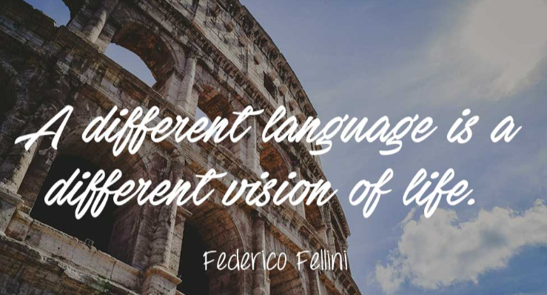

“a different language is a different vision of life”

*Frederico Fellini, Italian film director*

**How to prepare for Spanish at A Level**

**What should I know by now?**

Grammar practice booklet

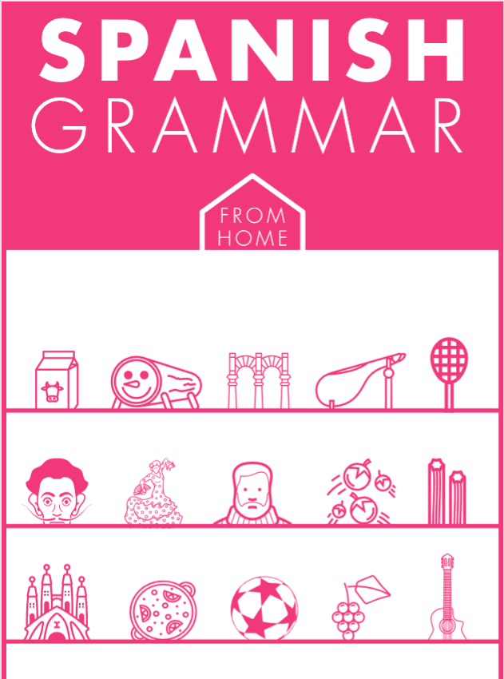

Complete the activities in the Spanish Grammar booklet (PDF) documents. See work on TEAMS.

Complete the Grammar Appendix 1 (see the end of the booklet) Bring this to your first lesson in September

Links to Grammar Practice Exercises

* Languages on line: The Grammar Revision resources on

[www.languagesonline.org.uk](http://www.languagesonline.org.uk/) are great as you can then select what tense you want to revise, read the explanations and complete the exercises. You can do these as often as you like and it gives you a percentage. Another useful tactic is to translate the examples and exercises into English to ensure you understand the meaning of each tense.h some of the AS Resources.

• Conjuguemos: a great website for practicing your verb conjugations. Find it here: <https://conjuguemos.com/>k here to access the Spanish verb exercises.

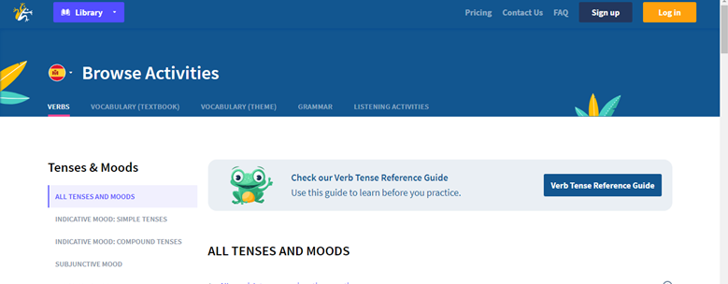

**A world of culture**

Your GCSE topics were mainly limited to personal matters and experiences. The next step is to try and develop a broader knowledge of the target language country’s society, government, history, fashion, art, music and lifestyle.

At the same time you will also be developing your listening and reading skills.

**Spanish cinema**

Watch films with subtitles in English first, and then in Spanish, will be an excellent preparation for the A level course. This way you listen and read so you see the spelling, hear the pronunciation and learn the meaning in a context, all at the same time. We study the Spanish film El Laberinto del Fauno.

*El laberinto del fauno* Guillermo del Toro (2006)

*Ocho apellidos vascos* Emilio Martínez-Lázaro (2014)

*María, llena eres de gracia* Joshua Marston (2004)

*Volver* Pedro Almodóvar (2006)

*Abel* Diego Luna (2010)

*Las 13 rosas* Emilio Martínez-Lázaro (2007)

*Voces inocentes* Luis Mandoki (2004)

|  |  |  |  |
| --- | --- | --- | --- |
|  |  |  |  |

**Spanish television**

<https://wwitv.com/tv_channels/8234.htm> This site allows you to choose from a number of Spanish TV channels that you can watch online. RTVE La 1 is the original Spanish channel and a good place to start.

On the BBC site <http://www.bbc.co.uk/languages/spanish/tv/> you can see access a variety of programmes online.

**Spanish literature**

You will be required to do more reading for your A level subjects. In year 13 we study the play La Casa de Bernarda Alba which you will read over the summer between year 12 and 13. This summer why not try to start reading a Spanish book.

You could get a translation of an English book/author you know eg. Harry Potter or Charlie and the chocolate factory.

You could read some of the famous comics such as Zipi y Zape or El justiciero fantasma.

Spanish books to try would be Manolito Gafotas, El Alquimista or Spanish short stories for beginners.

You can have access to free books at this digital library <http://bibliotecadigital.ilce.edu.mx/>

Keep your own vocabulary book for new expressions you come across. You could order it alphabetically, by topic area based on what we are going to study or just use it as a diary and scribble away your Spanish development in it.

**TOP** **TIP:** **Don’t** **look** **up** **every** **word** **you** **are** **not** **sure** **of** **when** **reading** **an** **article/** **book**

Yes… you read that right. When you are reading articles etc, try not to look up every word as it will take you forever. Skim and scan the text to get the gist. Remember to use the context or the article, cognates and common sense to figure out what the article is saying. Pick out a couple of words that you like the look of, that you feel may be real hurdles to getting the idea of the text, look them up carefully and add them to your vocab booklet. The aim at this stage is to get the gist of the article, not be able to translate it completely. Translation is a whole different ball game and you will learn it soon enough.

|  |  |  |  |
| --- | --- | --- | --- |
| 9788420474021: Manolito Gafotas - AbeBooks - Lindo, Elvira: 8420474029 |  |  | Libro El Alquimista Paulo Coelho - $ 250,00 en Mercado Libre |

**Spanish newspapers**

Read a foreign language newspaper.

El País has its own website <http://elpaís.com/> so that you can read the paper online. You do not have to read the paper cover to cover, just scan the headlines and pick out ONE article that grabs your attention. You could also use <http://www.elmundo.es>

This website is a more light-hearted newspaper which covers global stories as well as gossip. <http://www.20minutes.es> Also try <https://www.20minutos.es/videos/> This is the TV Channel for this newspaper.

In Spain there is also a news website for young people: <https://primerasnoticias.com/> It has sections on the Internet and Mobile Technology; Science and Wildlife; Education; Culture; Sport; Society and Health. A glance today contained articles about addiction to technology, secrets of Mexico and FC Barcelona to name but a few.

**Spanish radio**

The great thing about listening to the radio is that you can get on with something else at the same time. Listen live using the RTVE site. It can take a while to buffer so be patient.

RTVE Radio 3 <https://www.rtve.es/radio/radio3/> or M80 radio <https://radiofy.online/m80-radio>

Online radiobox <https://onlineradiobox.com/es/> allows you to choose from a range of radio eg Muy Buena or Los 40 principales.

**Spanish music**

Music artists are studied in year 12 as part of one of the topics. You will have come across some already. This is another great way to improve listening and reading skills. Use [www.lyricstraining.com](http://www.lyricstraining.com) to play!

Alvaro Soler, Rosalia, Bad Bunny, Juanes and many more …

|  |  |  |  |
| --- | --- | --- | --- |
|  |  | **6 Essential Tracks on Bad Bunny's 'YHLQMDLG': Editors' Picks ...** | **Juanes performing in 2008** |

**Spanish websites**

Switch to Spanish browsers such as and [www.terra.es/](http://www.terra.es/)or [www.es.yahoo.](http://www.es.yahoo.)comas well as www.google.es[.](http://www.google.fr/) This way, you will read Spanish every time you log on and it will become part of your everyday activity.

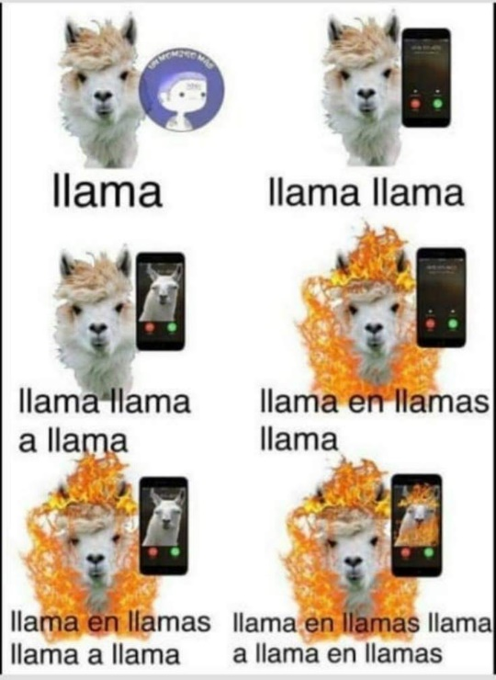

"learn a new language and get a new soul“

*Czech proverb*

**Online dictionary**

A good on-line dictionary is: <http://www.spanishdict.com/>



TIP1

When you look up a verb, click the Conjugation tab to see how the verb is conjugated in EVERY tense.

TIP 2 Add reverso to your browser <https://www.youtube.com/watch?v=bQKI9aC7tac>



**TOP** **TIP:** **Don’t** **look** **up** **every** **word** **you** **are** **not** **sure** **of** **when** **reading** **an** **article/** **book**

Yes… you read that right. When you are reading articles etc, try not to look up every word as it will take you forever. Skim and scan the text to get the gist. Remember to use the context or the article, cognates and common sense to figure out what the article is saying. Pick out a couple of words that you like the look of, that you feel may be real hurdles to getting the idea of the text, look them up carefully and add them to your vocab booklet. The aim at this stage is to get the gist of the article, not be able to translate it completely. Translation is a whole different ball game and you will learn it soon enough.

You will be surprised how much more enjoyable reading will be if you really pay attention to this tip.

**Tasks**

1. Summarise, in Spanish, 2 articles (that were in Spanish!) that you have read from one of the websites/ papers above and say why they interested you. If you cannot print the article, make a note of the website. Try and make these related to one of the topics we will study (as per the table above).

2. Choose something to watch/listen to/read from the ‘A world of culture’ section.

3. Create a Quizlet account. Join the KDHS AS group and start to look at the course vocabulary. <https://quizlet.com/join/Am3Wf49yg>

4.Translate the summary of *El Laberinto del Fauno*. Bring this along with you on paper to your first lesson.

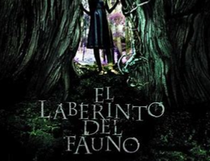

*Año 1944, posguerra española. Ofelia y su madre, Carmen , se trasladan a un pequeño pueblo al que ha sido destinado el nuevo marido de Carmen, Vidal un cruel capitán del ejército franquista por el que la niña no siente ningún afecto. La misión de Vidal es acabar con los últimos miembros de la resistencia republicana que permanecen escondidos en los montes de la zona. Otros personajes son: Mercedes (el ama de llaves, y el médico que se hará cargo del delicado estado de salud de Carmen. Una noche, Ofelia descubre las ruinas de un laberinto, y allí se encuentra con un fauno una extraña criatura que le hace una sorprendente revelación: ella es en realidad una princesa, la última de su estirpe, y los suyos la esperan desde hace mucho tiempo. Para poder regresar a su mágico reino, la niña deberá enfrentarse a tres pruebas.*

5. Complete the grammar booklet. (Pink PDF copy) Aim for one topic per week.

Complete the Independent task log or make your own one up but you will go through it with your Spanish teacher in September so make sure that it is clear and useful to you.

When you look at a website/link on here, highlight it and note the date and what you thought about it. You can then put a couple of notes in your task log.

Task Log

|  |  |  |
| --- | --- | --- |
| **Date** | **Website** **/** **source** | **Comments** |
|  |  |  |
|  |  |  |
|  |  |  |
|  |  |  |
|  |  |  |
|  |  |  |

Appendix 1: Grammar self-assessment

|  |  |  |  |  |  |
| --- | --- | --- | --- | --- | --- |
|  | | | | | |
|  |  | **I** **DO** **NOT** **KNOW** | **NEED** **TO** **LEARN** | **QUITE** **CONFIDENT** | **FULLY**  **CONFIDENT** |
| **Nouns**: gender, singular and plural forms |  |  |  |  |
| **Articles**: definite (el, la...), indefinite (un, una) |  |  |  |  |
|  |  |  |  |  |
| **Adjectives**: agreements (fem, pl...) |  |  |  |  |
| Position/word order |  |  |  |  |
| comparative and superlative (más, menos, el más.) |  |  |  |  |
| comparative and superlative irregular (mejor...) |  |  |  |  |
| indefinite (*cada*, *algunos, algunas*) |  |  |  |  |
| possessive (mi ti...) |  |  |  |  |
| interrogative (¿*qué?, ¿cuál?, ¿cuáles?...*) |  |  |  |  |
| **Adverbs**: comparative and superlative |  |  |  |  |
| interrogative (*¿cómo? ¿cuándo?*) |  |  |  |  |
| **Quantifiers/intensifiers** (*muy*, *bastante*...) |  |  |  |  |
| **Pronouns**: Subject (yo, tú...) |  |  |  |  |
| object: direct and indirect (lo, las, les...) |  |  |  |  |
| position and order (te veo) |  |  |  |  |
| reflexive (me, te...) |  |  |  |  |
| relative ( *que,*) |  |  |  |  |
| relative: *lo que, la que* (R) |  |  |  |  |
| **object**: direct and indirect |  |  |  |  |
| indefinite (*alguien*) |  |  |  |  |
| possessive (*el mío, la mía...*) (R) |  |  |  |  |
| interrogative (*¿Quién? ¿quiénes?*) |  |  |  |  |
| interrogative (*¿qué?*) (R) |  |  |  |  |
| **Verbs**: modes of address (*tú, vosotros, usted*) |  |  |  |  |
| verbs + infinitive |  |  |  |  |
| verbs + infinitive + preposition |  |  |  |  |
| Verbs + - me gusta/me interesa etc |  |  |  |  |
| Verbs + de ( acabo de) |  |  |  |  |
| negatives (no, nunca, jamás...) |  |  |  |  |
| Present (regular) |  |  |  |  |
| Present (irregular) |  |  |  |  |
| Perfect |  |  |  |  |
| Perfect with **reflexives** |  |  |  |  |
| Imperfect |  |  |  |  |
| Near Future (voy a + infinitive) |  |  |  |  |
| Future |  |  |  |  |
| Conditional |  |  |  |  |
| Future perfect (habrá hecho...) (R) |  |  |  |  |
| Conditional perfect (habría salido...) (R) |  |  |  |  |
| Pluperfect (había llegado..) |  |  |  |  |
| Present participle (comiendo...) |  |  |  |  |
| Subjunctive mood (how to form it) |  |  |  |  |
| Subjunctive mood (which expressions trigger it?) |  |  |  |  |
|  | | | | | |

**My** **notes/comments**

|  |  |  |  |  |  |
| --- | --- | --- | --- | --- | --- |
|  | | | | | |
|  |  | **I** **DO** **NOT** | **NEED** **TO** **LEARN** | **QUITE** **CONFIDENT** | **FULLY**  **CONFIDENT** |
| **Indirect** **speech** |  |  |  |  |
| **Inversion** **after** **speech** (R) |  |  |  |  |
| **Prepositions:** a/al/ a la... |  |  |  |  |
| with countries, towns, places |  |  |  |  |
| with month, dates, time |  |  |  |  |
| Desde hace, acabar de |  |  |  |  |
| **Number,** **quantity** **and** **time** |  |  |  |  |
| **Conjunctions** |  |  |  |  |
|  | | | | | |