**Takeaway Reading Menu**

**Mains**

**Singstar Seared Chicken**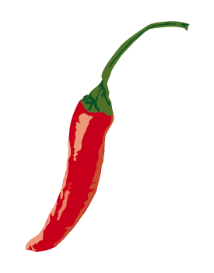

Re-write the lyrics to a song to capture a relationship presented in the book so far.

**Interview Confit**

Write an interview with the writer of the book. Make up her/his answers based on your knowledge of the book.

**Fillet of finger and thumb**

Draw around your hand. In each finger and thumb, write a different quotation that shapes the readers opinion of one of the main characters. Then analyse how these quotations shape reader’s opinions.

**Hidden Chicken Chapter**

At an appropriate point in the novel, write a hidden chapter. STRETCH- adopt the style of the writer.

**Breaking Beef******

Write a newspaper article to report a significant event that has occurred in the novel so far.

**Vegeletter Salad**

Write a letter as a main character to a member of their family. Try to capture the relationship you think they would have with them and their thoughts and feelings.

**Chilli Children**

Re-write the story so far but for young children, aged 6. Use rhyme, pictures and simple language to appeal to this audience.

**Deep Fried Opinionated Octopus **

Write an opinionated article about one of the issues the novel raises e.g. discrimination, bullying, belief in ghosts/aliens...

**Starters**

**Steamed Predictions:** 

Study and analyse the front cover of your book. Make 3 plot predictions by analysing the colours, pictures and book title.

**Peking at the Writer:**

Research the writer of your book. Make a PowerPoint presentation about his/her life and background.

**Current Soup:**

Make a poster summarising society’s affairs at the time the writer wrote the book. Consider where the writer is from for this.

**Satay Script**

After reading the first chapter of your book, transform it into a play script. Use stage directions to describe setting and the way your characters appear and should perform, then use their dialogue for the story.

**Desserts**

**Fruity Front Cover Fool**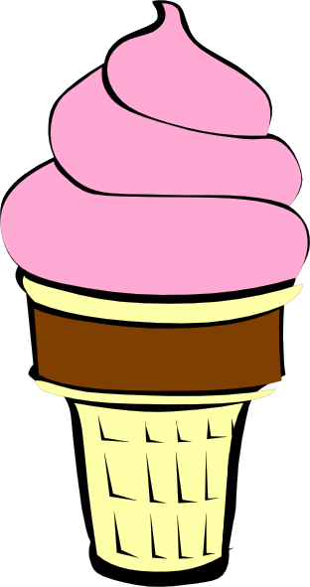

Re-design the front cover of your book capturing the most important theme you think the book presents.

**Chocolate Chapter Choices**

Come up with new chapter titles for the chapters in your book. Justify these titles by referring the events in the chapters.

**A Sticky Alternative **

Write an alternative ending for your book. STRETCH – try to adopt the same style as your writer.

**Quiz Sorbet**

Create 10—20 challenging quiz questions about your book. Consider themes, characters, settings and plot.

**Moving Meringue**

Create a movie of the book.

**Eton Mess-age**

Write a short essay exploring why you believe the writer wrote this book. Explain what you believe his/her message to young readers is. STRETCH – back up with quotations from the text.

**Sides**

**Word Find-u:** 

Write 5 nouns (people, places, things), 5 verbs (action words) and 5 adjectives (describing words) you have read today.

**Tweet and Sour Dip:** 

Write a series of tweets to summarise the content of each chapter in the book as you read it.

**Deep Fried Prawn Poem**

Write an acrostic poem using the title of the book to summarise the content of the book you have read so far.

**Sketchy Wontons**

Draw a sketch of one of the main characters in your book. Carefully consider and draw their costume, then label with justifications for their items of clothing. STRETCH – describe what the costume reveals about the character and use quotations to support these.

**Face-cook Chunks of Chicken **

Write a series of 5 Facebook status updates as 3 characters in your book. Try to capture their thoughts and feelings at 5 stages of the plot.

**You Dim Character Sum**

Consider what part you would play if YOU were introduced to the story. Write your character’s introduction to the plot as a hidden chapter.