18.01.2021

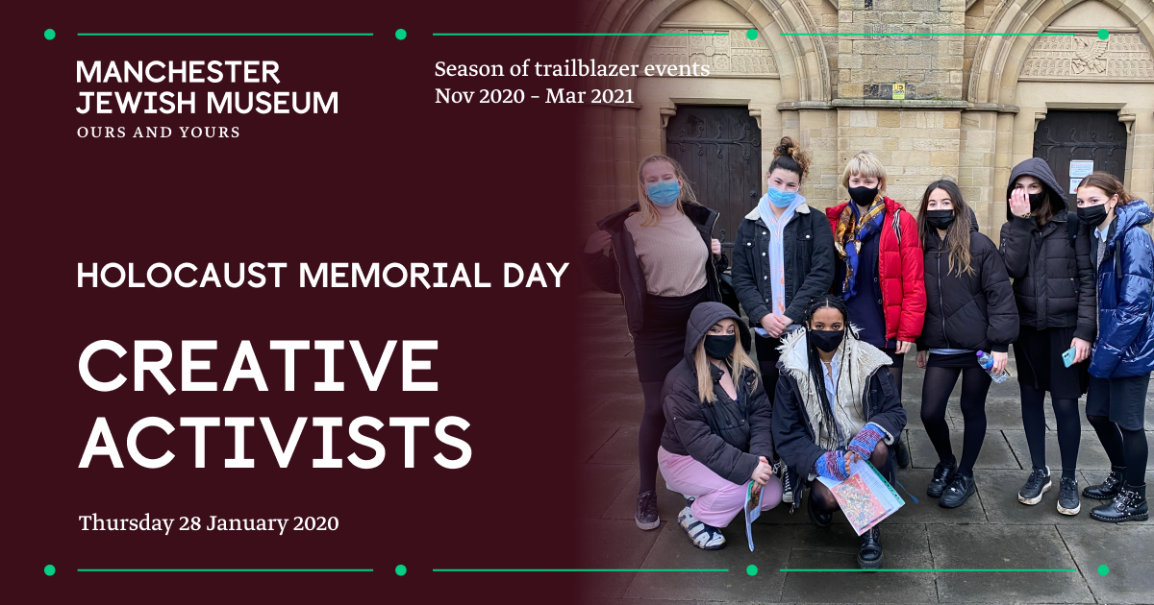
Caption: Creative Activists from King David High School, Crumpsall
Young Activists Keep Past Stories Alive as Manchester Jewish Museum Marks Holocaust Memorial Day

This January Manchester Jewish Museum’s third Trailblazer sees nine young people aged 16-18 become Creative Activists to create powerful acts of sharing and connection as they explore and share stories to commemorate Holocaust Memorial Day on Wednesday 27 January, inspired by real life stories past and present.

Responding to this years’ Holocaust Memorial Day theme, ‘Being a light in the darkness’, the nine activists from King David High School, Crumpsall, have been uncovering stories from the Museum’s own extensive archives, their own family histories and from speaking to Cheetham Hill residents about their own experiences and responses to Holocaust Memorial Day.

Working with theatre practitioner Kate Bradnam and the Museum’s Creative Producers Dara Laughlin and Dr Laura Seddon, these nine young activists will weave together these stories to create their own commemorative artworks, filming their process and telling the stories behind each creation. These artworks and films will then be gifted to community partners from Cheetham Hill in an act of sharing and passing on these stories and celebrating those lives.

These hidden stories, which will be included in the final film, include that of Hilde Davidsohn who fled Berlin and leaving her sister and mother behind and came to Manchester on a domestic visa, never to see her family again. Young activist Rivky will be commemorating her story by sculpting a bust of Hilde with a concealed speaker inside. Another activist, Beila, will be creating a sculpture of commemorative stones to celebrate Leicester Road in Cheetham Hill which became home to many Jewish refugees, and was where Beila herself lived when her family first moved to Manchester.

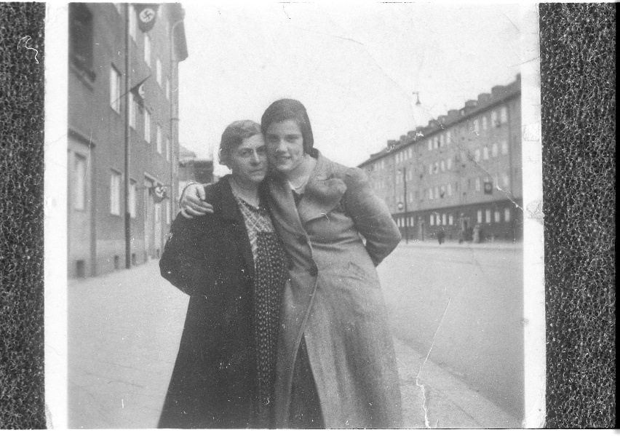
Hilde Davidsohn and her mother in Berlin, courtesy of Manchester Jewish Museum
Creative Activist Rivky talks about why keeping hidden stories alive is so important to her: “I think it’s special that we memorialise the people we don’t have much information on, as they are the ones who would be more ignored.”

On Thursday 28 January, the day following Holocaust Memorial Day, the Museum will share the final film of these young people’s journeys and the stories they have shared through their website, social media and YouTube channel. This act of sharing and connection is at the heart of the new Museum and its mission to connect Jewish stories to the world in order to explore both our differences and similarities and to celebrate that which makes people unique and which connects us all.

Manchester Jewish Museum may be waiting to open its doors once more in 2021 following a major capital development and extension, but it continues to inspire and engage communities across Manchester through a series of Trailblazer events leading the way to its reopening.

The next Manchester Jewish Museum Trailblazers will be February’s culinary delve into the archives with theatre chef Leo Burton’s ‘Eat The Archives’. These monthly events are a taster for Manchester Jewish Museum’s live year-round cultural programme which will include weekly Thursday Lates when it reopens to the public this year.
DOWNLOAD IMAGES HERE
ENDS.

For more information or image and interview requests, please contact Dan Jarvis, Marketing & Communications Manager at Manchester Jewish Museum on 07882531280 or daniel@manchesterjewishmuseum.com

Future Trailblazer Listings

Thursday 25 February 2021
Eat the Archives
Join Theatre Chef Leo Burtin live online for a culinary appetiser for his ongoing Eat the Archives journey through the museum’s archives, where stories come alive through taste. Leo uses food to bring people together and share stories and recipes, and this February there’ll be an opportunity to cook a Sephardi rice dish together (with spice kit provided for early bookers!) and hear about some of the personal histories of Jewish Manchester. A must for foodies who love stories as a side order.

All information and details on how to sign up to our mailing list and events, visit
manchesterjewishmuseum.com

About MJM’s Development Project
In 2017 Manchester Jewish Museum received a £2.89m National Lottery Heritage Fund Grant. This money is supporting an ambitious £5m development project that will see the museum, housed inside a former synagogue, double in size, with a new gallery, learning studio, shop and café built in an extension alongside the existing historic building. The Grade II* listed synagogue, meanwhile, is being repaired and restored.
The development builds on the museum’s increasing success. Visitor numbers have risen steadily since 2011, and it was listed as one of the UK’s top 10 small museums by The Times. In 2018 the museum became one of Arts Council England’s National Portfolio Organisations (NPOs).
The museum cares for over 31,000 objects, telling the story of Jewish Manchester, as well as broader stories of migration, communities and identities. Linked to the synagogue, an extension will create extra space in which to display this nationally significant collection, as well as a café and learning kitchen where people can make and eat traditional Jewish foods.

About Manchester Jewish Museum
Manchester Jewish Museum is common ground; a hospitable place that makes connections by showing and sharing universal experiences through the stories of one culture. We are a place to experience and explore how we are different, together. We connect Jewish stories to the world and to our society to explore both our differences and similarities, and to celebrate that which makes people unique and that which connects us all.
In doing so we look to spark reaction and change and to make real the knowledge that there is more that binds us together than separates us. We boldly explore and combine educational, cultural and artistic experiences to encourage those with whom we come into contact to feel and believe that we are all better together.
We make connections to make things better.

