Language Immersion Challenge

• This programme is open to all students from year 7 to 11
· Participants will be awarded Gold, Silver or Bronze certificates depending on the number of challenges they complete.
· Bronze Certificate = 4 challenges completed
· Silver Certificate = 8 challenges completed
· Gold Certificate = 12 or more challenges completed
· This booklet is to be used to keep a record of the challenges completed.
· Booklets must be returned to your MFL teacher in September. Following this, certificates will be awarded.

Name
Target Language (TL) chosen

Listen to the radio in the TL for 5 minutes 5 days a week for 4 consecutive weeks. Keep a radio diary (below) with detailed notes* at least once during each week. There are several radio stations that stream online, there are iPhone apps and channels can also be found on digital radios.

Date | Radio Station | Notes*  (once a week)

Find a song in the TL country charts that you like.

Song title

Artist

Why do you like it?

Make use of the radio , television, internet, newspapers in the TL to find 3 slogans for 3 different products sold in the TL country.

1.
2.
3.

Since we are all stuck at home we won’t be sending postcards from holidays, so instead, write an email to tell your MFL teacher what you’ve been doing at home to keep busy - in the Target Language of course!

Date sent:

To (Teachers name):

Find a recipe online and try it out following the instructions in the TL.

Recipe Title

Level of Difficulty

Result—your opinion

Result—someone else’s opinion

Watch a film in the TL. There are foreign language films on YouTube, Netflix and various other foreign language channels on the Internet.
Complete the notes below:

Title

Your favourite character

Did you like the film?

How well did you understand it? (circle the appropriate symbol)

Find a poem on the internet in the TL. Read it and complete the following:

Title

Poet

What was the poem about and did you like it and why?

Find a teenager who is writing a blog in the TL and write some information below about them.

Name:

Age:

Nationality:

Notes about the blog:

Find a newspaper in the TL online.

Name one headline.

What does it mean?

Send a text message to a friend in the TL.

Did they understand you? Yes/No*

Find out about a residential language course that is available for 16 year olds to improve their language skills in the TL country. Write the details, including cost, below

Create a cartoon with speech in the TL.

Create a cartoon with speech in the TL.

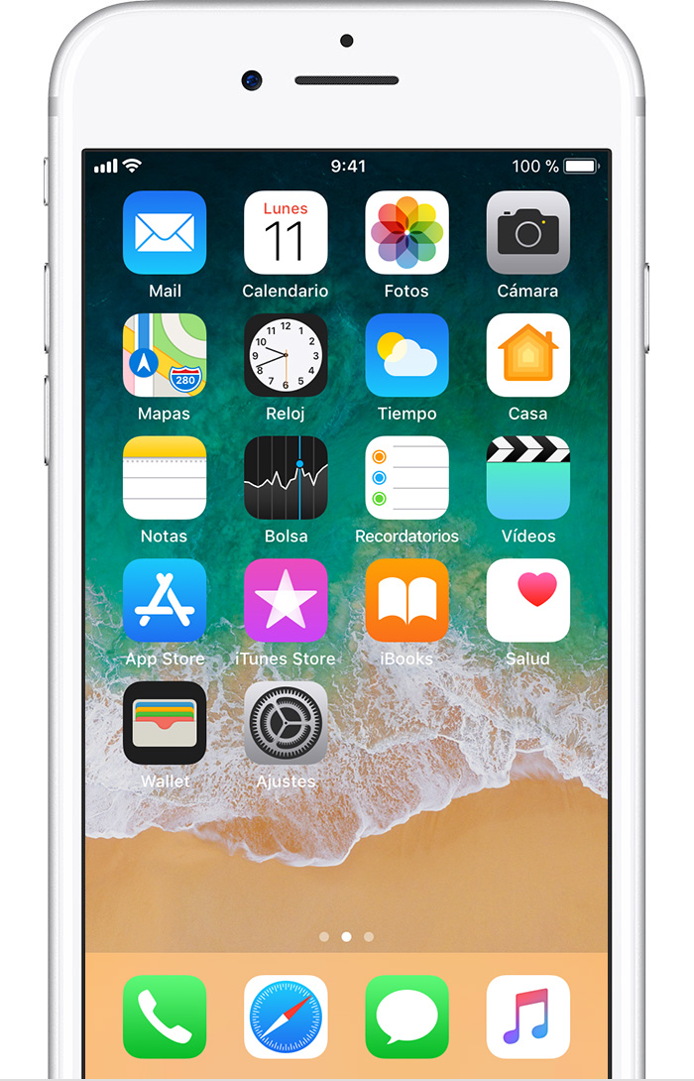

Change your mobile phone set up to the TL for four weeks.

Start date

End date

Write out the household weekly shopping list in the TL. Go online with your parents/guardian and order the weekly supermarket delivery with your parent/guardian(s) and translate the list for them as they order.

Date

Did you remember what everything was? Yes/No

