How to log in to Teams

Downloading the Teams Application
You will first need to download the Teams Application (unless you have already done this). This is available from the following link.
https://www.microsoft.com/en-gb/microsoft-365/microsoft-teams/download-app

Click on the option ‘Download for desktop’

Then click ‘Download Teams’

It will then download the Teams application to your device

Click to run and install the application.

Follow the steps as shown
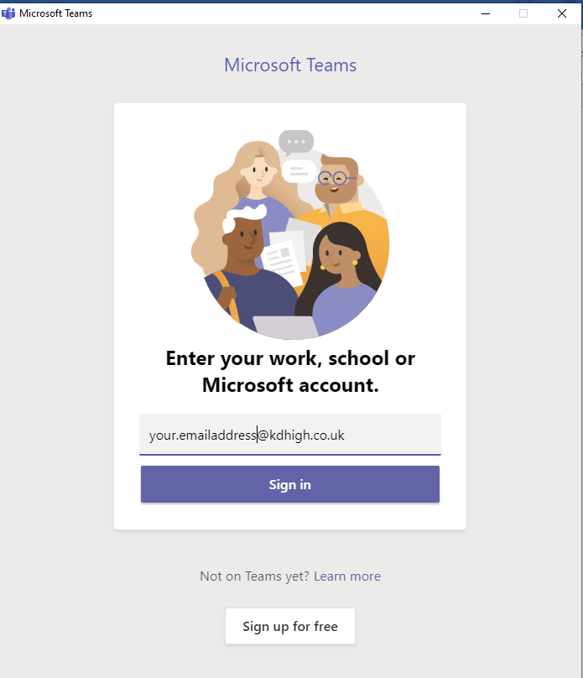
Enter YOUR SCHOOL email address e.g joe.bloggs@kdhigh.co.uk
Click ‘Sign In’

You will then be asked for your Password. This is your SCHOOL password that you use for your email and to logon to the school computers (they are the same).

Click ‘Sign on’

The next step is VERY Important to follow.

You will see a window as below
Please make sure that you UNTICK ‘Allow my organisation to manage my device’
Then click ‘No, sign in to this app only’
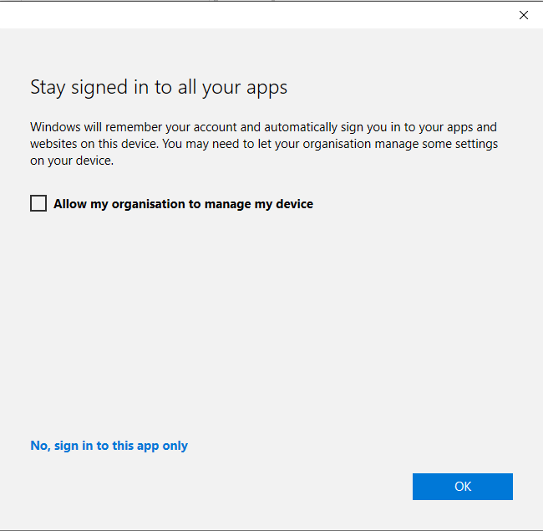
Once you have clicked on ‘No, sign in…….’

Teams will open up and a window will show with all of your Teams – these should be your classes.

Using the Teams application
Click on the name of the Team/class that you want to enter.

You will then be able to join your live lesson that is being broadcast by your teacher.

