FINE ART PERSONAL STUDY/INVESTIGATION July 2020 – January 2021
The Personal Study is a critical and visual appraisal or theoretical study of any aspect of the visual arts. It is usually an analysis of art or design that focuses on one or both of the following:
- Process and materials (the way an artist or group of artists use/s media);
- Subject or theme (the way an artist approaches a similar topic, generally with reference to composition, technique and the visual elements – line, texture, space, colour etc).
DURATION: JULY AND AUGUST
PART 1: Research, Analysis and Documentation and Collecting Primary and Secondary Sources
SKETCHBOOK WORK | TASK | AIM | OBJECTIVES |  | EXAMPLES
 | 1 | STATEMENT OF INTENT | Outline Proposal  What is the focus of your Study?  Explain what are your Intentions? |  | Complete NOTES FOR STATEMENT OF INTENT (at bottom of page, to help you.)  https://www.studentartguide.com/articles/writing-the-a2-art-personal-study  https://www.artpedagogy.com/preparing-for-the-personal-study.html
 | 2 | TITLE PAGE | 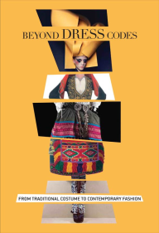  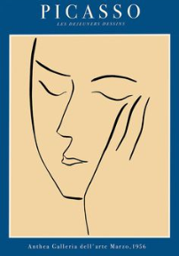  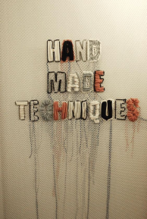  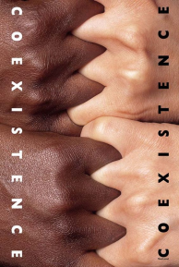  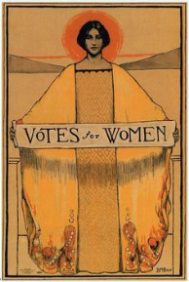  Design and create a title page to introduce your question  Give your Personal Study a punchy title  Once decided on your focus, set this out with a concise and ambitious title.  A two-part title or question might help. For example:  - Liar! Jeff Wall, photography and truth  - Modernism, Abstraction and the work of Barbara Hepworth  - ‘Identity, Consumerism, Popular Culture: How Composition Conveys a Message’.
 | 3 | WRITE  AN INTRODUCTION  ‘Students must select information which is relevant and analyse this in detail, evaluating and interpreting findings in relation to the focus of their study.’ | Write an introduction that leaves the reader wanting to read more  Your introduction should tempt the reader in. Do not just copy and paste pages from a thesaurus or website. It is better to start in a more straightforward way and simply get some initial thoughts down.  Your introduction should:  - Explain your interest in the subject and the connection that you have to this.  - Set out your intentions clearly.  - Provoke a desire to read on (for example, by using intriguing yet-to-be-answered questions).  - Reference relevant threshold concepts - the big ideas (or transformative knowledge) significant to your focus. | INTRODUCTION EXAMPLE 1  “I am fascinated with themes of identity. In particular I am interested in what 'identity' might mean to a portrait artist, and how they might set out to understand and capture a person's identity. Grayson Perry, contemporary artist, forms a main focus for this essay. His TV documentary "Who Are You?" has been a big influence on my work this year. After watching this series I found myself reflecting on how I might create a portrait that goes beyond simplistic observations to capture a stronger sense of identity.”  The following sentence starters seem to fit with the style of example 1, above:  I am choosing to focus on… (Artist / art movement) because…/ It astounds me how…/ I find it fascinating that…/ I found myself reflecting upon.../ I’m curious to know why…/I hope to...show, share, highlight, discover…
INTRODUCTION EXAMPLE 2
“There’s a common perception that a person’s identity is fixed - a fully-formed pearl found deep inside, resistant to change. But this perception strikes me as absurd. Identity is a far more complex, evolving matter. It can certainly be a struggle to determine one’s own personal identity, let alone identify or reveal someone else's. But this is a challenge every artist faces. Grayson Perry, in his TV documentary “Who Are You?” immersed himself into the lives of his subjects. His aim: to see through cracks of façade; to delve deeper beneath the surface and into the core of a person. Perry considers identity to be a journey, a voyage in pursuit of who we are: “Our identity is an ongoing performance that is changed and adapted by our experiences and circumstances.” This notion interests me. Perry clearly grasps the interchangeability of identity. His documentary sparked my enthusiasm and provoked a question I've been wrestling with ever since: How do I create a portrait that reaches beyond accurate representation to reveal the complexities of an individual identity?”

Example 2 uses a more elaborate style that incorporates a creative metaphor (identity as a pearl inside us all) and also a direct quote from the artist. Confident statements provide a greater sense of authority ("this strikes me as absurd", "Perry grasps the interchange-ability of identity"), but also - importantly - the writer is not setting themselves up as an absolute expert. There remains a reflective tone ("a question I've been wrestling with is...").
 | 4 | MIND MAP | Create a mind map that combines:  - Show thorough and in depth research of your topic  - Visually strong MAIN HEADING and clear SUB-HEADINGS. Use KEYWORDS, IMPORTANT INFORMATION, QUOTES and PHRASES (do not copy and paste)  - Add Illustrations and visual design work to emphasise the meaning of your topic  - Attach examples of artwork and relevant images to support the information you have found.  - Reference all your sources (information and image) | 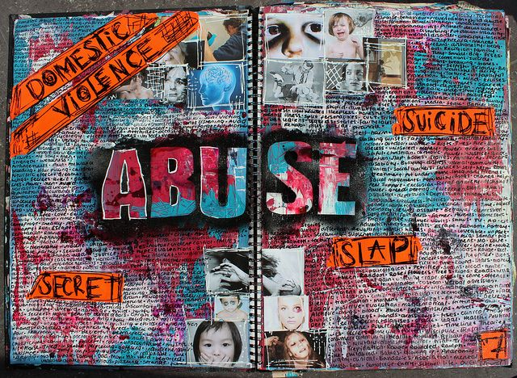  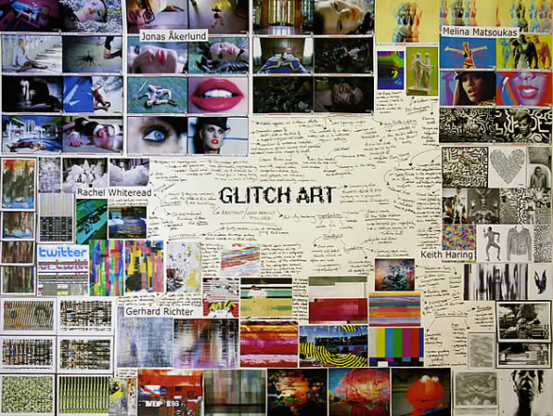  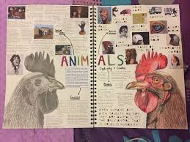  The three examples above illustrate how students have combined their research with visual imagery to support their understanding of their theme.  For a higher mark you need to show:  a) A deep understanding of your theme  b) Cover a wide context  c) Make imaginative connections.
 | 5 | VISUAL RESOURCE BOARD | Create a photomontage of images and words that identifies areas of personal interest in your topic.  - Take Primary Photographs (x 24)  - Collect Secondary Images (x 12)  - Artists’ works based on the concept (Maximum3 key works)  - Leaflets, pamphlets… textured surfaces/textures/papers…  - Arrange these creatively to reflect your theme.  NB. Keep all unused resource in a separate GO TO FILE/SKETCHBOOK... | 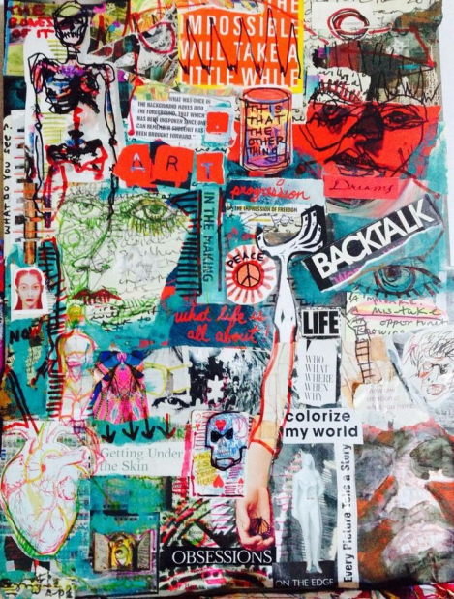  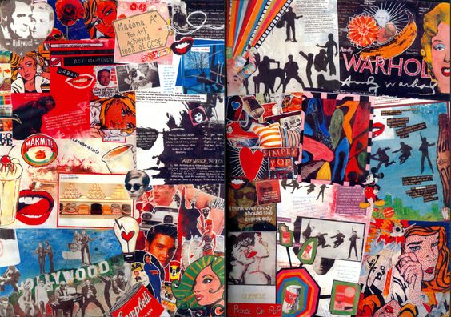  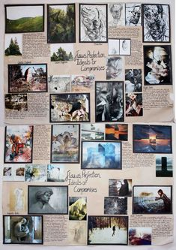
 | 6 | Series of Experimental Drawings | Create a series of experimental drawings from your visual resource board. Overlap images, personal ideas, areas of Interest, take risks with media and draw, draw, draw… | 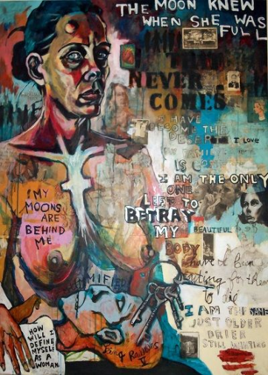  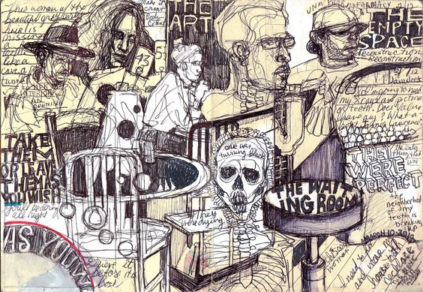  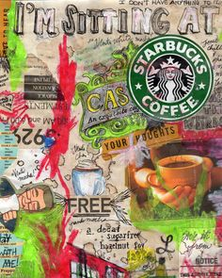
The above must be blu-tak’d in your sketchbook by the DEADLINE FOR PART 1: TUESDAY 2nd SEPTEMBER

Notes for Statement of Intent

STUDENT: | WORKING TITLE:
My theme is…
(Explain in detail, have you got a sub theme?)
I chose this theme because…
(Why this theme? What interests you about it and why?)
My initial inspirations were…
(Did you visit a gallery, were you inspired by an idea, or visual stimulus e.g. work of art, T.V programme… show and explain where and when)
- The first artist who inspired me is……
(Give details of artist and mention specific artworks)
The specific artwork that inspired me is…
(image, details of artwork…)
They inspired me because…
(Talk about why you chose them, link to your theme/topic, media, your own ideas, and explain how they will help you to progress with your work etc…)
- Another 2nd artist who inspired me was……
(Give details of artist and mention specific artworks)
The specific artwork that inspired me is…
(image, details of artwork…)
They inspired me because….
(Talk about why you chose them, link to your theme/topic, media, your own ideas, and explain how they will help you to progress with your work etc…)
- Another artist who inspired me was……
(Give details of artist and mention specific artworks)
The specific artwork that inspired me is…
(image, details of artwork…)
They inspired me because….
(Talk about why you chose them, link to your theme/topic, media, your own ideas, and explain how they will help you to progress with your work etc…)
By exploring this theme I hope to….
(Talk about what you intend to explore with your work and how? What you would like to achieve.

