The aerodynamics of an aircraft and Formula 1

Abstract
In this paper I will discuss what lift is and how an aircraft wing generates lift. I will also discuss what the flaps, slats, slots, speed brakes and spoilers are and how they are used and how they affect the lift created by the wing of an aircraft. I will also talk about what downforce is and how a Formula 1 car uses and generates it. Furthermore, I will compare lift and downforce and how they are created and affected by different factors.
Introduction
Aerodynamics is the study of how air flows over a surface. By studying this in aviation, you will be able to see how the different control surfaces on an aircraft interact with the air. On a wing of an aircraft, the flaps and slats can increase the amount of lift the wing is capable of generating. However, the flaps can also increase drag along with the spoilers and speed brakes.
On the other hand, in Formula 1, the use of aerodynamics helps the F1 teams develop their cars to create the most downforce to limit the effect of drag and dirty air. Formula 1 cars generate downforce by using aerodynamic add-ons, like the front and rear wing, the bargeboards and floor along with the diffuser. These help the driver attack the corner and know the car will stay stuck to the track and not slide over the surface of the tarmac.

What is lift and how is it generated?
Lift is the force that is opposite to the weight of the aircraft and holds it up throughout the flight. It can be generated by every part of the aircraft, but on most aircraft, it is primarily generated by the wings. Lift can only be generated when there is air flowing over the surface of the wings. On an aircraft, to get the air flowing over the wing, the aircraft is pushed forward by the engines, which suck the air into the engine and 70% of it, is accelerated straight out the back. The other 30% is compressed, mixed with fuel in the compressor and combustion chamber and then accelerated out the back of the engine.
There are a few misconceptions about how a wing generates lift. The most common one is that as a wing generates lift due to its characteristic shape, air travels farther over the top, so it must go faster than the air underneath the wing, so both streams meet at the trailing edge simultaneously.
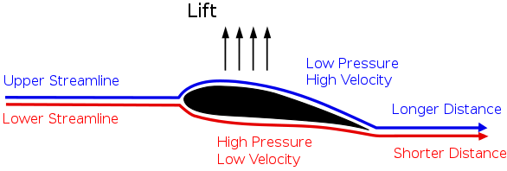
[1]

Experiments have shown that air streams don’t meet up at the back of a wing. Air that goes over the top of the wing goes significantly faster, reaching the trailing edge first.
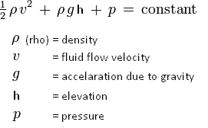
According to Bernoulli’s principle, faster flowing air exerts less pressure than the slower moving air underneath the wing. This pressure difference creates an upward force called lift.
[2]

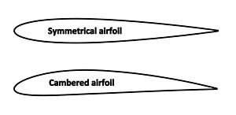
[3]
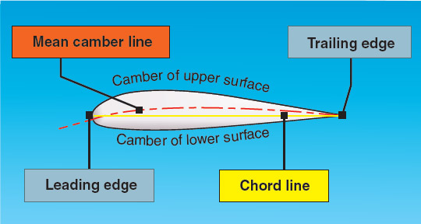
The key to an aircraft generating lift is deflecting air downwards. This can be achieved using different air foils or by increasing the angle of attack. Air under the wing is deflected down and by the Coanda effect, air above the wing is guided along its surface and down as well. In order for the air particle to take the curve, there should be more pressure at the top of the particle than at the bottom. This will supply the centrifugal force.
[4]
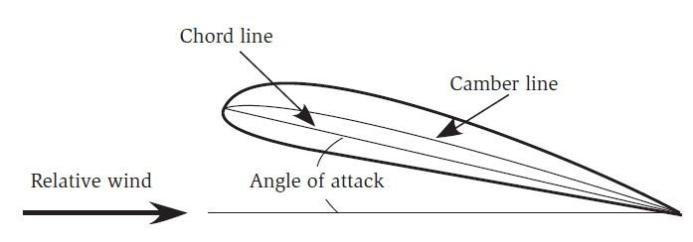
Since the air is slowed and deflected down by the wing, it pushes the wing up and back. This causes lift and drag. This is in accordance with Newton’s third law of motion.
[5]
If you explain lift only using the deflection of air and Newton’s third law, then Bernoulli’s explanation must be wrong. However, air does go faster over the top of the wing than air beneath the wing, creating a difference in pressure that generates lift. Then the Newtonian explanation was unnecessary, and Bernoulli was right.
Bernoulli incorrectly assumed that air over and under the wing must reconnect at the trailing edge and there is no mention of air being deflected down.
Both explanations completely accounts for the lift generated by a wing. They are two different ways of looking at the same thing.
The Coanda effect is the tendency for a fluid jet, in this case the air, to stay attached to a convex surface. The Coanda effect has applications in high-lift devices on aircraft where air moving over the wing is directed down by the use of flaps and a jet sheet blowing over the curved surface of the top of the wing. This results in aerodynamic lift.
[6]

The use and effect of flaps and slats
In modern airliners, they use high-lift devices. This consists of trailing edge flaps that are extended and moved down, leading edge flaps that move out and forward and leading-edge slats that extend out form the surface of the front of the wing.
Flaps are hinged panels mounted on the trailing edge of the wing. When extended, we are changing the shape of the wing from being quite flat and very streamlined to a curved shape. They also increase the camber and, in most cases, the chord line and surface area of the wing resulting in an increase of both lift and drag and a reduction of the stall speed. These factors result in an improvement in take-off and landing performance. They are used to take-off and land at fairly short runways. In this case, the aircraft needs to extract as much lift as possible at low speeds. While we have these extended, they also create a lot of drag which is useful when on approach as they are able to descend at a fairly steep angle without accelerating.
They can also create a lot of lift during take-off as most runways are not longer than two to two and a half kilometres to be able to get to enough speed to get the aircraft airborne. Another reason is that the landing gear wheels cannot spin faster than 200 knots, if they go any faster, they will actually explode. So, it is crucial to get in the air before that happens.
On departure, 5° or 10° of flaps are used and the higher setting like 30° and 40° are used for landing. This is because 5° and 10° creates a lot of lift without a lot of drag. Flaps set to 30° and 40° are used on landing as it generates a lot of lift and a lot of drag, which helps the aircraft fly at slower speeds, so it doesn’t need as much distance to stop on the runway.
On the Boeing 737, the leading-edge flaps are called Kruger flaps which work by extending outwards from the wing, changing the curvature of the wing, and extending the size of the wing. These are situated inboard of the engines; this means between the body of the aircraft and the engines.
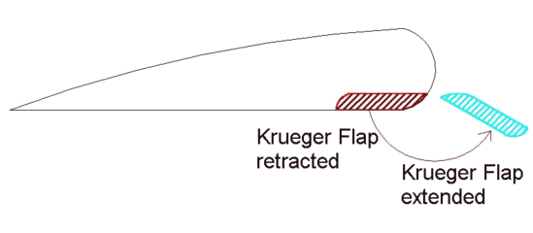
[8]
[7]

LE=Leading Edge
TE=Trailing Edge

Outside of the engine pylons, you have the leading-edge slats. The slats are a piece of the wing that move outwards, extending the surface of the wing, to gain more lift. These are moved by the same input as the trailing-edge flaps and move in relation to the flaps. With 5° and 10° of flaps, the slats are partially extended. You then get full extension of the leading-edge devices with anymore flaps. As the pilot selects the bigger flap setting, more and more of the flap will extend from the back of the wing and more and more of the slots are being shown. Slots are openings between the different stages of the trailing-edge flaps and in between the leading-edge slats and the wing allows a bit of air to run through and extends the boundary layer that makes the flaps and slats more efficient. The bigger the surface the trailing-edge flaps have, the more slots are going to need to be entered.
There are many different flap designs and configurations in use. Large aircraft sometimes incorporate more than one type, utilising different flap designs on the inboard and outboard sections of the wing.
- Plain Flap - The rear portion of the wing aerofoil rotates downwards on a simple hinge arrangement mounted at the front of the flap.
- Split Flap - The rear portion of the lower surface of the wing aerofoil hinges downwards from the leading edge of the flap, while the upper surface remains immobile.
- Slotted Flap - Similar to a Plain Flap but incorporates a gap between the flap and the wing to force high pressure air from below the wing over the upper surface of the flap. This helps reduce boundary layer separation and allows the airflow over the flap to remain laminar.
- Fowler Flap - A split flap that slides rearwards level for a distance prior to hinging downwards. It thereby first increases the chord line (and wing surface area) and then increases camber. This produces a flap which can optimise both take-off (partial extension for optimal lift) and landing (full extension for optimal lift and drag) performance. This type of flap or one of its variations is found on most large aircraft.
- Double Slotted Fowler Flap - This design improves the performance of the Fowler flap by incorporating the boundary layer energising features of the slotted flap.
[9]
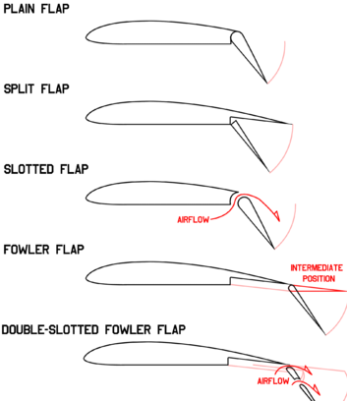

The use and effect of speed brakes and spoilers
If you are sat in the window seat close to the wing on a flight, I am sure you will have seen these panels being extended on landing just after touching down and maybe mid-flight. These are called the flight control spoilers. After touch down, they act as the ground spoilers, I will come back to this later. The flight control spoilers have three different purposes. On most jet airliners, they are operated hydraulically, as the aerodynamic loads on the spoilers can be very high.
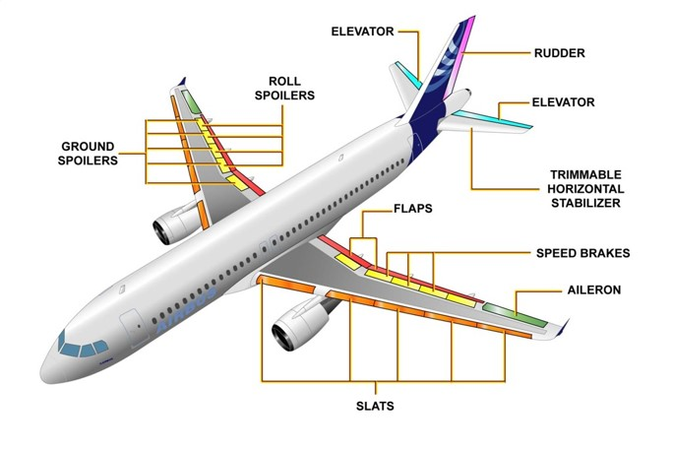
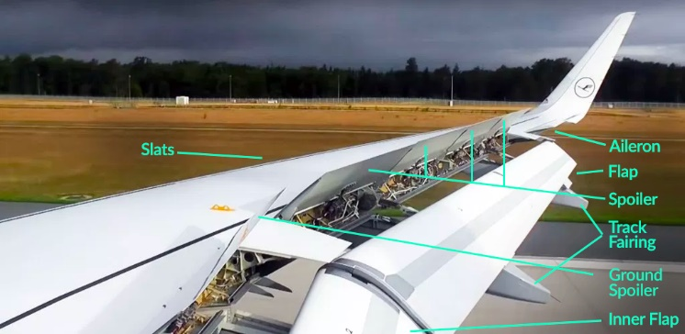
On the Airbus A320, the ailerons are close to the wingtips on either side of the aircraft and act as the primary flight controls, rolling the plane along its longitudinal axis. Next to the aileron, you can see the panels that make up the flight control spoilers acting as secondary control surfaces, which can be deployed manually by the pilot or under given circumstances they extend automatically. Each flight control panel is operated by one hydraulic actuator and each hydraulic system is taking care of at least one spoiler panel on each side. So, if one system fails, the matching spoiler on the other side of the wing will fail as well to avoid asymmetry.
[10]
[12]
[11]

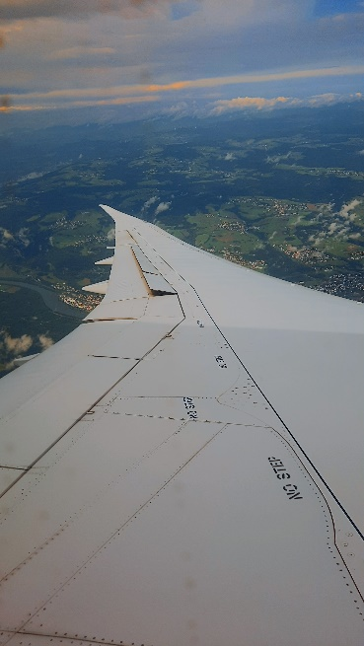
If we were flying at high speeds and you wanted to turn to the left, the aileron on the right wing will go down, increasing the lift. At the same time, the aileron on the left hand wing goes up, decreasing the lift. At high speeds, only minor deflections in the aileron will cause a lot of stress on the wing, creating a twisting and bending moment as there is more lift generated on just this part of the wing. On larger aircraft with larger wingspans, like the Boeing 777 or 787, to counteract this they have inboard ailerons which are used during high speeds to reduce the stress on the wing.
This picture is of a Boeing 787-8, G-ZBJA on approach to Zurich airport on the 26th of September 2021.
In the left turn, the right wing goes up and the left wing goes down, but the aircraft has a tendancy for the nose to turn right, so it is an opposite yaw moment, but at the same time it is rolling, so you get this left turn, it is called the adverse aileron yaw. To counter this effect, you could increase the drag on the downward wing, and that’s when the flight control spoilers come into effect. So by increasing the drag on the downward wing, the yawing moment is reduced and the rolling moment increased. On smaller aircraft like a cessna 152, they have to use opposite rudder to counter this as they don’t have spoilers. One or more spoiler panels will delfect in harmony with the aileron on the associated wing to enhance the roll authority and response.
The second purpose is the speedbrake function. A way to think about this is to imagine you are holding your hand out of the window and you tilted your hand, so your palm is facing the wind and the passing air pushed your hand rearwards. This is demonstarting that your hand is acting as a speedbrake.
If you move the speedbrake control lever in the cockpit, it creates that tilting moment you do with your hand and it deflects the spoilers up. Once you extend the speed brakes, they create drag and decrease the lift over the wings. This automatically will lead to a pitch down moment, so you will pull back on the control column and therefore reduces speed. This is the best way to quickly reduce speed during level flight. As a passenger or pilot, you can hear and feel as the deflection causes the air to become very turbulent and passes over the horzontal stabilizer, which will start to shake the plane as if you were flying through minor turbulence. It is also an effective way of increasing your vertical speed downwards if you are on approach as you are able to decend faster with a lower speed.
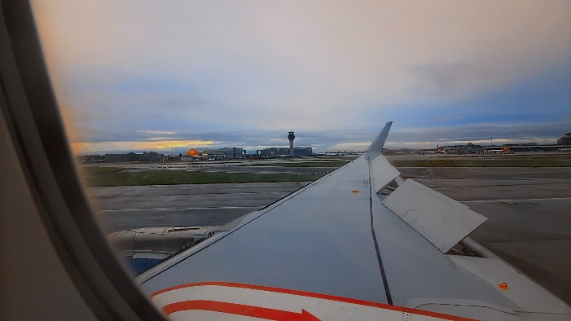
The third and most noticeable action of the flight control spoilers is the ground spoiler function. As the plane comes in for landing and touches down, all spoiler panels are extended to their maximim angle. The primary puprose of the ground spoilers is to maximize the wheel brake efficiency by dumping the lift generated over the wing and at the same time forcing and pressing the full weight of the aircraft onto the landing gear. It also helps slow the aircraft down by creating aerodynamic drag.
This picture is of an Airbus A321 neo, G-NEOP on landing at Manchester airport on the 28th of September 2021.

Formula 1 aerodynamics
Formula One is one of the most popular sports in the world. It is the highest class of international racing for single-seater formula racing cars. Formula One is sanctioned by the Fédération Internationale de l’Automobile (FIA) which was established on 20 June 1904. Formula One was inaugurated on 13 May 1950 as the World Drivers’ Championship at Silverstone in the United Kingdom. In 1981 it became known as the FIA Formula One World Championship.
Several races called the Grands Prix are held over all over the world over a season. These races taken together are called a Formula One season. The word ‘Formula” refers to a set of rules that all participating teams must adhere to. Grand Prix is a French word that translates as grand prize in English. The races are run of tracks that are graded “1” by the FIA. Hence the name Formula One was adopted.
The races take place on purpose-built tracks certified by the FIA all over the world. Most tracks are situated in remote locations well connected with cities. There are a few races such as the British Grand Prix and the Singapore Grand Prix that are held on closed public roads. Formula One is one of the premium forms of racing around the world and draws huge audiences. This is because the best 20 drivers in the world racing for the World Drivers Championship. The 10 teams with 2 drivers each are also competing for the constructor’s title.
What is downforce and how is it generated?
The role of aerodynamics in Formula 1 is to reduce drag and maximise downforce. Downforce is a force acting downwards, similar to lift, but in the opposite direction. Aircraft use wings to generate lift to take off, however, F1 reverses this as the teams invert an aicraft wing.
Downforce is crucial in F1 as it keeps the cars stuck to the road to increae cornering speeds and reduce trye wear. At high speeds, and F1 car generate enough downforce to drive upside down in a tunnel.
Formula 1 cars generate downforce at the front and back of the car. The front wing and bargeboards generate the downforce at the front and the diffuser, rear wing and floor at the back of the car.

The front wing
The front wing is one of the most important parts of an F1 car. It is the first part of the car to encounter the oncoming airflow, which makes it fundamental for aerodynamic performance.
The wing has two main functions; one to create downforce, the other to slip the oncoming air around the front tyres so they don’t get held back by the force of high-speed air.
For downforce, this is achieved with endplates. When the air encounters the wing, it slides over the top. The endplates are there to prevent the high-pressured air from spilling back underneath. The weight of this air pressed on the endplates drives the car down onto the tarmac, providing drivers with better handling, cornering speeds, and more responsiveness. The tips of the wings creates a vortex that improves airflow for the whole car, esspecially the front tyres. This means that more air is fed to the diffuser and the ccar becomes more streamlined, particularly around the floor and underside.
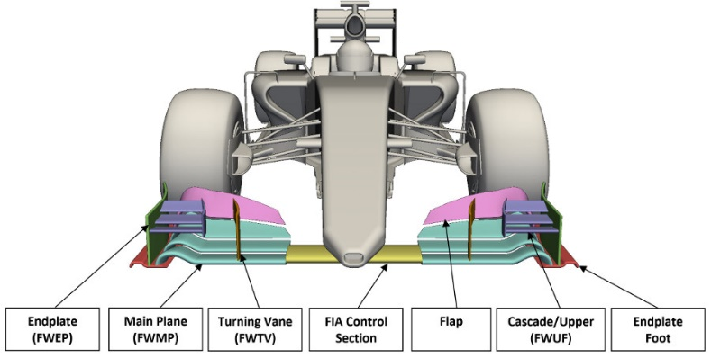
The front wing is also responsible for modifying the handling characteristics of the car. By rotating the front flap angle, the level of downforce generated by the front wing can be altered. As a result, the total downforce level can be redistributed between the front and rear tyres, permitting the race engineer to correct for understeer or oversteer. The setup can be modified to suit different circuits, weather conditions, tyre wear and driver preference.
[13]

Bargeboards
Bargeboards smooth the air round the sidepods whilst adding to the ground effect of the car via forming a vortex seal where the vortices generated by the front wing travel towards the bargeboard, where small flaps called turning vanes create their own co-rotating vortices – many small vortices co-rotating in the same direction being more powerful than one large vortex. Turning vanes guide vortices towards the floor of the car, sealing off the air underneath the floor from the air around the car: a vortex seal – adding to the ground effect.
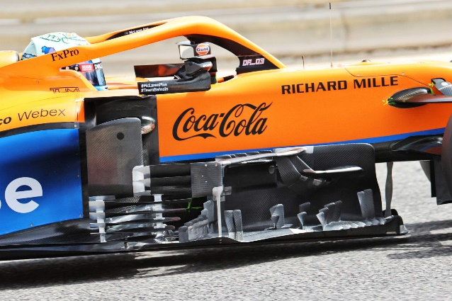
[14]

The floor
People think that the air comes in at the front of the car, and goes all the way along the uderside of the floor and into the diffuser. But it doesn’t work like that. The air that hits the diffuser looks more like a Coca Cola bottle, so it comes in quite close to the centre of the car, goes out wide to edge of the floor and then comes back into the centre of the floor to the diffuser.
The air flow that comes off the tyre wants to push sideways and go into the diffuser. This is called tyre square, it is a vortex that comes off the trye and if that gets into the diffuser, then it will disrupt that air flow already there and reduce downforce. So the teams were putting slots towards the rear od the floor, just infront of the rear tyres, and this introduced high pressure air above the floor and bring it underneath the floor and in the gap between the diffuser and the rear tyre. This stopped the tyre square and straightened up the air underneath the floor.
At the front of the floor, the teams had little fences and slots that produced outwash and keeps the front tyre wake away from the back of the car.
2020 vs 2021
[15]
FIA aimed at slowing down the cars by removing some of the aerodynamic downforce. This was decided after a series of tire failures at Silverstone, which suggested that the downforce levels were stressing the tires too much. The key change is that the rear floor, where much of the downforce is generated as the airflow leaves the car, has been narrowed by 100 mm (3.9 inches) just in front of the rear tires. Less area means less downforce. In addition, the FIA ruled that slots, strakes, and vortices-generating curls, which help to smooth airflow around the rear wheels and tires should also be outlawed. There were various other details, but the overall goal was to reduce downforce by 10%.
This has benefitted the higher rake cars, like red bull (see image 17 below) as the car naturally generated more downforce due to its higher angle. Whereas cars like Mercedes that are a low rake car, depended on the slots to create the downforce that was missing in 2021. This allowed red bull, driven by Max Verstappen to have a better car than Lewis Hamilton in Mercedes, who has dominated the last 8 seasons, and this created the tightest championship in the history of the sport.
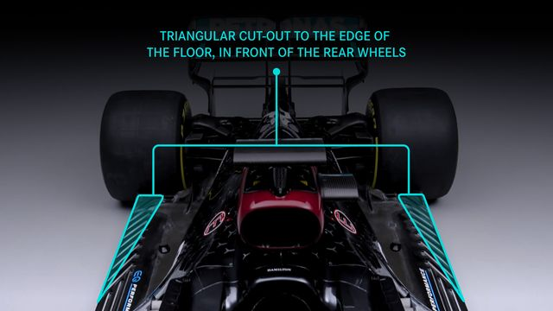
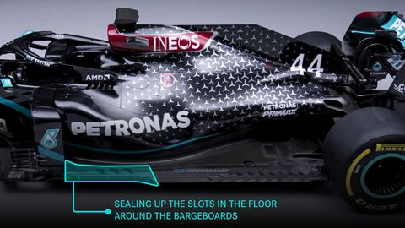
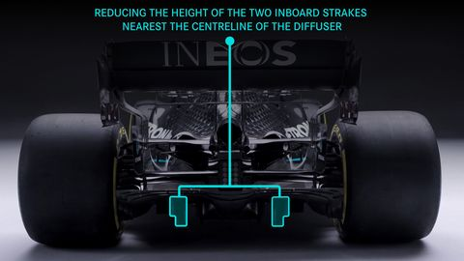
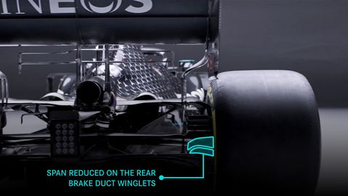

The diffuser
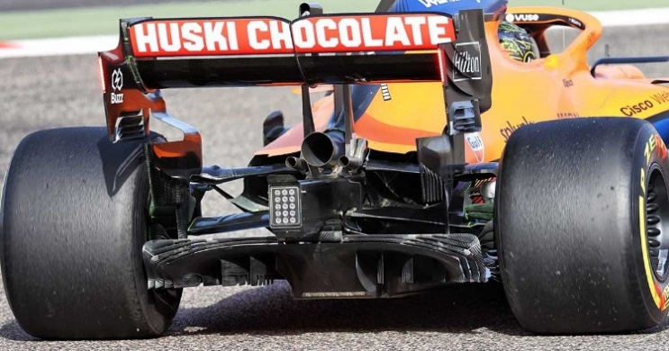
The diffuser is designed and engineered to create downforce and provide stability. It is positioned at the rear of the floor, with a flared opening for sucking in air, moving it through smoothly and creating a low-pressure zone. This low pressure works to enhance the force of the air pressing on top of the car, increasing downforce so drivers have more control when tackling apexes.
[16]
The job of the diffuser is to reduce the flow of turbulent air from beneath the car for improved performance. If you consider the work of the front wing, cutting the air as the car comes in contact, redirecting it around and over the car body, you can easily see that the airflow under the car will be moving at a different speed to the high-pressure airflow above.
The diffuser is responsible for maintaining an equal balance of pressure below the car so that driving conditions are predictable and stable and the downforce pressure above has some glue to stick to. Without the diffuser (or without a well-designed diffuser) high-pressure pockets of turbulent air would occur, disrupting the car’s stability and reducing the floor efficiency in streamlining movement. By using a diffuser that is carefully shaped with that expanding flare, engineers are able to funnel air through (using the front wings to help with directing on target) and accelerate the underside airflow, at the same time the diffuser flare ensures there is no separation of airflow as it exits, allowing that sustained and controlled pressure.
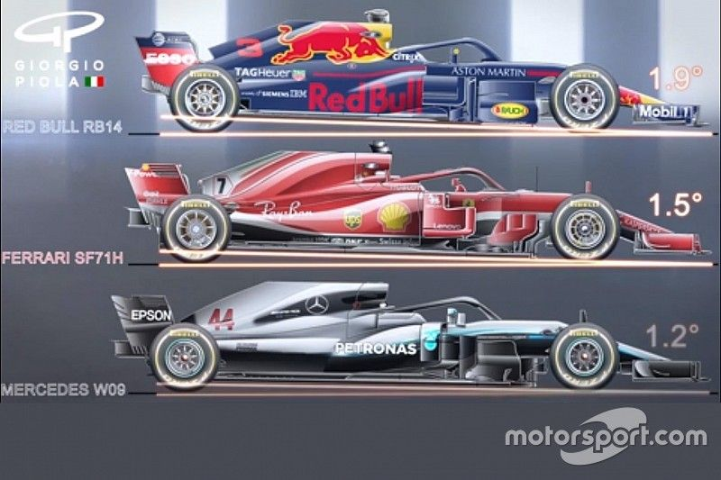
The diffuser is also responsible for producing half of all the downforce produced by the car. Teams can alleviate this by adding rake to the car – where the car is tilted at an upwards angle of around 1 to 2 degrees, so that the air is compressed at the front of the car, accelerated to even faster speeds.
[17]

The rear wing and DRS
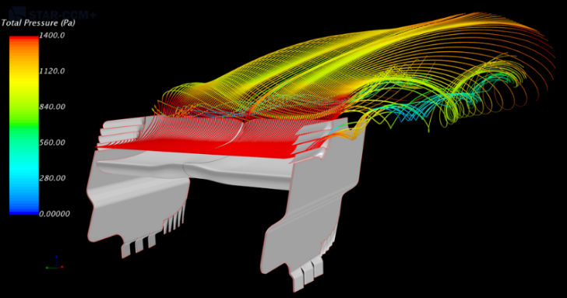
The rear wing plays one of the most important roles in generating downforce on a Formula 1 car as it helps keep the car firmly on the ground. The downforce generated by the rear wings helps the car improve speeds while cornering. But the driver will have to pay for it on the long straights. The speed of a car at the end of a straight will depend on the profile and the angle of attack of the rear wing. The teams must strike a very fine balance between cornering speeds and speeds on straight to achieve better lap times. As Formula 1 cars can reach speeds of an excess of 200 mph, they can literally take off. However, unlike aeroplanes, the car is meant to race on a track. Planes are fitted with aerofoils which help them take off the ground at an optimum speed.
[18]
The wings of a Formula 1 car are in fact aerofoils fitted inverted to that of those on a plane. The purpose of these aerofoils is to produce a downforce several times the weight of the car. This helps the car to remain stuck on the track. As a result, the car tyres get a good grip on the tarmac and the car does not skid on turns. This means the driver can push harder in the turns and be sure that the car will not slide over the surface of the track.
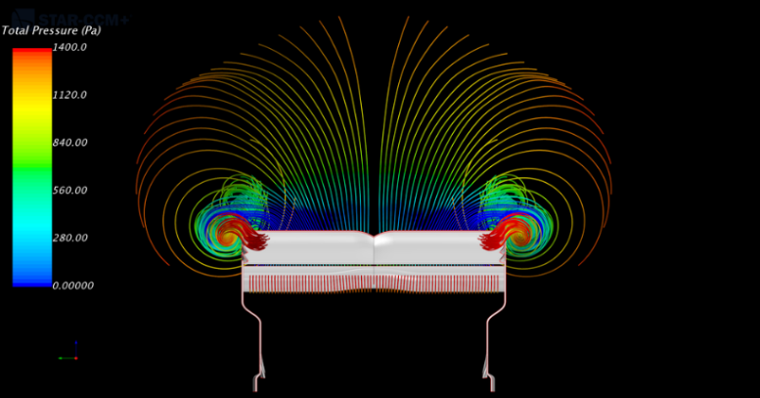
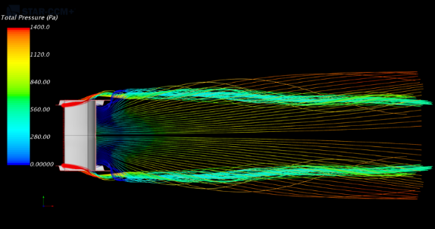
The drag due to rear wings is induced due to the vortices created by the wing ends. There are ways to reduce the drag and one of the options is to reduce the line of attack and reduce the chord. This results in less drag but that also reduces the downforce that the wing produces. It also reduces the area for mounting or accommodating the DRS pod.
[18]
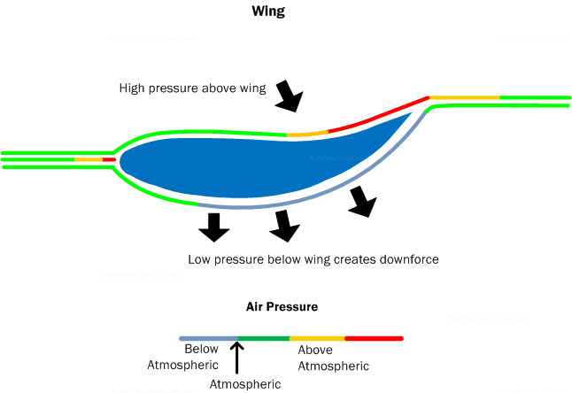
Another approach is to reduce the chord towards the end of the tips of the wing while reducing the angle of attack. This results in reducing the power of the tip vortices. This in turn reduces the drag on the car (see image 18 and 24).
[19]

Monza vs Monaco
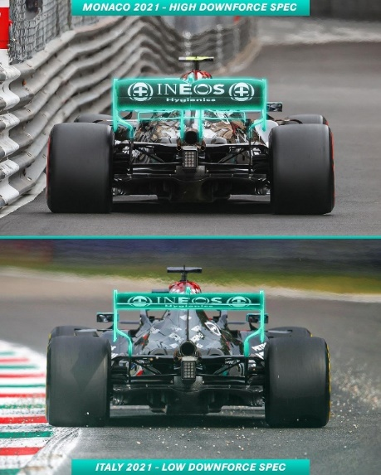
Monza in Italy has long straights and fast corners, so requires as little downforce as possible to reduce the amount of drag produced and therefore it increases the top speed. However, In Monaco, it has very tight and slow corners and requires a lot of downforce to maximise grip as it is a street circuit. It therefore increases drag, but it doesn’t really matter as Monaco doesn’t have a long straight, so it doesn’t require a high-top speed.
[20]
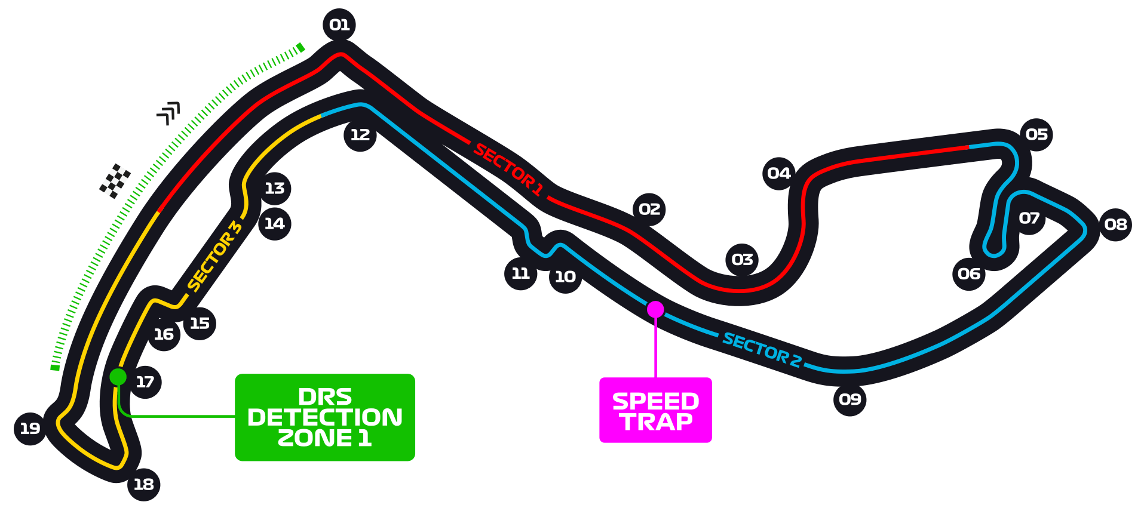
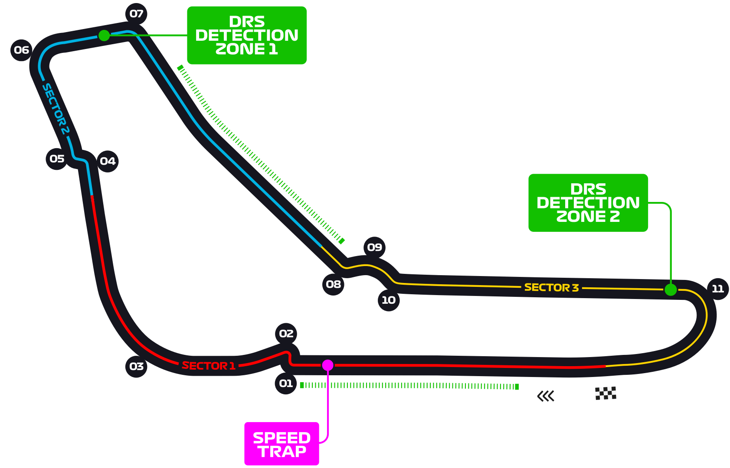
Monaco
[21]
Monza
[22]

DRS
[23]
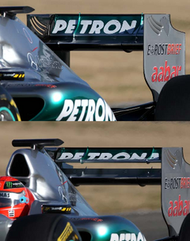
The drag reduction system (DRS), introduced in 2011, is the device that allows part of the rear wing to open on a straight. When activated, the system lifts the leading edge of the wing up by 70 millimetres to create a much larger slot gap - and reduces the frontal area of the car. This means that the car has less drag, providing a boost to the top speed. The system contains an actuator mounted on the rear wing, which is connected to a linkage, which lifts the wing up or down almost instantly.

Usually when the driver lifts off the accelerator or brakes, the DRS closes off automatically and the airflow reattaches to the rear wing, ensuring that the driver gets their downforce back to assist with the corner by the time the car has reached the turn at the end of the straight.
Around a circuit there are several DRS zones, usually on the longer straights, where the system can be activated. You cannot have a DRS zone with a significant corner, as the loss of rear downforce would be so extreme, the cars would fly off the track. When a driver is less than a second behind a rival on track, they may use DRS to try and overtake the car ahead. It may not be used for the first two laps of the race, after a race restart or when the safety car is deployed. Or if the race director deems it to be unsafe, for example if it starts to rain.

2021 vs 2022
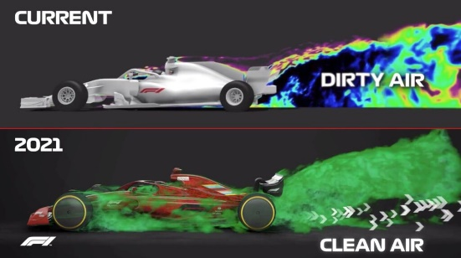
The 2022 Formula 1 season will see the biggest regulation changes in the history of the sport. This is to try and reduce the dirty air produced by the cars and makes it easier for the cars behind to follow and overtake in a race. Or as F1 technical director Ross Brawn calls it, the “raceability” of the cars and this has negatively impacted the quality of racing. F1 says that the current cars lose 35 percent of their downforce when they are around three car lengths behind another car, with the loss increasing to 47 percent when they are about one car length behind. The new rules promise to lessen those downforce losses to 4 percent and 18 percent.
[24]
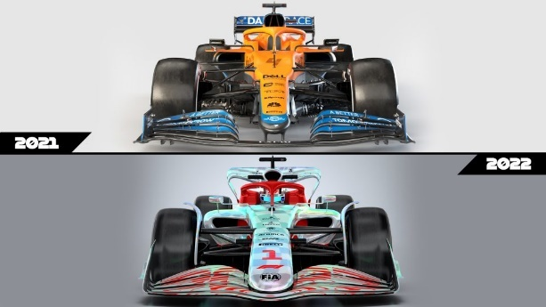
A redesigned front wing is simpler than before and has wing flaps that now stretch all the way to the nose. This eliminates the inner wingtips found on the current cars, which created a vortex that produced much of the "dirty" aerodynamic wake.
[25]
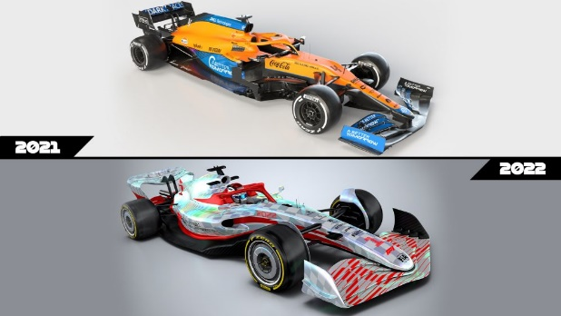
Another big change comes underneath the car. While current F1 cars have a fairly flat floor with a stepped design, the 2022 version will feature deep underfloor tunnels to produce downforce through a ground effect, because simpler wings will yield less downforce. This is said to allow for sleeker bodywork, create less dirty air, and be less impacted by the dirty air when following another car. The bargeboards (pieces of bodywork placed vertically for better aerodynamics) protruding from the floors of the current cars have also been scrapped.
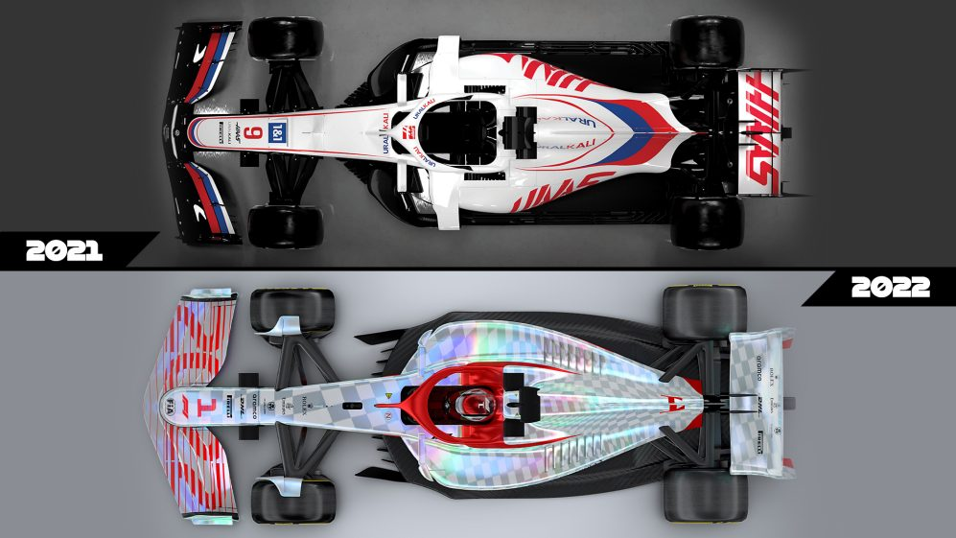
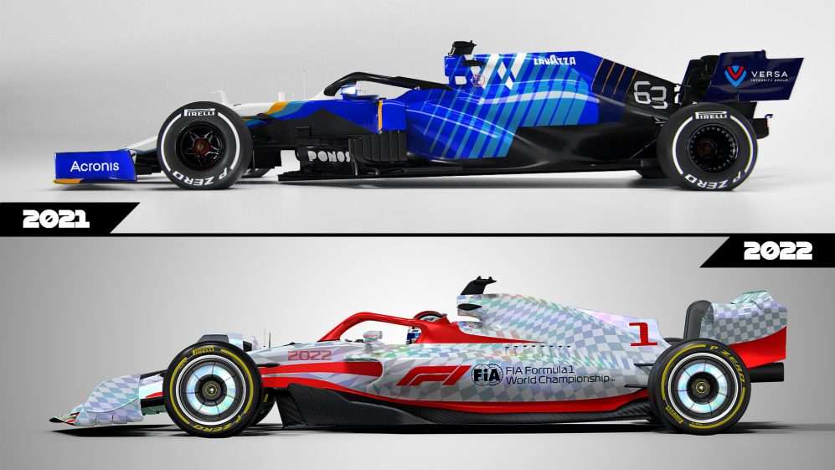
[25]

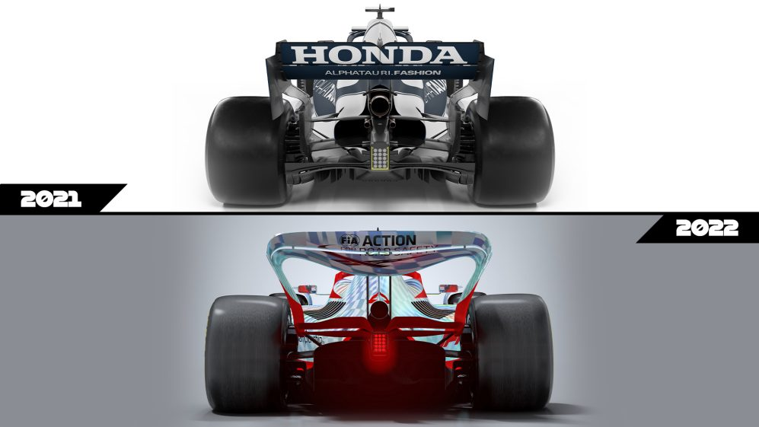
The rear wing also gets an overhaul, with rounded edges compared to the boxy wings on the 2021 cars. This new design is meant to direct the aerodynamic wake coming off the back of a car upward and over any following cars, so that drivers have less disturbed air to contend with when setting up a pass.

Dirty air
[26]v
As air passes over a Formula 1 car’s surfaces, it produces a wake of turbulent air that hampers the aerodynamic flow of cars directly behind it. This wake – nicknamed ‘dirty air’ – can be of benefit to a following car on the straight, as the car in front is effectively punching a hole in the air and doing more work.
Dirty air does, however, hamper the efficiency of the following car’s own aerodynamic surfaces, reducing downforce, making it slower in the turns, and limiting the effectiveness of the cooling system. (See images 17, rear wings)
[26]v
Ground effect and Venturi tunels
The problem with these extreme ground effects is that if the seal is broken – for example, if the skirts are damaged, the car went over an uneven portion of the road, the car was nudged by another car, et cetera – then a large portion of that downforce would be almost instantly lost, potentially causing the car to hurtle off the track.
This caused Niki Lauda’s crash in the 1976 German Grand Prix at the Nürburgring, where he lost control of the rear of the car and collided with the barriers. The force of the impact then directed him back into the middle of track and then he was struck by another car and burst into flames.
Optimising ground effect and making it work for you is all about creating an underfloor profile that expands the airflow as it goes rearward, commonly called a venturi. This will generate low pressure underneath the car as the airflow speeds up to accommodate that expansion.
A venturi is an expanding duct, and as long as the expansion is not too dramatic that expansion will pull the airflow through the restricted area much faster than the free stream airflow is travelling.
As it does that, this low pressure is working between the floor surface of the car and the track surface. In effect, it is trying to either pull the track surface up, which is fairly difficult, or pull the car down to increase the force on the tyre, which in turn gives more grip.
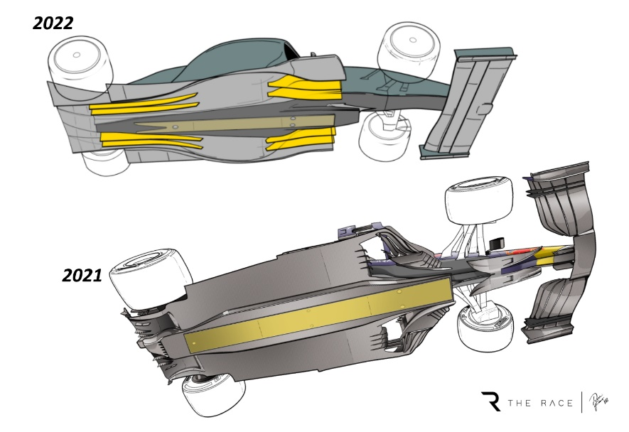

Conclusion
In conclusion, lift is the force that is opposite to the weight of the aircraft and holds it up throughout the flight. It is primarily generated by the wings on an aircraft and the flaps and slats contribute heavily to the amount of lift the wings can create. The flaps also decrease lift and increase drag along with the spoilers and speed brakes to assist in short landings and to slow the aircraft down on landing to protect the landing gear.
In Formula 1, the force that pushes the car into the track is called downforce and is used similarly to aviation. So instead of pushing the air down to create a low pressure on top of the wing, whereas in Formula 1, they have a low pressure under the wing as they are identical but inverted. All the extra aerodynamic devices create a lot more dirty air, so the new regulations for 2022 are going to try and reduce this and improve the quality of racing. This is done by directing air over the following car.

References
[1] https://upload.wikimedia.org/wikipedia/commons/thumb/a/a4/Equal_transit-time_NASA_wrong1_en.svg/879px-Equal_transit-time_NASA_wrong1_en.svg.png (08/01/2022)
[2] https://encrypted-tbn0.gstatic.com/images?q=tbn:ANd9GcS8fuNzKesVwc9uPDMnsVuN6DVAm68adPrdKQ&usqp=CAU (08/01/2022)
[3] https://upload.wikimedia.org/wikipedia/commons/thumb/e/e9/Airfoil_camber.jpg/450px-Airfoil_camber.jpg
(10/01/2022)
(10/01/2022)
[4] https://www.flightliteracy.com/wp-content/uploads/2021/03/3-8.jpg
(10/01/2022)
[5] https://qph.fs.quoracdn.net/main-qimg-e2e66c2506d007a99051c520ff2686bf-c
(17/01/2022)
[6] https://en.wikipedia.org/wiki/Coand%C4%83_effect
(17/01/2022)
[7] https://upload.wikimedia.org/wikipedia/commons/6/68/Krueger-Flap.png
(17/01/2022)
[8] https://www.737ng.co.uk/B_NG-Flight_Controls.pdf
(17/01/2022)
[9] https://skybrary.aero/articles/flaps
(20/01/2022)
[10] https://aircraft.airbus.com/en/aircraft/a320/a320ceo
(21/01/2022)
[11] https://aviationnuggets.com/blog/41/a320-enhanced-electric-rudder
(21/01/2022)
[12] https://thepointsguy.com/news/how-airplane-wings-work/
[13] https://www.totalsimulation.co.uk/secrets-formula-1-part-3-role-front-wing/
(25/01/2022)
[14] https://the-race.com/formula-1/gary-anderson-how-mclarens-new-f1-bargeboards-work/
(25/01/2022)
[15] https://www.autoweek.com/racing/formula-1/a35923925/more-changes-to-the-2021-f1-car-than-you-might-think/
(26/01/2022)
(26/01/2022)
[16] https://www.planetf1.com/news/mclaren-diffuser-trickery-loophole/
[17] https://au.motorsport.com/f1/news/revealed-how-wheelbase-rake-of-f1s-top-teams-compare/3174242/
(26/01/2022)
(27/01/2022)
[18] https://grabcad.com/library/f1-rear-wing-cfd-study-1
(28/01/2022)
[19] https://www.buildyourownracecar.com/race-car-aerodynamics-basics-and-design/4/
[20]https://www.reddit.com/r/formula1/comments/pm4eg3/comparison_between_the_mercedes_rear_wing_at/
(28/01/2022)
[21] https://www.formula1.com/en/information.monaco-circuit-de-monaco-monte-carlo.2ZWRtIcSI6ZzVGX1uGRpkJ.html
(29/01/2022)
[22] https://www.formula1.com/en/information.italy-autodromo-nazionale-monza.FiJN1jnQlRLeHqOxIt13m.html
(30/01/2022)
(30/01/2022)
[23] https://f1.fandom.com/wiki/Drag_Reduction_System
(30/01/2022)
[24] https://allf1.in/f1-2022-car-your-cheat-sheet/
[25] https://www.formula1.com/en/latest/article.analysis-comparing-the-key-differences-between-the-2021-and-2022-f1-car.4xYDhtOjDee4cEQ3P4RsK9.html
(30/01/2022)
(30/01/2022)
[26] https://www.mclaren.com/racing/f1-playbook/dirty-air/
[27] https://the-race.com/formula-1/gary-anderson-what-2022-style-f1-ground-effect-looks-like/
(30/01/2022)

