The King David High School aims to foster young people who are curious, enthusiastic and have a genuine love of learning.
Extended learning and reading around the subject fires students’ enthusiasm, improves their achievement, helps them take control of their own education and develops the independence that is the foundation for lifelong learning.

Year 7 to Year 9

Reading for pleasure: recommended reads for year 7
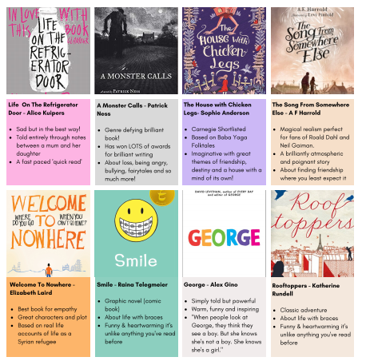
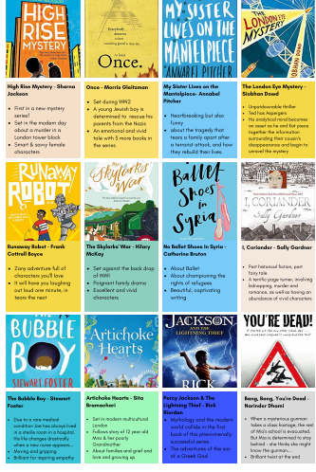
Reading for pleasure: recommended reads for year 8
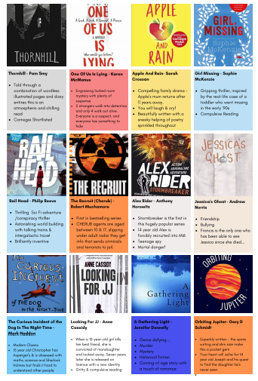
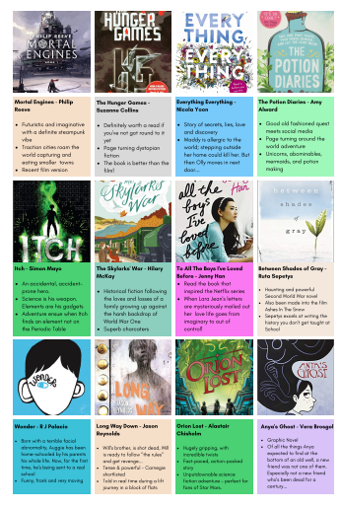
Reading for pleasure: recommended reads for year 9+
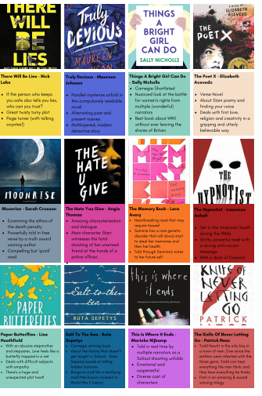
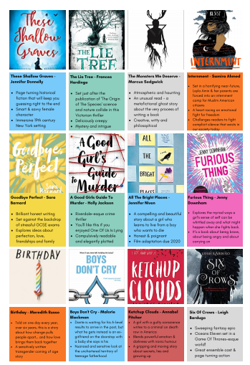
Computing
Computer Applications (free resources):
- Logo - http://www.transum.org/software/Logo
- MonkeyJam - http://monkeyjam.org/
- SQL - http://sqlzoo.net/
Computer Programs (free resources):
- BlueJ - http://www.bluej.org/
- BYOB - http://byob.berkeley.edu
- Greenfoot - http://www.greenfoot.org/door
- Kodu - http://www.microsoft.com/en-us/download/details.aspx?id=10056
- MIT App Inventor - https://sites.google.com/site/appinventor
- Pygame - http://www.pygame.org/download.shtml
- Python - http://www.python.org
- Scratch - http://scratch.mit.edu
- SmallBasic - http://smallbasic.com
- Visual Studio - http://www.visualstudio.com/en-US/products/visual-studio-express-vs
Hardware:
- Gadgeteer - http://research.microsoft.com/en-us/projects/gadgeteer/default.aspx
- Raspberry Pi - http://www.raspberrypi.org/
General Resources:
- Beltchley Park - http://www.bletchleypark.org.uk
- British Informatics Olympiad - http://www.olympiad.org.uk/
- Computing at School - http://www.computingatschool.org.uk
- Computing Cipher Challenge - http://www.cipher.maths.soton.ac.uk/
- CryptoClub - http://www.cryptoclub.org/
- Elite Engineering Programme for Schools - http://www.eep-schools.org.uk/about-us/
- E-Safety - http://www.thinkuknow.co.uk/11_16/
- Manchester Museum of Science and Industry (MOSI) - http://www.mosi.org.uk
- Manchester University Department of Computing - http://www.cs.manchester.ac.uk
- National Media Museum - http://www.nationalmediamuseum.org.uk/
- National Museum of Computing - http://www.tnmoc.org
- STEMNET - http://www.stemnet.org.uk
- Teach ICT - http://www.teach-ict.com/
- Unity (School Portal) - http://unity.kdhs.org.uk/
- WISE - http://www.wisecampaign.org.uk/about-us
- Young Rewired State - http://youngrewiredstate.org/

Modern Foreign Languages (French and Spanish)

“A different language is a different vision of life.”
Federico Fellini
Books/films
 | French | Spanish
Films | Le Petit Prince - Antoine de Saint-Exupéry  Le petit Nicolas film de Laurent Tirard  Kirikou et la sorcière - Michel Ocelot  Kirikou et les animaux sauvages - Michel Ocelot.  Boule et Bill  Belle et Sébastien  Les Choristes  La Grande Vadrouille  Bienvenue chez les Ch’tis | Valentin  Voces Inocentes  El misterio de pez
Books | Le petit Nicolas de René Goscinny  BD Astérix et Obélix  BD Boule et Bill | http://www.gloriafuertes.org/index.php/literatura-inf  http://www.milcuentos.com/ (interactive stories)  https://www.storyplace.org/es
Books | https://www.littleredlanguages.co.uk/ Stories and poems in French and Spanish

Languages Magazines (Years 7-11)
A variety of French (Bonjour, Ça Va and Chez Nous), Spanish (¿Qué Tal?) language magazines are available from your languages teachers- just ask!
https://maryglasgowplus.com/subscribe

News Websites
French
www.1jour1actu.com (simplified news stories for children in French)
Spanish
https://www.periodicoelgancho.com/ (simplified news stories for children in Spanish)
BBC
Keep up to date with stories in Europe andFranco-, and Hispanophone world on http://www.bbc.co.uk/news/world/ and http://www.bbc.co.uk/news/world/europe/ .
There are also stories in French about francophone Africa here: http://www.bbc.co.uk/afrique and hispanophone South America here: http://www.bbc.co.uk/mundo

Podcasts
https://podcast.duolingo.com/
Improve your language skills and gain new perspectives on the world by listening to easy-to-follow, fascinating true stories in French/Spanish.

DuoLingo
Use the following classroom codes to share your progress with your teacher.
French - BWUKHZ
Spanish - VNJWZU
Hebrew - DBQCYR
Italian - DQBMEX
German – MQGXQK
Mandarin- WXCHJN

Challenge essays
“A different language is a different vision of life.” – To what extent do you agree?
Design a poster outlining the importance of learning languages.

Geography
Tim Marshall, Prisoners of Geography
Hans Rosling, Factfulness: Ten reasons we’re wrong about the world – and why things are better than you think
Mr Faraday’s Super Cool Geography Stuff on padlet: Super Cool Geography Stuff (padlet.com)
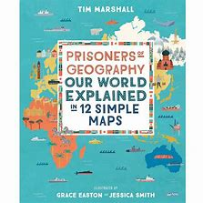

History
Reading
The best historians read a lot so that they know more about the subject and get better at using language. Try some of the following books (in rough chronological order):

Year 7
Terry Deary: The Horrible Histories
- You’ve probably heard of these!

Jim Eldridge: Roman Invasion
- A novel set in the time of Roman Britain

Alex Scarrow: Time Riders
- Time-travelling adventures set in Ancient Rome and the Middle Ages

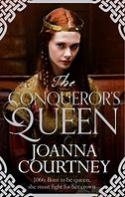
Kevin Crossley-Holland: Arthur and the Seeing Stone
- The first of a trilogy set in Medieval England

Joanna Courtney: The Conqueror’s Queen
- The story of 1066 from the perspective of William’s wife

Philippa Gregory: Changeling
- It’s 1453 and all signs point to the end of the world

Sellar and Yeatman: 1066 and All That
- Classic comic account of British History

Year 8
Cynthia Harnett: Stars of Fortune
- What happened when Elizabeth I was imprisoned by Mary I?

Susan Cooper: King of Shadows
- A time travel adventure set in the world of Shakespeare

Celia Rese: Witch Child
- A horror mystery set in the sixteenth century witch hunts

Berlie Doherty: Children of Winter
- A village isolated by the plague in the 1600s

Jennifer Donnelly: Revolution
- A seventeen-year-old in Paris uncovers a diary from the French Revolution revealing the lost King of France

Stephen Crane: Red badge of courage
- A novel describing the cruelty of the American Civil War
Malorie Blackman: Noughts and Crosses
- An alternative history when Africans enslaved Europeans

Jacqueline Wilson: Hettie Feather and Sapphire Battersea
- Simple stories set in Victorian times

Berlie Doherty: Street Child
- The story behind the foundation of Dr Barnardo’s children’s homes

Year 9
Simon Sebag Montefiore: Monsters: History’s most evil men and women

Michael Morpurgo: Private Peaceful, Warhorse
- Novels set in the First World War

Erich Maria Remarque: All Quiet on the Western Front
- A description of the horrors of the First World War from the perspective of a German soldier in the trenches.

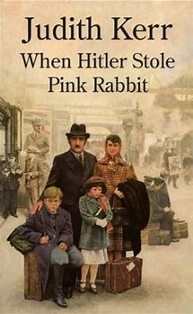
Harper Lee: To kill a Mockingbird
- A description of racial equality in 1930s America.

Anne Frank: The diary of Anne Frank
- The experiences of a Jewish girl during the Second World War.

Judith Kerr: When Hitler Stole Pink Rabbit

John Boyne: The Boy in the Striped Pyjamas
- The holocaust from the perspective of a young boy

Philippe Sands: Ratline
- A Nazi war criminal on the run

Roald Dahl: Going solo
- The true story of Dahl’s experiences in Africa and then as a pilot during the Second World War.

Michelle Magorian: Goodnight Mr Tom
- The story of a young Second World War and the old man who cares for him.

Robert Westell: The Machine Gunners
- The adventures of a group of children in the North East of England during the Blitz.

Morton Rhue: The Wave
- An American high school experiment to understand Nazism gets out of hand.

George Orwell: Nineteen Eighty-Four
- An attack on totalitarianism

Tom Sharpe: Riotous assembly
- A novel set in South Africa under apartheid regime.

Vocabulary
Learn 10 new words from a dictionary: Try to use them in your writing or conversation this week!

Challenge essays
Try one of these…
“History has been shaped by villains not heroes.” How far do you agree? Explain your answer.
“The First World War was the bloodiest war in History.” How far do you agree? Explain your answer.
“There is too much focus on wars in school History.” How far do you agree? Explain your answer.
“There is no point learning about the past.” How far do you agree? Explain your answer.

Or make up your own question using the style above

Local History

Do some research into local History. Visit a museum or historical site, or find out about members of your family.

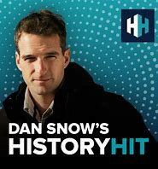
Podcasts
History Hit
- Varied and entertaining podcasts from TV historian Dan Snow.

Programmes and Films
Watch one of these programmes or films. Think about how useful it is to historians (provenance and how far it agrees with your contextual knowledge of the period).

Blackadder
Glory
Testament of Youth
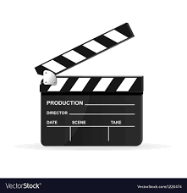
Wipers Times
The Great Gatsby
The Boy in the Striped Pyjamas
Hope and Glory
Pearl Harbour
Jojo Rabbit
The Zookeeper’s Wife
Warhorse
Valkyrie
Forrest Gump
JFK
The Imitation Game

History in the News

Find a story in a newspaper or news website that relates to History. How does it link to the past

Ivrit
Reading
Read the Bereshit newspaper (on SharePoint – Language Department- Ivrit- Bereshit) – an introductory Hebrew newspaper for beginners.
Read an article, summarise the main focus of the article and rewrite it in your own words. Be ready to present it in front of the class.
You will be reading about the most contemporary and widely-used Hebrew. The articles focus on Israeli and international current events, as well as holidays and Jewish values. You will read proper Hebrew as well as Hebrew slang words, commonly used phrases and even words that have been adopted from other languages. The newspaper includes Hebrew-English dictionary of the new words which- (The dictionaries also include transliteration which helps to know how to read the words properly).
- For advanced readers use https://hadshon.edu.gov.il/ to read the daily news.
Vocabulary
- Download the free app Duolingo or go on https://www.duolingo.com/ and learn Hebrew in a fun and interactive way.
Films- Listening extension

- Films on YouTube
Ushpizin אושפזין
Salach Shabati סלאח שבאתי
- Series on Netflix
Shtisel שטיסל
Fauda פאודה
Remember to listen for details and focus on words you know. Ignore what you don’t know and try to understand it without having to read or use the subtitles .
- Alternatively watch films in English but with Hebrew Subtitles
e.g. In front of the class בחזית הכיתה
Music
- Listen to Reshet Gimel to Israeli Music on https://www.kan.org.il/live/radio.aspx?stationid=9
- Watch on YouTube to Israeli singers and learn a whole song in Ivrit
E.g
- Sttatic and Ben El- Silsulim סטטיק ובן-אל -סילסולים
- Omer Adam - Shnei Meshugaim שני משוגעים
- Arik-Einstein- Ani Ve’ Ata ,אריק איינשטיין - אני ואתה

Maths
Maths books and online resources
1. Nrich.maths.org is a website run by the University of Cambridge.
It provides thousands of free online maths resources for all school ages. This includes puzzle pages and articles.
Examples:
https://nrich.maths.org/9469
articles about various mathematical topics. https://nrich.maths.org/books
lists books suitable for all ages on the history of maths, mathematical puzzles and thinking mathematically. https://nrich.maths.org/8516
live problems for all ages that you are invited to submit your solutions to online. https://maths.org/step/ online support programme for STEP. This is the entrance exam used by Cambridge and some other universities for entry to Maths and some other STEM courses.
Sixth Form students who are thinking of studying Maths at university would benefit from the Cambridge reading list: https://www.maths.cam.ac.uk/undergrad/admissions/files/reading-list.pdf
2. Numberphile
Two Youtube channels. https://www.youtube.com/user/numberphile is accessible to a wide age range. The second channel goes into greater detail: https://www.youtube.com/numberphile2
3. Maths Careers website
https://www.mathscareers.org.uk/ has articles about Maths and how it is used in everyday life. Job profiles of people who use a lot of Maths in their work.
4. Plus
An online Maths magazine https://plus.maths.org/content/ You can subscribe to it and receive an email update every two or three weeks. Like most online magazines you can follow it on social media as well. Plus is probably more suitable for KS4 and Sixth Form students.
5. Quanta
Quanta magazine is a Science and Maths magazine aimed mainly at Sixth Form students.
https://www.quantamagazine.org/about/
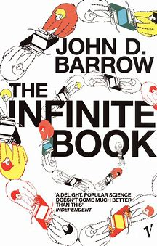
Physics
Ian Stewart, The Magical Maze
Nassim Nicholas Taleb, Fooled by Randomness
John Barrow, The Infinite Book
Roger Penrose, The Emperor's New Mind
Stephen Hawking, God Created The Integers
Robe Eastaway and Jeremy Wyndham, Why do Buses Come in Threes?

Science
BBC science news:
https://www.bbc.co.uk/news/science_and_environment

General
The Week is a good general summary of news and stories each week, and has a junior edition.

Lots of good advice on revision planning and technique is available here:
www.lifemoreextraordinary.com
www.bbc.co.uk/bitesize

GCSE
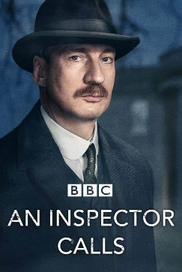
English
Essential reading:
The texts studied during the course are:
An Inspector Calls by J B Priestley or Blood Brothers by Willy Russell
A Christmas Carol by Charles Dickens or The Strange Case of Dr Jekyll and Mr Hyde by R L Stevenson
Macbeth by William Shakespeare
AQA Poetry Anthology (Power and Conflict)

Study Guides:
Study guides for all of the above texts are available from: York notes, Sparks notes, Mr Bruff, Collins, CGP and No Fear Shakespeare. Many of these also publish English Language revision guides.

Reading and wider awareness
The greatest barrier to a pupil’s success in English is because (s)he does not read beyond the scope of the course and has limited knowledge of the wider world. Reading (anything – it does not have to be literary or academic) and wider engagement, is absolutely vital.

Websites
We recommend the following websites for revision and wider reading:
www.universalteacher.org.uk
www.bbc.co.uk/bitesize/subjects
www.english.cam.ac.uk
www.senecalearning.com
www.sparksnotes.com
www.thevictorianweb.org (for context relating to Dr Jekyll and Mr Hyde/A Christmas Carol)
www.literature-study-online.com
www.Englishbiz.co.uk
www.absoluteshakespeare.com

Audio/visual Resources:
Youtube: The Mr Bruff videos are really useful and cover both Literature and Language. Similar resources can be found from Stacey Reay, Mr Salles and RevisionWorld TV.
Film versions of the set texts are also a good way for pupils to revise, and particularly filmed versions of Macbeth. Obviously, pupils do need to be aware that some film versions can differ quite significantly from the text, and certainly do not act as substitutes for the text.
Amazon, Youtube, Soundcloud and other sites also offer audio versions of texts. These can be particularly useful for pupils who would rather listen than read, and can often be downloaded and listened to via mobile phones at a pupil’s leisure.

Geography
Tim Marshall, Prisoners of Geography
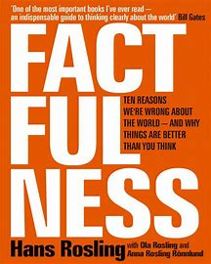
Hans Rosling, Factfulness: Ten reasons we’re wrong about the world – and why things are better than you think
Mr Faraday’s Super Cool Geography Stuff on padlet: Super Cool Geography Stuff (padlet.com)

History
Students should use the past exam questions in their revision guides from school to practise planning questions. This is a good way to review work that they’ve studied that week.

The purple Revise Edexcel GCSE (9-1) History revision guides and revision cards are also very useful, as is the bitesize revision website: https://www.bbc.co.uk/bitesize/examspecs/zw4bv4j

Reading around the subject is an excellent way to deepen your knowledge and feed your passion for History:
Simon Webb: Execution: A History of Capital Punishment in Britain
Hallie Rubenhold: The Five: The Untold Lives of the Women Killed by Jack the Ripper
Joanna Courtney: The Conqueror’s Queen
Ben Elton: Two Brothers
Nathaniel Harris: The Rise of Hitler
Andrea Warren: Surviving Hitler
Andew Langley: Days of Decision- Hitler and Kristallnacht

Podcasts on Norman England
https://podtail.com/en/podcast/norman-centuries-a-norman-history-podcast-by/episode-7-after-hastings/
Ivrit
We recommend radio and podcast material that extends student engagement with language, song, literature and current affairs.
Students could listen to these stations and pause whenever they feel they need to listen to it again

103FM: https://103fm.maariv.co.il/
Galgalatz and Rehet Gimel for music: https://glz.co.il/
www.kan.org.il/

Maths

Y10 and 11 students have access to the Mathswatch revision website. Their teacher has their username and password:
https://vle.mathswatch.co.uk
This consists of videos and practice questions.

Another good source of GCSE practice material is Corbett Maths. Year 11 will find the 5-a-day questions particularly useful for general revision:
https://corbettmaths.com/5-a-day/gcse/

Mymaths is a good revision resource for all ages with walkthroughs and practice questions: https://www.mymaths.co.uk/

The Maths Department has a Year 11 revision site in SharePoint that students can access through their school login. This has a large selection of practice papers, solutions and topic-based material. In the Autumn term this has just a few practice papers to help with revision for the Mocks. This is to prevent students becoming overwhelmed at the start of their revision. Additional material is then added over the spring term.
https://kdmcr.sharepoint.com/sites/Y11MathsGCSERevisionResources

The Maths Department sells the CGP AQA GCSE Maths revision and practice revision guides (£6 each). We think it is currently the best guide available.

The MrBartonMaths website is also an excellent revision site.
http://www.mrbartonmaths.com/students/gcse/
Modern Foreign Languages (French and Spanish)

Kerboodle
https://www.kerboodle.com/
Pupils have their own username and password. Activities are assigned by their class teacher and there are also lots of resources for further independent learning.

BBC Bitesize
French https://www.bbc.co.uk/bitesize/examspecs/zr8bmfr
Spanish https://www.bbc.co.uk/bitesize/examspecs/z4yyjhv

Quizlet
French https://quizlet.com/join/762dDPgcX
Quizlet is a lightning fast way to learn vocabulary: www.quizlet.com

https://glz.co.il/ 6
Music
James Stevenson’s youtube channel is good for an overview of the set works: https://www.youtube.com/watch?v=JPogdlxjWgA&list=PLSSqb164OqxhEzlcTX4dh7JIKB7MIC6Kh
The London Symphony Orchestra’s teacher’s area is quite useful for advice on composing https://www.lpo.org.uk/education/lpo-soundworks-studio-teachers.html
Free online revision guides on each set work are available at www.rhinegold.co.uk

Physics
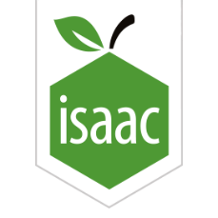
Years 10 and 11 should regularly be accessing Isaac Physics which is used for Physics homework. Students should go back and review these problems as part of their ongoing learning and revision: https://isaacphysics.org/

Also useful is the Antonine Education site, which has the syllabus content and questions/answers and tests: http://www.antonine-education.co.uk/
General revision advice and resources

Lots of good advice on revision planning and technique is available here:
www.lifemoreextraordinary.com
www.bbc.co.uk/bitesize
The Anki app allows you to create flashcards on your phone and tests you on them

Sixth Form
Biology

In order to truly excel in Biology, you will need to do some extra reading about the topics you are learning in lessons. Extra reading brings numerous benefits:
- It helps to put the new ideas that you are learning about in your lessons in context.
- It helps you to broaden your knowledge – your A-level specification doesn’t cover everything.
- It allows you to spend more time learning about topics that particularly interest you.
- Biology is a fast-moving subject, and there are always new discoveries to find out more about.
- When applying for some Uni degrees you may need to discuss your wider reading at interview.
- You can’t achieve top marks in your essay without showing knowledge beyond the specification.

Where can you start?
- Books: Pick books that really interest you, and you are more likely to finish them, understand them, and remember them. Here are some suggestions:

  - Genetics
    - The Immortal Life of Henrietta Lacks. Skloot, R.
    - The Language of the genes. Jones, S.
    - The Serpent’s Promise. Jones, S
    - In the blood. Jones, S.
    - Y: the Descent of Men. Jones, S.
    - Genome. Ridley, M.
    - DNA: The Secret of Life. Watson, J.
    - Double Helix: Personal Account of the Discovery of the Structure of DNA. Watson, J.
    - Mutants: On the Form, Varieties and Errors of the Human Body. Leroi, AM.

  - Evolution
    - On the origin of species. Darwin, C.
    - The Beak of the Finch. Weiner, J
    - Almost Like a Whale. Jones, S.
    - A Devil's Chaplain. Dawkins, R.
    - The Selfish Gene. Dawkins, R.
    - The Blind Watchmaker. Dawkins, R.
    - Wonderful Life. Gould, SJ.
    - Dinosaur in a Haystack. Gould, SJ.
    - Trilobite. Fortey, RA.
    - The Rise and fall of the Third Chimpanzee. Diamond, J.
    - The Ancestor's Tale. Dawkins, R.
    - The Thinking Ape: Evolutionary Origins of Intelligence. Byrne, R.
    - The Kiwi's Egg; Charles Darwin and Natural Selection. Quammen, D.
    - The Greatest Show on Earth. Dawkins, R.
    - The Seven Daughters of Eve. Sykes B.

  - Physiology
    - Why Elephants Have Big Ears. Lavers, C.
    - The Energy of Life. Brown, G.
    - Keep on Running. Newsholme, Leech, Duester.
    - Power, sex, suicide: mitochondria & the meaning of life. Lane, N.
    - Oxygen. Lane, N.
    - Life at the Extremes. Ashcroft, F.

  - Immunology
    - Immunology: Comparative Approach. Turner, RJ.
    - Friendly Fire: Explaining Auto-immune disease. Isenerg, E.

  - Neuroscience/Psychology
    - The Man Who Mistook His Wife for a Hat. Sacks, O.
    - An Anthropologist on Mars. Sacks, O.
    - Awakenings. Sacks, O.
    - Mapping the Mind. Carter, R.
    - How the Mind Works. Pinker, S.
    - The Language Instinct. Pinker, S.
    - The Brain Story. Greenfield, S.

  - Microbiology
    - Missing microbes. Blaser, M.
    - Gut: The inside story of the body’s most underrated organ. Enders, G.

  - Others
    - The Machinery of Life. Goodsell, D.
    - This Is Biology: The Science of the Living World. Mayr, E.
    - Plan and Purpose in Nature. Williams, GC
    - The Diversity of Life. Wilson, EO.
    - The Origin of Humankind. Leaky, R.
    - A Short History of Nearly Everything. Bryson, B.
    - What A Plant Knows. Chamovitz, D.

There is a small collection of Biology books (including some of the ones above!) in room 318 that you are more than welcome to borrow.
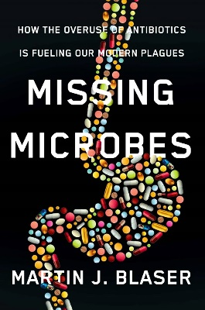

- Publications: Some publications such as New Scientist or Biological Sciences Review are really useful and interesting but unfortunately you need a subscription - we have some issues in school that you can borrow though. Big Picture is free, and you can download and read all the past issues as pdf files here.

- Free online courses: There are lots of these, but some require a high level of time commitment or are pitched at more of a university level (e.g. EdX is incredible, and has courses from the best universities in the world). However there are shorter, less in depth courses out there such as these from the University of Leeds which are 2 hours a week for 2 weeks. The Open University also has short, free courses and activities at introductory level, some of which can be completed in less than 10 minutes.

- Websites:
  - www.ibiblio.org/virtualcell/index.htm – interactive cell biology site.
  - www.accessexcellence.org/RC/VL/GG – website showing illustrations of processes in biotechnology.
  - http://www.uq.oz.au/nanoworld – visit the world of electron microscopy.
  - http://www.dnai.org/a/index.html – explore the genetic code.
  - http://nobelprize.org – details of the history of the best scientific discoveries
  - http://nature.com – the world’s best scientific journal
  - http://royalsociety.org – podcasts, news and interviews with scientists.
  - http://www.nhm.ac.uk – London Natural History Museum’s website with lots of interesting educational material.
  - http://www.bmj.com – the website of the British Medical Journal.
  - http://www.bbc.co.uk/news/science_and_environment – BBC news page for Science.
  - Read the papers, watch the news, follow up on stories. BBC News has lots of articles which link to further research.

- YouTube: Not exactly reading, but it’s another way to access information, and you may well be inspired to do some further research. Here are some popular Youtube channels.

  - Crash Course
  - iBiology
  - Amoeba sisters
  - Moof University
  - Osmosis
  - Khan Academy
  - MIT OpenCourseWare
  - Bozeman Science

- TV: Again, not exactly reading, but there are lots of relevant programmes about and on catch-up, like Planet Earth, for example.

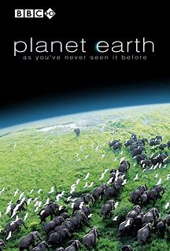

Business and Economics

The Economist magazine – the school has a free online subscription

Tim Harford, The Undercover Economist

Naomi Klein, Shock Doctrine

Naomi Klein, No Logo

Naomi Klein, Fences and Windows

Noam Chomsky, Hegemony or Survival

Will Hutton, The State We’re in

Chemistry
Oxford chemistry primers is an excellent series - all cost between £10 - £14. They are very thin and approachable, but have some deceptively advanced content!

Shriver & Atkins, Inorganic Chemistry
Housecroft & Constable, Chemistry
Atkins & de Paula, Physical Chemistry
Monk & Monro, Maths for Chemists
James Keeler and Peter Wothers, Why Chemical Reactions Happen

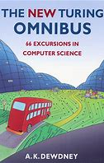
http://www.amazon.co.uk/Chemical-Reactions-Happen-James-Keeler/dp/0199249733/ref=sr_1_1?s=books&ie=UTF8&qid=1323636162&sr=1-1
Computing
A.K.Dewdney, New Turing Omnibus

French
Emile Zola, Germinal
Charles Baudelaire, Les Fleurs du Mal
Andre Breton, Nadja
Geography

Tim Marshall, Prisoners of Geography
Tim Marshall, Divided
Tim Marshall, Worth Dying For - The Power and Politics of Flags
Hans Rosling, Factfulness: Ten reasons we’re wrong about the world – and why things are better than you think
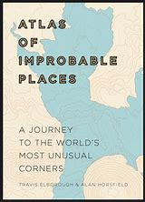
Alistair Bonnet, Unruly Places
Simon Garfield, On the Map
Harm De Blij, The Power of Place
Robert D Kaplan, The Revenge of Geography
Jeremy Brotton, A History of the World in 12 Maps
Charles Montgomery, The Happy City
Ken Jennings, Map head: Charting the Weird World of Geography Wonks
Travis Elborough, Atlas of Improbable Places
Dharshini David, The Almighty Dollar
Paul Collier, The Bottom Billion: Why the Poorest Countries are Failing and What Can be done about it
James Lovelock, The Revenge of Gaia: Why the Earth is Fighting Back and How We Can Still Save Humanity
www.ted.com
www.withouthotair.com

Health and Social Care
Books:
Pig Heart Boy by Malorie Blackman
Wonder by R.J. Palacio
This is Going to Hurt by Adam Kay
When Breathe becomes Air by Paul Kalanithi
The Hate U Give by Angie Thomas
Me Before you by Jojo Moyes
The Fault in Our Stars by John Green
The Story of Baby P by Ray James
Savage Girls and Wild Boys by Michael Newton
The Language of Kindness by Christie Watson
I am Malala by Malala Yousafzai
The Boy Who Couldn’t Stop Washing by Dr Judith Rapaport

Netflix:
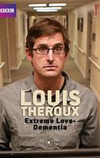
Babies
Marriage Story
Louis Theroux: Extreme love, Dementia
Five Feet Apart
Brain on Fire
Theory of Everything
What to expect when you’re expecting
Unbroken
Girl, interrupted
Call the Midwife
13 Reasons Why
Pandemic: How to prevent an outbreak

BBC iPlayer:
Elizabeth is Missing
Rio & Kate: Becoming a Step family
Jesy Nelson: Odd one out
Bohemian Rhapsody

4 On Demand:
Confessions of a Junior Doctor
Born to be different
Secret life of… Year Olds
Still Alice
Amazon Prime:
The Children Act
The Upside
Beautiful Boy
Miss you Already

History

Unit 1: The Civil War Years 1625-1701
Peter Ackroyd, Civil War: The History of England Volume III (History of England Vol III), 2015
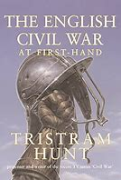
Christopher Hill, The World Turned Upside down: Radical ideas during the English Revolution (2019)
Leanda de Lisle, White King: The Tragedy of Charles I (2019)
Tristram Hunt, The English Civil War: At First Hand (2011)
Ian Mortimer, The Time Traveller's Guide to Restoration Britain (2018)
Barry Coward, The Stuart Age

Edward Vallance, The Glorious Revolution: 1688 - Britain's Fight for Liberty (2013)

Jenny Wormald (editor), The Seventeenth Century (Short Oxford History of the British Isles, Oxford University Press, 2008)

William G. Naphy, The Protestant Revolution: From Martin Luther to Martin Luther King Jr. (2007)
Thomas Hobbes, Leviathan

Websites

BBC
English Civil War website and also content on the Glorious Revolution
www.bbc.co.uk/history/british/civil_war_revolution/

Documentaries
The Stuarts https://www.bbc.co.uk/iplayer/episodes/p01lkn5l/the-stuarts
Channel 4
Monarchy, presented by David Starkey
https://www.youtube.com/watch?v=fdDKO-Klflo - Oliver Cromwell - The King Killer https://www.youtube.com/watch?v=mypTm0VRF4g – The Glorious Revolution

Podcasts
BBC Radio 4, In our Time podcasts https://www.bbc.co.uk/programmes/b01rw1k7 - The Putney Debates https://www.bbc.co.uk/programmes/b00kpzd6 - The Trial of Charles I https://www.bbc.co.uk/programmes/p00547bx - The Restoration https://www.bbc.co.uk/programmes/p00547fk - The Glorious Revolution https://www.bbc.co.uk/programmes/b01f67y4 - George Fox and the Quakers https://www.bbc.co.uk/programmes/p003k9l1 - Thomas Hobbes https://www.bbc.co.uk/programmes/p003hyds - The Royal Society https://www.bbc.co.uk/programmes/p004y28g - John Locke and Empiricism

Paper 2: Russia in Revolution, 1894–1924
John Reed, Ten Days That Shook the World
- A buccaneering east-coast American radical despatched to cover the revolution is hypnotised by it and his reports combined to make a book that had a huge impact in the US and beyond. Decades later, Warren Beatty made it into a movie, Reds, in which the most electrifying sections were the appearances by witnesses who had known Reed.

Albert Rhys Williams, Through the Russian Revolution
- Williams was already in Petrograd when Reed arrived and acted as a calming tutor to his wilder and more activist colleague. His book is in some ways a more solid work, helped by several conversations with Lenin and other Bolsheviks, as well as their opponents.
Orlando Figes, A People’s Tragedy: The Russian Revolution 1891-1924 (2017)
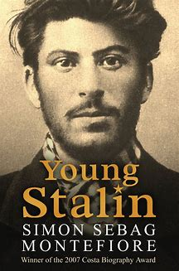
Robert Service, The Last of the Tsars: Nicholas II and the Russian Revolution (2018)
Sean McMeekin, The Russian Revolution: A New History (2018)
Sheila Fitzpatrick, The Russian Revolution (2017)
Michael Foley, Russian Civil War: Red Terror, White Terror, 1917-1922 (2018)
Simon Sebag Montefiore, Young Stalin
Simon Sebag Montefiore, Stalin: The Court of the Red Tsar

Websites
Russian Revolution timeline 1900-1917
https://www.bl.uk/russian-revolution/articles/timeline-of-the-russian-revolution

Documentaries
Empire of the Tsars, Romanov Russia with Lucy Worsley, Episode 3 – The Road to Revolution - https://www.bbc.co.uk/programmes/b06vmlcg/episodes/guide
Podcasts
BBC History Hour: The Russian Revolution – The Bolsheviks take Control https://www.bbc.co.uk/programmes/w3csvstw
History Hub, Podcast: Judith Devlin on the Russian Revolution http://historyhub.ie/judith-devlin-the-russian-revolution BBC Radio 4, In our Time, Lenin - https://www.bbc.co.uk/programmes/p00546pv
BBC Radio 4, In our Time, Tsar Alexander II's assassination https://www.bbc.co.uk/programmes/p003k9b2
15 Minute History, Episode 101 - The Bolshevik Revolution at 100 https://15minutehistory.org/podcast/episode-101-the-bolshevik-revolution-at-100/

General
Simon Scharma, A History of Great Britain
George Orwell, Nineteen Eighty-Four
Robert Graves, I Claudius
John K. Galbraith, The Great Crash 1929: The classic account of economic disaster
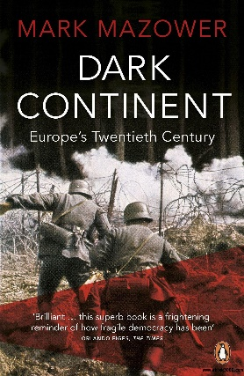
Michael Burleigh, Sacred Causes: religion and politics from the European Dictators to Al Qaeda
Mark Mazower, Dark Continent: Europe's Twentieth Century
Niall Ferguson, War of the World: History’s Age of Hatred
Niall Ferguson, The Pity of War (1999)
History today magazine

Podcasts
BBC Radio 4, In our Time podcasts https://www.bbc.co.uk/programmes/b01rw1k7 - The Putney Debates https://www.bbc.co.uk/programmes/b00kpzd6 - The Trial of Charles I https://www.bbc.co.uk/programmes/p00547bx - The Restoration https://www.bbc.co.uk/programmes/p00547fk - The Glorious Revolution https://www.bbc.co.uk/programmes/b01f67y4 - George Fox and the Quakers https://www.bbc.co.uk/programmes/p003k9l1 - Thomas Hobbes https://www.bbc.co.uk/programmes/p003hyds - The Royal Society https://www.bbc.co.uk/programmes/p004y28g - John Locke and Empiricism

Historical Association
Podcasts on Cromwell, including the execution of Charles I and Tudor and Stuart women:
www.history.org.uk/podcasts/#/e/289

You’re dead to me
From the makers of Horrible Histories but more adult!

History Hit
Varied and entertaining podcasts from TV historian Dan Snow.

BBC History Extra

Lots of really interesting different topics are covered here

Historiography
David Cannadine What is History Now?
E.H. Carr, Professor Richard J. Evans What is History?
Professor Ludmilla Jordanova History in Practice
Alan Bennett, The History Boys (Book/film)
Mr Pitt’s padlet: https://padlet.com/jpitt10/8uq5mt99vdr04w91

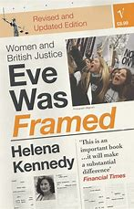
Law
www.thelawyer.com
Helena Kennedy, Eve Was Framed: Women and British Justice
Helena Kennedy, Just Law
Tom Bingham, The Rule of Law
Geoffrey Rivlin, Understanding the Law
Marcel Berlins and Clare Dyer, The Law Machine
Law in action podcast

Maths

David Acheson, 1089 and all that: A Journey into Mathematics

Graham Farmelo (editor), It Must be Beautiful

Simon Singh, Fermat’s Last Theorem

Simon Singh, The Code Book: The Secret History of Codes and Code-breaking

Solomon Golomb, Polyominoes

Edwin Abbott, Flatland: A Romance Of Many Dimensions

Rob Eastaway and John Haigh, How to Take a Penalty

Sarah Flannery and David Flannery, In Code: A Mathematical Adventure

Ian Stewart, The Magical Maze

David Wells, The Penguin Dictionary of Curious and Interesting Numbers

Apostolos Doxiadis, Uncle Petros and Goldbach’s Conjecture

John Conway and Richard Guy, The Book of Numbers

William Dunham, The Mathematical Universe: An Alphabetical Journey Through the Great Proofs, Problems, & Personalities

Ian Stewart, Does God Play Dice?

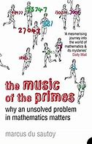
Timothy Gowers, Mathematics: A Very Short Introduction

Michael J de Smith, Maths for the Mystified

Eli Maor, e: The Story of a Number

Robin Wilson, Four Colours Suffice

Keith Devlin, The Millennium Problems

Robert Kanigel, The Man Who Knew Infinity: A Life of the Genius Ramanujan

Marcus du Sautoy, The Music of the Primes

Here is a list of recommended books for Sixth formers from the Mathematical Association https://www.m-a.org.uk/resources/booklist07.doc
Online lectures
Hannah Fry presented the Royal Institution Christmas lectures this year on the theme of Secrets and Lies: The hidden power of Maths. There are many other interesting Maths and Science lectures you can watch from previous years https://www.rigb.org/christmas-lectures/watch
The BBC 2 Horizon series of programmes also covers a wide range of themes in Science and Maths https://www.bbc.co.uk/iplayer/episodes/b006mgxf/horizon
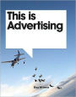
Media
https://www.theguardian.com/media/series/media-briefing
Connell, B, Exploring the Media – Text, Industry, Audience, Auteur
Williams, E, This is Advertising
Lacey, N., Media, Institutions and Audiences

Medicine, Dentistry, Nursing, Midwifery etc.
Mr Christo’s Medsoc section of the King David High School website has a wealth of resources:
http://www.kdhs.org.uk/medsoc.html

Physics

Feynman Lectures (online): https://www.feynmanlectures.caltech.edu/
Hyperphysics: http://hyperphysics.phy-astr.gsu.edu/hbase/index.html
IOP: www.iop.org
How Stuff Works: www.howstuffworks.com
NASA: www.nasa.gov
Physics: www.physics.org
Physics World: www.physicsworld.com
CERN: www.home.cern
Physics classroom: https://www.physicsclassroom.com/
Data: https://www.wolframalpha.com/examples/science-and-technology/physics/
American Physical Society: https://aps.org/
Physics forums: https://www.physicsforums.com/

Books
Stephen Hawking, A brief history of time
John Gribbin, In search of Shroedinger’s cat
Brian Greene, The elegant universe
Michio Kaku, Parallel worlds: a journey through creation, higher dimensions and the future of the cosmos
Leonard Susskin, The black whole war
Lisa Randell, Warped passages: unravelling the mysteries of the universes hidden dimensions
Richard Feynman, 6 easy pieces
Richard Feynman, 6 not so easy pieces
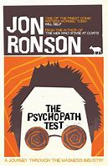
Richard Feynman, Surely you’re joking Mr Feynman

Psychology
Social Psychology
Zimbardo P. (2008) The Lucifer Effect: How good people turn evil
Milgram S. (2010) Obedience to Authority: An experimental view
Pelonero C (2016) Kitty Genovese: A true account of a public murder and its private consequences

Psychopathology
Malik C (2015) The Nacissist Test: How to spot outsized egos and the surprising things you learn from them
Ronson J (2011) The psychopath test
Dutton K. and McNab A. (2014) The good psychopath’s guide to success: How to use your inner psychopath to get the most out of life

Free Will vs Determinism
Mischel W. (2014) The Marshmallow Test: Understanding self-control and how to master it
Plomin R. (2018) Blueprint: How DNA makes us who we are
The Adjustment Bureau (2011) – can we control against the agents of fate? Film starring Matt Damon

General
Harari Y. N. (2015) Sapiens: A brief history of humankind
Sacks O. The Man who mistook his Wife for a Hat

Sociology
Texts
Judith Butler: Gender Trouble: Feminism and the Subversion of Identity
Owen Jones: Chavs: The Demonisation of the Working Class
Louis Theroux, The Call of the Weird: Travels in American Subcultures
Kate Pickett and Richard Wilkinson, The Spirit Level: Why Equality is Better for Everyone
Sudhir Venkatesh: Gang Leader for a Day
Simone de Beauvoir, The Second Sex
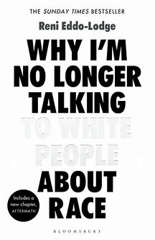
Reni Eddo-Lodge: Why I’m no Longer Talking to White People About Race
Films and television
Riot Club
Where to Invade Next
Louis Theroux: The Most Hated Family in America etc.
Going Clear: Scientology and The Prison of Belief
Examined Life
Faking it (British Channel 4 TV series)
Websites
www.revisesociology.com
The Teacher Sociology: https://www.youtube.com/channel/UC6VpoZj33Df_rNb8KymCczw
Summaries of classic sociological texts: https://www.tutor2u.net/sociology/collections/classic-texts-summaries-sociology-students
Mr Pitt’s padlet: https://padlet.com/jpitt10/8uq5mt99vdr04w91

Precooked sociology: https://www.precookedsociology.com/

John T. Pullinger’s Sociology Presentations :
John T. Pullinger’s Sociology Presentations - Earlham Sociology and Politics Pages (earlhamsociologypages.uk)

Esher College YouTube Podcasts:
(1) Esher Sociology - YouTube

Chris Livesey’s SHORTCUTSTV Site: ShortCutstvSociology

Twitter Accounts geared to AS and Advanced Level Sociology Units [Organised by Ken Browne]
Culture and Identity: #SOCCUID
Understanding Social Inequality: #SOCUSI
Education: #SOCED
Families and Households: #SOCFAM
Work, Poverty and Welfare: #SOCWPW
Health: #SOCHTH
Globalisation and the Digital World: #SOCGDW
Crime and Deviance: #SOCCD
Global Development: #SOCGD
Social Differentiation and Stratification: #SOCSD
Mass Media: #SOCM
Beliefs in Society: #SOCBiS
Theory and Methods: #SOCTM

The Sociology Guy: (1) The Sociology Guy - YouTube
Podcasts on Families and Households, Sociology of Development, Education, Methods in Context and Crime and Deviance [including Crime and the Media]Twitter@The SociologyGuy
Padlet of Sociology Resources shs_sociology (sociology_shs) profile | Padlet
Truly encyclopedic padlet of resources on Families and Households, Education, Crime and Deviance, Beliefs and Theory and Methods

Spanish

Grammar
Butt, John & Carmen Benjamin, A New Reference Grammar of Modern Spanish, 4th ed., London: Arnold

Texts
Federico García Lorca, La casa de Bernarda Alba
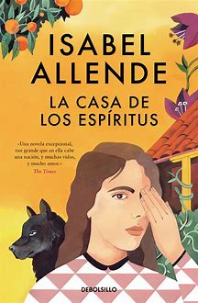
Gabriel García Márquez, Crónica de una muerte anunciada
Laura Esquivel, Como agua para chocolate
Ramón J. Sender, Réquiem por un campesino español
Carlos Ruiz Zafón, La sombra del viento
Isabel Allende, La casa de los espíritus
Gustavo Adolfo Bécquer, Rimas
Fernando Fernán-Gómez, Las bicicletas son para el verano
Luis de Castresana, El otro árbol de Guernica
Gabriel García Márquez, El coronel no tiene quien le escriba

Films
El laberinto del fauno, Guillermo del Toro (2006)
Ocho apellidos vascos, Emilio Martínez-Lázaro (2014)
María, llena eres de gracia Joshua Marston (2004)
Volver, Pedro Almodóvar (2006)
Abel Diego, Luna (2010)
Las 13 rosas, Emilio Martínez-Lázaro (2007)
Oxbridge
https://myheplus.com/
This is from the university of Cambridge. There are different subject pages to look at.

https://openlibrary.org/
Lots of free access to different texts.

https://www.hist.cam.ac.uk/welcome-our-virtual-classroom
This is the virtual classroom of the History Faculty at Cambridge. Some good sources etc to look at that might help with preparation for aptitude tests.

https://podcasts.ox.ac.uk/
Loads of podcasts and lectures from the University of Oxford. Definitely worth searching for your areas of interest.

https://theconversation.com/uk
This is discussion of various issues of the day by academics. It’s also a good idea to follow any academics you like on twitter.

General
Lots of good advice on revision planning and technique is available here:
www.lifemoreextraordinary.com
…and here:
Tony Buzan, Use Your Head: How to Unleash the Power of Your Mind www.intelligencesquared.com

www.tedtalks.com
- Online talks on a huge range of subjects

Attend one of the societies: Law Society, Medsoc, Politics Society, Psychology Society etc. or set up your own.

