Chapters 9 -13: Mrs Ayres and Uncanny Events

Chapter 9 – Noises in the house & scribbling on walls

‘she [Caroline] didn’t know what frightened her more, the prospect of discovering something dreadful in the room beyond it, or the possibility - which at that moment, given her mother’s behavior seemed quite strong – of there being nothing untoward in there at all.’ P. 308

‘”How this house likes to catch us out, doesn’t it? As if it knows all our weaknesses and is testing them, one by one”’ p. 309 (Mrs Ayres)

‘Caroline looked at her for a moment, struck by the lines of age and sadness in her face, and suddenly seeing her – as, when we are young, we are now and then shocked to see our parents – as an individual, a person of impulses and experiences of which she herself knew nothing and with a past, with a sorrow in it, which she could not penetrate.’ P. 309

‘”I didn’t suppose there was any trace of her left, you see.” She placed her hand above her heart. “ Except in here. She has always been real to me, in here. More real, sometimes, than anything else…”’ p. 317(Mrs Ayres)

“Its as though, when she looks at you, she isn’t really seeing you at all. She’s seeing something else”’ p. 318

‘”I remember being cross, because everyone had always told me I was the eldest child, and I thought it wasn’t fair if I hadn’t been really.”’ P. 318

Chapter 10 – Mrs Ayres ‘locked’ in nursery and cuts her hands

Consider the significance of Faraday’s portrayal of Mrs Ayres’ visit to the nursery on pages 339-341:

‘All she could think, with growing horror, was that the figure must be Betty’s after all, but that the girl had somehow lost her wits and was racing up and down the nursery passage like a lunatic.’ P. 343

‘the figure was catching at the panels of wood with its fingernails…a small, sharp-fingered hand – a child’s hand’ p. 344

‘the whistling was purposeful, demanding – something like the wail of a siren, or the cry of a hungry baby.’ P. 344

‘In an instant she was transported back, twenty-eight years, to her first child’s sickbed.’ P. 345

‘She had, by this time, begun to weep tears of fright, which almost blinded her… somehow it cut into her fingers and would not give.’ P. 345

‘They saw Mrs Ayres shrieking from between the nursery bars – shrieking like a child, Mrs Bazeley said – and beating her hands against the edges of broken window.’ P. 346

‘”I was afraid of her, and I failed her!”’ p. 348

‘” Well, isn’t it obvious?...Its something in this house! Something that’s been here all along, and just …woken up. Or something that’s come here, to punish and spite us. You saw how my mother was, when you arrived. You heard what happened to her. You heard Mrs Bazeley, and Betty,”’ p. 352

Consider the significance of the dialogue between Faraday and Caroline on page 353:

‘“She must have made your sister into a sort of figure for everything she’s lost.”’

‘She began to stir and murmur as I stood beside her bed, but I laid my hand across her forehead, and stroked her pale, anxious face; and soon she was still.’ P. 355

Chapter 11

‘I could see that her eyes were dark and still glassy from the sedative I’d given her the day before, and her pose was a rather weak one.’ P. 357

“Mother’s very good, you know at hiding her real feelings. All that generation are; especially the women.”’ P. 359

[Seeley]: ‘”Then again, its generally women, you know at the root of this sort of thing. There’s Mrs Ayres, of course, the menopausal mother: that’s a queer time, psychically. And don’t they even have some teenage housemaid there, too?”’ p. 380

Chapter 12 – Mrs Ayres’ death

‘”Women are built for pain. Now, if you men had to go through childbirth…”’ p. 390

‘”I’m an old-fashioned woman, and you weren’t quite the match I’d planned for her.”’ P. 390

‘her expression had something terrible in it, a mixture of absolute loneliness, huntedness, and fear.’ P. 391

Consider the top paragraph on p. 393:

‘”You don’t actually think I should abandon her to her delusions, purely for the sake of keeping intact some sort of …class pride?”’ p. 399

‘What her gaze met instead were the windows of her mother’s bedroom …And her heart, at the sight of it, seemed to die in her breast.’ P. 411

‘There is a particular horror to the appearance of a hanged person, and Mrs Ayres looked dreadful, bloated and dark.’ P. 412

‘But one or two, I saw with horror, had the appearance almost of bites…the systematic business of torturing herself to death.’ P. 414

‘I found I had almost to creep abjectly away with my eyes lowered and my head bowed.’ P. 416

‘” You feel it? The house is still at last. Whatever it was that was here, it has taken everything it wanted.”’ P. 416

Chapter 13 – Mrs Ayres’ funeral

‘I realized I had a darker reason for wanting to perform the post-mortem myself. I had been afraid of some detail emerging that would throw suspicion … on Caroline.’ P. 419

‘The loss itself he [Rod] seemed hardly to register. It was the fact of her death that impressed him. For he saw it as evidence that she, too, had finally fallen victim to that diabolical ‘infection’ he had struggle so hard to contain.’ P. 423

‘I thought of the time, nearly thirty years before, when I had stood beside my parents in my College blazer to watch another Ayres funeral, its coffin half the size of this one; and I though it with an almost giddy feeling, as if my life were twisting round its head to snap at its own tail.’ P. 424

Consider the last paragraph on p. 425 that finishes on the top of p. 426:

‘I remember the period following the funeral as one of the brightest of my life.’ P. 437

The Significance of the Title

Emma Parker:

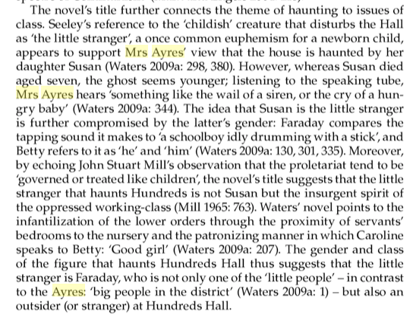

Ramona Koval: Describe what a speaking tube is.
Sarah Waters: It was something set up to allow people to communicate, usually with servants. So in Hundreds Hall, for example, it's basically a long tube that runs through the walls of the house, rather like the wires that would ring a bell in the servants' basement. But in this instance there's a mouthpiece in one end in the nursery with a stopper in it with a whistle in it, and if somebody in the nursery wanted to speak down to a servant in the kitchen, they'd take out the whistle, blow down the tube, and the whistle would sound at the other end, then the servant would take that out, put their ear to the tube, which I was very taken with, this kind of thing. You know, what would your voice sound like, how would it be distorted? There's something very quaint and slightly sinister about it to me. So it plays this rather sinister role in the novel later on. There were details like that.
I've just been at a festival in Cornwall at a house called Port Eliot which is an ancient house down there which is still very intact and I was taken on a tour of the servants' basement, and it's just an amazing glimpse of an older way of life. There would have been a whole team of servants running a house like this. There was the lamp room, the gun room, the knife room, the housekeeper's pantry, the butler's pantry, it's just a whole world of its own, just incredibly evocative, I think.

