Unit 2: Revision Guide

Time to pass the exam!
Key definitions glossary
You need know and understand what all of these key health and social care terms mean, and make sure to use them in your exam answers – remember you can get better marks for using appropriate health and social care terminology!
Key word / term | Definition / explanation
Rehabilitation

Adaptations

Personal care

Assessment

Care Values

Anti-discriminatory practice

Empowerment

Individualised Care

Promoting rights

Active Support

Dignity

Risk Assessment

Safeguarding

COSHH

PPE

RIDDOR

The Data Protection Act (1998)

Code of Practice (Workplace)

Confidentiality

Codes of Conduct (professional codes)

Revalidation procedures

Whistleblowing

Multi-disciplinary team working

Holistic care needs

Settings of health and social care services

Statutory

Voluntary

Private

Hospice

Domiciliary Care

Referral

Eligibility

Advocate

Complaints Policy

CQC

NICE

OFSTED

NMC

HCPC

GMC

Service Regulation

National Occupational Standards (NOS)

Continuing Professional Development (CPD)

Codes, Policies and Regulations
A code of practice is something that sets out the professional standards you are required to meet.

A regulation is something that is strict (like a law) which you have to follow.
A policy is a document that specifies the actions that you need to take in response to a situation, or actions that you should take in carrying out your day to day responsibilities.
Policies in Health and Social Care
Policy | What you would expect it to cover
Anti-discrimination policy

Safeguarding policy

Health and Safety policy

Lone Working policy

Confidentiality policy

Complaints policy

Adapting Services
Different people have different needs; this means they will need different things from services. They might also require different arrangements in accessing services.
Have a look at the different pictures; what might you need to do in order for people with these needs to be able to use a service?

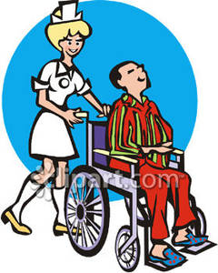

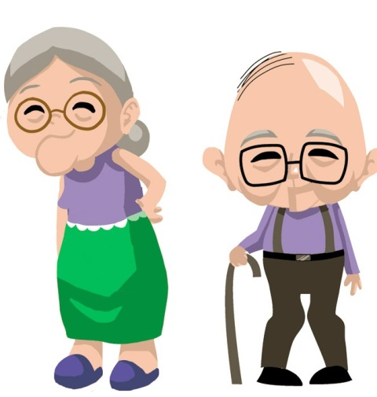

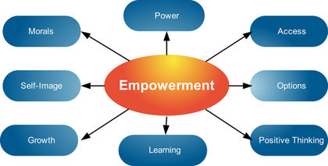

Whatever question you might get about empowerment, remember these key points:

Empowerment is about giving a person control in their own lives.

Empowerment can be achieved in a number of ways, but the 3 key points to remember are:

Individualised care: This means providing care that meets the individual needs of the person. This is empowering because it shows that person that their needs are important, and they can access the care they need which helps to raise self-esteem.

Raising self-esteem is a way of empowering a person because if you have higher self-esteem then you are more likely to feel confident in your choices, which means that you will have more independence in your life.

People can be empowered through being made aware of their rights – for example the right to not be discriminated against. If people are aware of the rights they have, this can help them to take action, or know what to do if their rights are violated. This helps empower people as they can feel good about themselves if they are able to stand up for themselves.
Empowerment as an 8 mark question
Remember DISCUSS questions require you to look at BOTH sides – therefore if you get empowerment in a discuss question, you would need to acknowledge that it may not always work, and, for this you would use the case study that you have.
For example, Brian – obese male who had to undergo surgery
You had the question
“Discuss how health and social care staff could empower Brian”
Your answer could include this:
“Empowerment means giving person control in their own lives, health and social care staff can empower people in a number of ways. (1)
Brian could be empowered through an occupational therapist making adaptations to his home; (1) this would enable Brian to continue to be independent following his operation helping to raise his self-esteem.(1) However, just because Brian can be independent does not mean that his self-esteem will be high, because he may still be depressed about his weight. Therefore he might struggle in his day to day life. (1)
Another way that Brain could be empowered is through being involved in decisions about his care, therefore making sure that he received personalised, individual care. (1) For example, Brain could work with a dietician to decide which foods he was going to eat and to help Brain understand about correct portion sizes. This would help Brain to continue to make his own choices, but give him the support needed to make healthy decisions. (1) However, Brain could feel as though choices are being made for him, causing him to feel as though he is not in control of his decisions. This could result in his self-esteem being lowered, which could make him less motivated to be healthy. (1)
All health and social care staff working with Brain would have to ensure that Brain was aware of his rights; for example his right to not be discriminated against due to his weight. This could help Brian to stand up for himself, making him feel better and raising his self-esteem. (1) (Total 8 marks)

Now have a go at this:
“George is a 24 year old man who has just moved into semi-independent accommodation. He has a moderate learning disability that affects his ability to read and write, but he can communicate well with others verbally. A support worker visits George a couple of times a week to see how he is getting on, and to help him with any problems that he is having.
When visiting George last week, the support worker was discussing the possibility of George finding a job. George was feeling frustrated because he felt that he was being turned down for jobs due to his disability, and employers believing that he would not be able to do the job because of this.”

Imagine you are George’s support worker; discuss ways that you could empower George at this time.

Once you have completed your answer, please bring it to me for marking.
How health and social care professionals ensure service users are kept safe
Safety measure | How it protects service users
Risk assessments

Safeguarding from abuse

Hand washing

COSHH

PPE

RIDDOR

Complaints

The Data Protection Act
Why should we protect people’s personal information?
What is it?
Confidentiality
What is it?
When can we break confidentiality?
Why is confidentiality important?
Being accountable to professional bodies (NMC, GMC, HCPC)
For each of the statements below, explain why professionals should do this and try to come up with examples for how this can be met.
Following the code of conduct (professional code as set by the NMC, GMC, HCPC)

Ensuring that revalidation procedures are followed

Following safeguarding regulations

Follow whistleblowing procedures

Multi-Disciplinary Team Working
YouTube – there are a lot of different videos about how MDTs support different service users with different conditions on YouTube
Watch a few of them and make yourself some notes about the strategies they use and how these benefit the service users

Now think about this:
Explain the benefits of Multi-Disciplinary Team working
For each section of your answer you should
Identify a benefit (1 mark)
Explain why it is a benefit (1-2 marks)

Monitoring of Employees
People who work in health and social care are monitored in their roles by their line managers to make sure they are carrying out their jobs properly and to the correct standard.
Other reporting methods are used to ensure people are working effectively as well:
For example:
Complaints made by service users
Feedback from service users
Inspections by external agencies (e.g. OFSTED, CQC)
Make some notes here about how all of the above helps to regulate staff members in health and social care sector:
Now try this:
Explain the importance of monitoring staff in the health and social care sector:

Settings for Health and Social Care Services
The main settings that you need to know about are listed below:
Hospitals
Day care units
Hospice care
Residential care
Domiciliary care
The workplace
You need to be able to explain why health and social care is provided in these different settings.
Think about things like
The different needs people have
Accessing and using services
Offering individualised care

Carry out some additional research on health and social care service provision, and why there are so many settings available for health and social care services. Make notes on what the ADVANTAGES and DISADVANTAGES could be of having health and social care services in different settings.
(Use the next page for notes)

Notes Page

Access to Health and Social Care Services
When we talk about ‘barriers’ affecting access to services, we mean anything that can prevent someone from accessing or using a health and social care service they need.
Barriers can occur at any stage of accessing a service
Stage on of accessing a service is REFERRAL – referrals can come from yourself or from a professional
At this stage of the process, what things could prevent you from either referring yourself or being referred by a professional?

Stage 2 of accessing a service is ASSESSMENT
You have to be assessed in order to establish what services / medication / help that you need
At this stage of the process, what could prevent you from being properly assessed?

Stage 3 of the process is the ELIGIBILITY CRITERIA – this is the criteria used to determine whether you can be provided with a service or not
What could become a barrier at this point?

How could the following things prevent someone from accessing or using a service they need?
Barrier | Example / explanation
Specific needs

Individual Preferences

Social

Culture

Geographical Location

Financial barriers

Representing the Service User
Organisations have a responsibility to make sure that the views of service users are represented within health and social care organisations.
This is done through:
Advocacy
Patient groups / charities
Complaints
Service user feedback
Think: Why is it important to let service users have a voice?

How could service users involvement benefit the organisations?

How could this cause problems?

Organisations that regulate health and social care professionals and health and social care services
Complete the table showing what the organisations do, how they do it, and what their key responsibilities are
The organisation | What they do
NMC

GMC

HCPC

CQC

NICE

OFSTED

Make sure you have the following information:
How regulation and inspection are carried out
How organisations and individuals respond to regulation and inspection
Changes in working practices required by regulation and inspection
How services are improved by regulation and inspection

Responsibilities the organisation has towards the people that work for them
Organisations (like hospitals, care homes, etc) have a responsibility to look after the people that work for them (not just the service users)
For each responsibility the organisation has, explain what it means giving an example.
Make sure employees know how to implement organisation’s code of practice

Meet national occupational standards (NOS)

Undertake continuing professional development (CPD)

Dealing with internal and external complaints properly

Take part in whistleblowing

Have membership of trades unions / professional associations

Follow protocols of regulatory bodies

Describe 2 responsibilities the organisation that you work for has towards you.
1)

2)
The Impact of Poor Working Practice
This was the least well answered question on the exam paper by large – some people had some good ideas but failed to relate them to real life examples of problems that had occurred.
So, make sure you know about some real examples of poor working practices and how this impacted people and their families.
Example of how you could use this in exam:
“Mid Staffordshire trust had a lot of poor practices, for example poor hygiene. This poor hygiene practice led to a woman getting three different hospital superbugs and she had to be in hospital for 9 months. This was just after the birth of her baby. The result of the poor practice here was that she was separated from her husband and children for 9 months, including the new baby. This meant that she did not bond with the baby properly in the early stages meaning that the child could experience poor attachment which can impact their emotional health. There would also be a strain on her marriage with the husband having to cope with everything alone.”
- Here you have explained what the poor practice was, how this led to the woman’s health problems and then explained how this affected not only her, but her children and husband as well.
Research into some other situations where poor healthcare has impacted upon service users.
Look at news stories, news reports and find some specific examples of people and their families that have been impacted by poor working practices and record some examples that you believe that you will be able to remember.

Case Study Scenario 2:
Learning Disability Stacey is a 13-year-old girl who attends her local residential special school, which caters for her learning disability needs. Stacey often becomes angry and frustrated at school as a consequence of her learning disability. She enjoys sport, and wants to get more involved in team sports. Her support worker thinks that playing more sport would help her deal with the anger and frustration. Stacey’s residential special school has recently had an inspection and received a notice to improve the care it offers. Stacey’s parents are now concerned about the standard of care being offered although they like the school and its staff.
2 (a) Outline the role of external agencies in inspecting health and social care services. 2 marks

(b) Describe two activities that could be undertaken by an occupational therapist employed in a special school. 4 marks
Explain how staff could empower service users such as Stacey to promote their rights, choices and wellbeing. 6 marks
d) Discuss how Stacey could be supported to play team sports successfully. 8 marks

Case Study Scenario: Physical/Sensory Disability Camilla, aged 28 years, has a long-term visual impairment and has a guide dog called Rosa. Rosa is an essential part of Camilla’s life, helping her to be mobile and enabling her to work as a teaching assistant. Rosa has been trained to guide Camilla safely around obstacles and to adapt to changes in elevation or tripping hazards. However, when visiting a friend in hospital, Camilla was told that dogs were not allowed entry. Camilla contacted the Guide Dogs for the Blind Association who wrote a letter on her behalf to the hospital stating: “Guide dogs are allowed to accompany their owners in any part of a hospital where there is no risk of infection, since they are an essential mobility aid.” The hospital apologised to Camilla and stated that her guide dog could accompany her during any future visits. The member of hospital staff had made a mistake when implementing its official code of practice, which does in fact allow entry for guide dogs.
3 (a) Outline one UK law or act that promotes the rights of those with a disability. 2 marks

b) Apart from the guide dog issue, describe two other barriers that service users with a sensory disability could face when accessing health and social care services.. 4 marks
Explain the responsibilities that people who work in health and social care organisations have towards service users with visual impairments, such as Camilla. 6 marks
(d) Discuss how health and social care staff are accountable to their respective professional bodies for their conduct and performance. 8 marks

