Behavioural Epigenetics: Principles, Methodology and Potential Uses
Nechama Giffen
The King David High School

Abstract
Behavioural epigenetics is the study of molecular biological changes in the brain caused by the environment around an individual via DNA and histone modification and methylation; relatively young science which Meaney and Szyf brought to prominence with their experiments investigating the effects of varying levels of care with rats; in humans, most of behavioural epigenetic is investigated via retrospective study designs; example of a prospective study in human behavioural epigenetics and potential uses of behavioural epigenetics are presented.

Introduction
Throughout history the debate of ‘nurture versus nature’ has troubled philosophers. Plato favoured nature. Aristotle favoured nurture. If nature is true, then how can identical twins who contain the same DNA end up with completely different personalities? Yet, if it is nurture, then how do separated identical twins share habits (Rich, 2011)? Epigenetics is the study attempting to resolve this debate, via investigating how nurture changes nature (Powledge, 2011). Behavioural epigenetics is a field within epigenetics which studies how environmental stimuli trigger molecular biological changes that modify what happens in brain cells (Ochalefu, 2018).

What is behavioural epigenetics?
Behavioural epigenetics is the science investigating how the environment around any organism causes molecular biological changes that influence what occurs in the brain. In this field of research, the word “environment” encompasses everything that happens in every stage of life: social experience, nutrition, hormones, toxicological exposures prenatally, postnatally and in adulthood (Powledge, 2011).
However, the heritable changes that are investigated in epigenetics are not due to changes in the DNA sequence. Instead, epigenetics investigates changes in the phenotype caused by chemical groups added to DNA and histones, not by a change in the DNA sequence.
An example of these modifications are DNA methylation and histone acetylation. Both DNA methylation and histone deacetylation repress gene transcription. When histones are acetylated, their interactions with DNA become weaker, resulting in relaxed chromatin, which promotes transcription; transcription is impeded when histones are deacetylated (Lee, 2020).
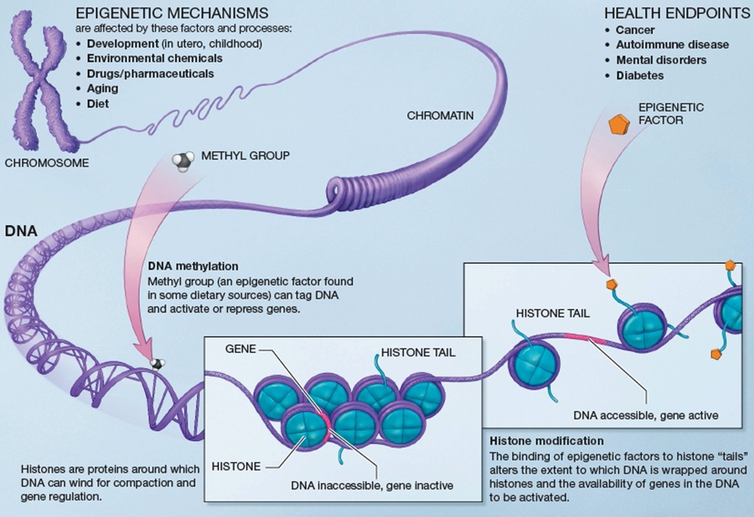
Figure 1: Epigenetic mechanisms and their health endpoints (https://academic.oup.com/bioscience/article/61/8/588/336969)

Experiments investigating behavioural epigenetics
Meaney and Szyf conducted an experiment with rat pups demonstrating the relevance and significance of behavioural epigenetics. They investigated how varying levels of caregiving quality affected the rat pups. Rats exposed to low level quality of caregiving- where the mothers exhibited low frequency of licking the pups, grooming and arch-back nursing- displayed high levels of methylation at a specific stress gene, the glucocorticoid gene nr3c1 which is expressed in the hippocampus. Offspring of more nurturing mothers tended to be less anxious than those of neglectful mothers (Powledge, 2011) (Provenzi, 2018). Interestingly, DNA methylation in the promoter region of the nr3c1 gene is closely associated with human childhood adversity and suicide (Na, 2014).
Before Meaney and Szyf, behavioural epigenetics wasn’t seen as a relevant field of research, however this has changed dramatically recently (Provenzi, 2018).
Contrastingly, (unlike Meaney and Szyf) in McGowan’s experiments, rats whose mothers were low quality caregivers were then cross fostered with good quality caregiver mothers, and the nr3c1 methylation pattern was reversed to levels like those rats born and raised by high-quality mothers, reversing the detrimental effects of the phenotype (Provenzi, 2018). This study may indicate that it is possible to reverse the effects of trauma in children by providing them caring homes. Further research is needed to demonstrate this in humans.
Studies have also established that both DNA methylation and histone modifications are essential for learning and remembering, as demonstrated in experiments with mice (Powledge, 2011). Sweatt notes that in experiments where mice are conditioned to fear locations where they’ve been electrocuted, there is an increase in DNA methyltransferase in the hippocampus- where memories are formed. When the enzyme was inhibited, the memories were prevented from forming indicating that blocking acetylation of histones in the hippocampus interferes with fear associated behaviour, and restricting deacetylation reverses these effects and strengthens the formation of fear associated memories (Powledge, 2011).
All the experiments above were conducted with animals, which is an issue for researchers as different organisms react differently.

Issues in conducting human behavioural epigenetic experiments
Although behavioural epigenetics does have great potential, with humans it is difficult to conduct research. This is due to the limitations of human experimentation due to ethical reasons stressful conditions cannot be administered to infants and children. Therefore, behavioural epigenetic experiments in humans are more limited, and are investigated mostly through retrospective study designs (Provenzi, 2018).
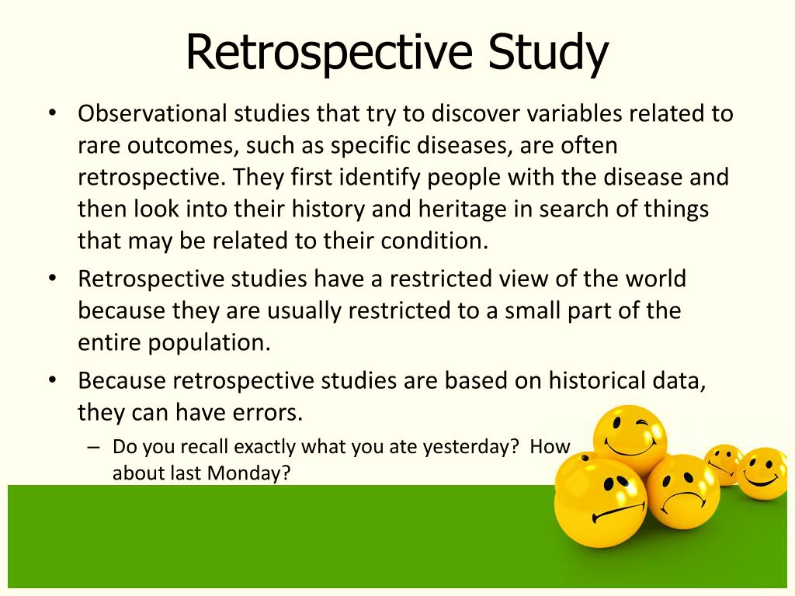

Figure 2: Summary of Retrospective Study Design https://www.slideserve.com/jadon/experiments-and-observational-studies-powerpoint-ppt-presentation

In retrospective study designs the data is collected by asking the participants to recall exposures, as the outcome of interest has already occurred to the subject (Ranganathan, 2018).
Advantages to conducting retrospective studies:
- Compared to prospective studies, retrospective studies are cheaper, swifter, and easier to conduct
- Can investigate rare diseases and discern possible risk factors.
- Helpful in developing H₀ (initial hypothesis) to be investigated further (Nickson, 2020)
Retrospective study designs are often considered inferior to prospective study designs (the outcome has not occurred when the study began, and the participants are followed up over a period of time (Hess, 2004) (Ranganathan, 2018). ) Reasons as to why retrospective study is considered inferior to other study designs:
- Substandard evidence compared to prospective study designs (Nickson, 2020)
- Controls are not representative of the general population, as they are often fabricated via convenience sampling (Nickson, 2020)
  - Convenience sampling is a method adopted by researchers who collect data from a convenient pool of respondents (Fleetwood, 2022)
- Susceptible to recollection biases or misclassification biases (Nickson, 2020)
  - Recollection/recall bias is a systematic error occurring due to variations in ability to recollect past experiences- a participant may forget pertinent details, or memories may be altered through hindsight. (12) (Recall bias, 2022)
  - Misclassification bias happens when individuals are placed in the incorrect category, therefore reducing accuracy of study and even altering conclusion of study. (Misclassification bias, 2022)
- Only demonstrate association, that certain factors seem to relate to a particular outcome, however, cannot indicate causation (Nickson, 2020)
Another issue in behavioural epigenetic research is that a major focus of epigenetic variations is concerned with early life adversities, rather than protective care exposures. Possible factors as to why there is such a huge interest in adversity related epigenetic variations in human behavioural epigenetics:
- It is easier to translate models from animal behavioural epigenetic studies in human developmental sciences when investigating the effects of early life exposures to damaging caregiving
- Difficult to set up care-related epigenetic variations studies in humans, contrastingly to animals where it is relatively easy to set up
- Most human care and protective interventions occur after the happenings of an unideal situation like stress, trauma, or abusive conditions, and timing of adversities and protective care isn’t fully predictable
(Provenzi, 2018)

Example of a prospective human behavioural epigenetic studies
A prospective study is where participants are entered into the study before the outcome or the disease that is being investigated occurs. This is the opposite of a retrospective study (Glen, 2022). A longitudinal study is where the individuals are followed up over long periods of time- sometimes even years. (Caruana, 2015).The reason why in this article the focus is on prospective studies is because they are rarer in this field.
In 2014 an experiment was conducted by Roberts and collaborators investigating SLC6A4 methylation in children with anxiety disorder before the experiment (T₀) then after (T₂) being exposed to a cognitive-behaviour therapy (T₁). Post-treatment effects occurred at six-month intervals (T₃) measuring in terms of reduction of anxiety treatment. Findings indicated that SLC64A methylation partially elucidated the difference in children who improved and those who did not after the psychotherapy. (Provenzi, 2018)
Due to the writer’s lack of understanding, other examples are not included. Furthermore, as previously stated, prospective study designs are quite unique in behavioural epigenetics.

Potential uses of behavioural epigenetics
Although behavioural epigenetics is still quite a young field, it has been heralded as a possible solution for:
- Medical problems, like:
  - Mental retardation- affects 2-3 % of the population, where a person has exceedingly below average cognitive abilities and a decreased ability to adapt to one’s surroundings (Daily, 2000)
  - Neurodegenerative disorders- affecting body activities such as balance, movement, breathing and heart function. Examples include:
    - Alzheimer’s disease
    - Amyotrophic lateral sclerosis
    - Friedreich ataxia
    - Huntington’s disease
    - Lewy body disease
    - Parkinson’s disease
    - Spinal muscular atrophy
(Bethesda, 2022)
  - Schizophrenia- severe mental disorder where people interpret reality abnormally. May result in a combination of:
    - Hallucinations- seeing or hearing things that don’t exist, yet for schizophrenics they have the full force and impact of normal experiences
    - Delusions- false beliefs not based on reality, for instance a person thinking they are being harmed or harassed.
    - Disorganised thinking- inferred from disorganised speech, communication being impaired, answers to queries may be unrelated.
    - Extremely disorganised motor behaviour- could display in numerous ways, from childlike immaturity to unpredictable agitation.
    - Negative symptoms- reduced ability to function normally examples include, neglect of personal hygiene, lack of emotion, loss of interest in everyday activities.
(Mayo Clinic Staff, 2022)
  - Autism- developmental disability that may cause significant social, communication, and behavioural challenges. Symptoms include:
    - Not pointing at objects to demonstrate interest
    - Not looking at objects when someone else points at them
    - Trouble relating to others, or not have an interest in other people
    - Avoid eye contact and desire to be alone
    - Trouble understanding others’ feelings or communicating their own
    - Rather not be cuddled or held
    - Appear unaware when others talk to them
    - Interested in people, yet not know how to speak, play or relate to them
    - Echo phrases said to them
    - Issues expressing their needs using typical words
    - Not play imaginary games- for instance not playing with dolls.
    - Repeatedly repeating actions
    - Difficulty adapting when a routine changes
    - Unusual reactions to the ways things smell, taste, look, feel, or sound
    - Lose skills they once had
(Autism Spectrum Disorder, 2022)
- Social issues, for instance:
  - Suicide
  - Aging
  - Addiction
  - Child abuse
  - Neglect
(Ochalefu, 2018)
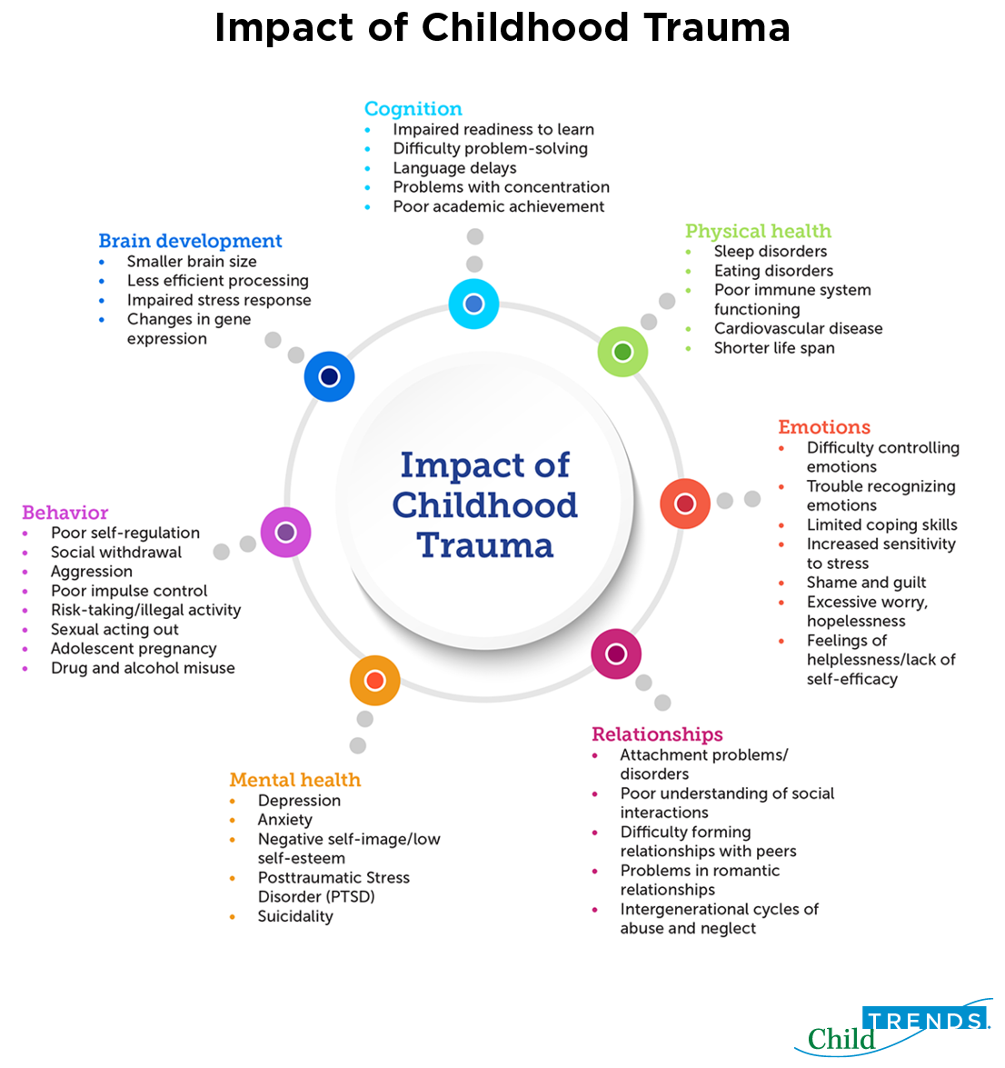
Figure 3: Impacts of Childhood trauma to indicate adverse effects upon society. https://www.childtrends.org/wp-content/uploads/2019/05/impact-of-childhood-trauma-figure-4.30-002.png
Conclusion
Overall, behavioural epigenetics does seem to be a promising area of research. Although behavioural epigenetics is an exceedingly young area of research, with one article even comparing behavioural epigenetics to being an embryo, already a plethora of information has been discovered, and scientists are only scraping the surface. Behavioural epigenetics could play a pivotal role in preventing multitudes of medical issues and social issues which are debilitating to society.
However, an area of concern is that most of human behavioural epigenetic research is investigated using retrospective study designs, which are considered inferior to prospective study designs. Although there is that criticism, it must be recalled that this is a relatively young area of study- behavioural epigenetics is still growing and evolving.

References
Autism Spectrum Disorder. (2022, January 30). Retrieved from Centers for Disease Control and Prevention: https://www.cdc.gov/ncbddd/autism/facts.html
Bethesda. (2022, January 30). Degenerative Nerve Diseases. Retrieved from MedlinePlus: https://medlineplus.gov/degenerativenervediseases.html
Caruana, E. J.-S. (2015). Longitudinal studies. US National Library of Medicine National Institutes of Health.
Daily, D. K. (2000). Identification and Evaluation of Mental Retardation. American Family Physician.
Fleetwood, D. (2022, January 25). Convenience Sampling: Definition, Advantages and Examples. Retrieved from QuestionPro: https://www.questionpro.com/blog/convenience-sampling/amp/
Glen, S. (2022, January 30). Prospective Study: Definition, Examples. Retrieved from StatisticsHowTo.com: https://www.statisticshowto.com/prospective-study/
Hess, D. R. (2004). Retrospective studies and chart reviews. PubMed.gov.
Lee, H. O. (2020). The Key Role of DNA Methylation and Histone Acetylation in Epigenetics of Atherosclerosis. J Lipid Atheroscler.
Mayo Clinic Staff. (2022, January 30). Schizophrenia. Retrieved from Mayo Clinic: https://www.mayoclinic.org/diseases-conditions/schizophrenia/symptoms-causes/syc-20354443
Misclassification bias. (2022, January 26). Retrieved from Catolog of bias: https://catalogofbias.org/biases/misclassification-bias/
Na, K. H.-M.-K.-K.-H.-K.-S.-J. (2014). Association between Glucocorticoid Receptor Methylation and Hippocampal Subfields in Major Depressive Disorder. PLoS One.
Nickson, C. (2020). Retrospective Studies and Chart Reviews . Life In The Fastlane.
Ochalefu, D. A. (2018). Epigenetics in Medical Practice in the Twenty First Century. Journal of Biomedical Research & Clinical Practice.
Powledge, T. M. (2011). Behavioral Epigenetics: How Nurture Shapes Nature. BioScience.
Provenzi, L. B. (2018). Methodological Challenges in Developmental Human Behavioral Epigenetics: Insights Into Study Design. Frontiers in Behavioural Neuroscience.
Ranganathan, P. A. (2018). Study designs: Part 1 – An overview and classification. US National Libarary of Medicine National Institutes of Health.
Recall bias. (2022, January 26). Retrieved from Catalogue of Bias: https://catalogofbias.org/biases/recall-bias
Rich, M. (2011, April 16). Nature vs. Nurture, as Seen by Economists. Retrieved from Economix: https://economix.blogs.nytimes.com/2011/04/16/nature-vs-nurture-as-seen-by-economists/

