Bacteriophages: Do They Do More Harm Than Good?

Abstract

Antibiotics resistance could be solved by using bacteriophage (phage) therapy. It is a treatment using viruses that lyse bacteria thus killing them. Many studies have shown that phage therapy can be very effective when given as early as possible 1 with some showing a high dose is needed 2  while others showing that phages ‘auto-dose’ themselves, whilst reproducing in bacteria cells 3.

Many pros of using the treatment include low toxicity, auto-dosing and being able to be cleared out of the body after lysing all of the bacteria.

The cons include the possibility of releasing toxins after the bacteria have been lysed and lots of testing that needs to be done to identify the strain of bacteria so the right phages can be used.

High specificity can be a curse as well as a blessing to phage therapy. It can lead to low amounts of resistance but also can cause problems in finding the right phage that not only is specific to the bacteria but also is in a lytic phase.

Introduction

Antibiotic resistance is an increasingly prevalent problem in today’s society. Superbugs are becoming more common such as Escherichia coli (E. coli) and Methicillin-resistant staphylococcus aureus (MRSA). Antimicrobial resistance is estimated to cause at least 700,000 deaths around the world each year 4.

Superbugs appear in a multitude of ways. Historically, prescriptions for antibiotics have been given to patients when not needed or patients were given the wrong ones, and this still persists today. Not finishing the course of treatment also can lead to antibiotic resistance.

Due their increasing ineffectiveness, antibiotics don’t need to be the only treatment to turn to. Phage therapy may be an alternative treatment of bacterial infections. This involves bacteriophage viruses replicating inside the bacteria, lysing it, thus killing it.

Instead of using antibiotics, bacteriophages, a large group of viruses that infect bacteria, could be used instead. These viruses are found all over nature too.

Phages are made up of protein or proteolipid capsids containing fragments of nucleic acids (most often DNA, but also RNA) and are present wherever bacteria can be found 5. They are thought to prevent the extreme growth of bacteria and keep the population down and prevent them from dominating the natural biodiversity.

This essay investigates whether phage therapy can be the solution for antibiotic resistance.

Figure 1: diagram of a bacteriophage <https://en.wikipedia.org/wiki/Enterobacteria_phage_T2>

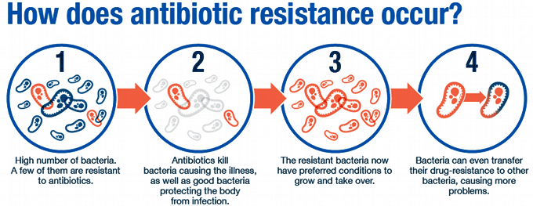What is Antibiotic Resistance?

Figure 2: how antibiotic resistance occurs

<http://modmedmicro.nsms.ox.ac.uk/learn-more-about-antibiotic-resistance/>

Antibiotic resistance is the natural selection of bacteria. It is mutation, which is a change in the nucleotide bases, thus changing the function of the chromosome controlling certain aspects of the bacteria. Mutations can be sporadic or caused by other mutation inducing factors 6. For example, these mutations can cause bacteria to produce more efflux pumps which pump antibiotics out of the cell 7.

How Bacteriophages Infect Bacteria and Reproduce 8

To reproduce, bacteriophages can use two different cycles: the lytic and the lysogenic cycles. The lytic cycle is similar to a eukaryotic infecting virus, in that it lyses the cell when bursting out of it.

The lysogenic cycle is unique in that the bacterium isn’t destroyed while the phage is reproducing – the bacterium cell gets reproduced along with the phage. They can switch between lytic and lysogenic cycles.

The Lytic Cycle

The phage attaches proteins in the ‘tail’ to specific receptors on the bacterium cell and injects the DNA or RNA into the cell cytoplasm. The phage genetic code is then copied by the bacterium and used to make capsid proteins. Capsids assemble from the capsid proteins and are stuffed with DNA to make lots of new phage particles. Late in the lytic cycle, the phage expresses genes for proteins that poke holes in the plasma membrane and cell wall. The holes let water flow in, making the cell expand and burst like an overfilled water balloon. Each cell can release hundreds of phages that can go onto reproducing more phages.

The Lysogenic Cycle

The phage tail still attaches to the specific bacterium receptors and injects the genetic code. But the genetic code can be integrated into the bacterium’s code or even remain as a separate genome. The phage code is then passively copied along with the bacterium’s code and the bacterium reproduces with the phage’s code inside. The phage genetic code, called the prophage, is passive in this cycle but can become active in the right conditions, 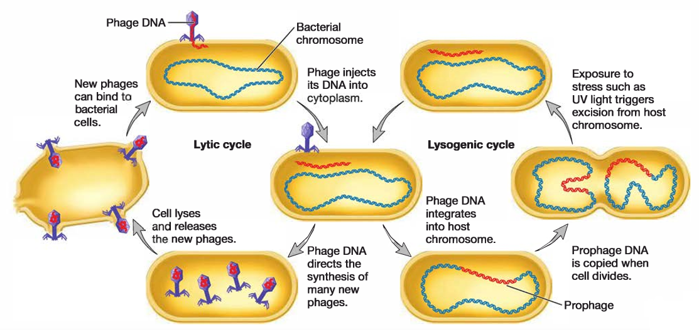triggering the remaining steps of the lytic cycle.

Figure 3: the lytic and lysogenic cycles of phage reproduction

<https://istudy.pk/bacterial-transduction/>

A History of Bacteriophage Therapy

The use of bacteriophages has been around for more than one hundred years. They were first isolated in 1917 by Félix d’Hérelle and then successfully used to treat bacterial infections of dysentery, plague and cholera.

During the peak of WW1, a group of soldiers outside of Paris, suffered from a breakout of dysentery. D’Hérelle was tasked with investigating the bacterial infection that the soldiers were suffering from. He used their faecal samples and noticed that the bacteria would lyse after being left for a certain amount of time. D’Herelle published his observations in 1917 proposing that the lysis was caused by an “invisible microbe antagonistic to the dysentery bacillus”.9

During the Second World War, advances in penicillin use saw a halt to most of the research into bacteriophages.

Though most alternative treatments had been abandoned after the war, the Soviet Union continued its research and now Russia, Poland and Georgia are the only countries to still use phage therapy due to the lack of antibiotics supplied to them 10.

The Soviet Research

Case study 1 – Dysentery in the Donbass region of Ukraine, 1929 11

The Soviet Union became very invested in the phage therapy research. During the 1920s, a heavy industrial area of Ukraine – the Donbass region, had frequent breakouts of scarlet fever, typhoid and dysentery.

In 1929, Moisei Mel′nyk and his colleagues of the Kharkov Institute, initiated a program of testing phages for the therapy and prophylaxis of dysentery. The bacteriophage collected, against the Shiga strain of the dysentery bacteria (now called Shigella Disenteriae) was isolated from local waters. These water samples were added to various cultures of the Shiga strain on agar plates collected from human faeces. The phages were left to lyse the bacteria, turning the cloudy culture clear. The remaining liquid was mixed with other cleared cultures and filtered through a bacteria filter to remove the unwanted pathogen and other debris: this separated the phages as they were allowed through.

Several goals were achieved, as it increased the number of local phages that were specific to the local Shiga sub-strains, leading to a highly localised treatment for many diverse, local patients.

For the Donbass patients who received the treatment, mortality was halved. Although a few patients died, they were in a late stage of infection. Recovery came quicker with the phage therapy; 55% of patients were discharged after 4 days of treatment.

Following the promising start, the trials were modified, and physicians delivered oral phage preparations with soda water (to reduce the stomach acidity believed to interfere with the treatment). They were also instructed to give the treatment at the earliest time possible.

Mel′nyk insisted on complete fasting by patients on the day the phage was first given as well as the subsequent observance of a strict diet thereafter. In hypertoxic cases, he recommended giving antidysentery serum injections and phage therapy simultaneously. This was thought to fight the toxins produced by the bacteria although it didn’t always work.

His conclusions included:

* Phage therapy must be given early to have the most effect.
* The strains of phages must be specific to the epidemic region.
* Polyvalent mixes are efficient but still had to be specific to local strains.

Case study 2 – the Prophylaxis of dysentery in children in Tbilisi, Georgia, 1963-1964 12

A total of 30,769 children between the ages of 6 months to 7 years old were used. On one side of a street in Tbilisi 17,044 children were given the Shigella strain of phages orally, once every seven days, while 13,725 children on the other side of the street weren’t given any phages. The children were visited regularly – about once a week and monitored. Children with gastrointestinal disorders had faecal samples taken and analysed for the presence Shigella SPP and other non-specific diarrhoea causing bacteria.

The placebo group had an incidence of dysentery (6.7 per 1000 children) compared to the group with the phage treatment (1.76 per 1000 children) during the 109-day study.

From the culture confirmed cases, the incidence of dysentery in the placebo group (1.82 per 1000 children) was again higher than the group with phage treatments (0.7 per 1000 children).

The phage effectiveness index (disease incidence per 1,000 children in the placebo group divided by the corresponding number in the phage-treated group) was highest in younger children ages 6 months to a year and the lowest of the older ages of 5 to 7 years old.

An interesting outcome of the study was the reduction (2.3-fold) of diarrheal diseases of unknown origin among children treated with phages compared to the children in the placebo group. It was believed to have been the case that some dysentery cases were not diagnosed but prevented by the Shigella phages or other unknown gastrointestinal pathogen may have been killed even though the phage is specific to one bacterium.

More Recent Studies of Phage Therapy 13

The more recent studies of phage therapy has been done in preclinical trials using animals in *in vivo* phage therapy. These trials had been looking at acute bacterial infections with both gram-positive and gram-negative bacteria being studied. Typically, the bacteria and phage were administered simultaneously although there was a high ratio of phages to bacteria.

The phages were administered in a multitude of ways.

* Intramuscular: an injection into muscles
* Subcutaneous: an injection between the muscle and skin
* Intraperitoneal: an injection into the peritoneal cavities
* Orogastric: tubes directly into the stomach from an external source through the mouth
* Intracranial: through the brain past the blood barrier
* In the animal feed to be eaten
* In the drinking water

In several studies intraperitoneal delivery was shown to result in higher concentrations of systemic phage, delivered earlier, remaining in circulation for longer and allowing phage access to numerous host organs including lungs, spleens and kidneys. Better outcomes were seen for lung infections when phages were administered using the intraperitoneal or systemic route instead of using pulmonary delivery.

It has been shown that giving a high dose of phages to begin with has helped with better clinical outcomes, and just like case study 1&2, administering the phages as quickly as possible increases the likelihood of being a successful treatment. However, the longer the delay, the longer bacteria have to replicate and overwhelm the immune system with toxins.

Further inoculations of animals without the bacteria, were found to have no adverse health effects. Although after a while no traces of phages were present which suggests that the host immune system cleared them out.

Encapsulation of phage in liposomes (for treating gastrointestinal infections) was shown to increase the retention time of phage in the host with better therapeutic efficacy.

As with case study 1 & 2, Phage therapy works best with a cocktail of phages. This is due to the probability of encountering mutated bacteria with resistance. Cocktails of phages may be suited for a collaborative effect of better access to the bacteria with mucus and biofilms and degrading them with a necessary enzyme while also suited to kill the bacteria. This leads to an enhanced treatment of phage therapy.

Benefits of Phage Therapy 14

Less doses of phages may be required by the patient

As bacteriophages are viruses, they can self replicate using the bacteria they are targeting. It is theorised only one dose of phages is needed as they will continue to replicate; this is called auto-dosing. Phages would even stop replicating when the bacteria have been killed. The auto-dose means that there is a convenience to the patient not having a strict regime for administering antibiotics.

It is possible that only a single low dose would be needed although there are studies showing the success of a single high dose.

Low inherent toxicity

Most phages are made up of nucleic acids and proteins so inherently non-toxic. There is a possibility that phages can interact with the immune system but in many studies, there is little evidence showing any significant harm to the immune system.

To reduce any toxicity, a highly purified phage preparation would have to be done to prevent anaphylaxis.

Specificity of phages

The phages have to be highly specific to the strain of bacteria it is targeting. This means that there is minimal disruption to the normal flora. This further means that there is little effect on normal bodily functions compared to chemical antibiotics which have a broader spectrum of activity and would have some adverse effect on symbiotic colonies of bacteria.

The relatively narrow host range shown by most phages could reduce the likelihood of mutations in the bacteria causing some type of resistance. Mutations of bacteria in studies have actually been shown to be resistant to phages but the near complete loss of their virulence which makes the bacteria a very good vaccine 15.

Formation versatility

Phages have been found to work well in a ‘cocktail formation’ mixed with many different phages and antibiotics. These can be administered as liquids, creams or tablets. This can have a collectively greater antibacterial spectrum of activity.

Drawbacks of Phage Therapy 14

Need high specificity in strains and qualities

Phages in order to achieve a successful treatment, phages have to be highly specific to the bacteria. It’s not just the strain that needs to be specific, but the phage has to be in a lytic cycle otherwise it won’t kill the bacteria. They should have a high virulence to bacteria.

Phages if clinically used should have a high virulence (good primary pharmacodynamics), low potential to do harm to the patient (minimal secondary pharmacodynamics) and a high ability to reach the target bacteria (good pharmacokinetics).

The high specificity of strains of phages needed for the bacteria causes difficulty when treating patients as the correct phage would be needed for success. This would require lots of testing to identify the most appropriate phages to use.

Phages have the potential to do harm

Phages can cause an immune response as after all they are foreign objects that the immune system would possibly try to attack. Just like some antibiotics, they have the potential to release toxins in situ from where the bacteria have been lysed causing harm to the body.

Not enough research

In the developed world e.g. Europe, North America, Australasia, the most significant limitation for using phage therapy is the relative lack of research and drug regimes. This has restricted their use being recommended by these countries’ clinical bodies such as NICE in the UK and the FDA in the USA.

Conclusion

It is clear from the research that has been carried out over the last hundred years, phages could play a part in treating antibiotic resistant infections. Unfortunately, though phage therapy has not yet been approved for people in the United States or in Europe. According to an article by Healthline “There has been experimental phage use in a few rare cases only. One reason for this is because antibiotics are more easily available and are considered to be safer to use 16.”

There doesn’t seem to be any single reason why phage therapy hasn’t taken off. From the development of antibiotics, it seems to have grown out of favour as a treatment. Perhaps this is because drug companies don’t want to invest in the significant levels of research required to develop treatments that may ultimately be unsuccessful.

References

1: Dmitriy Myelnikov: ‘An Alternative Cure: The Adoption and Survival of Bacteriophage Therapy in the USSR, 1922–1955’, J Hist Med Allied Sci, 2018 Oct 12, page 4-5

2: Danish J. Malik, Ilya J. Sokolov, Gurinder K. Vinner, Francesco Mancuso, Salvatore Cinquerrui, Goran T. Vladisavljevic, Martha R.J. Clokie, Natalie J. Garton, Andrew G.F. Stapley, Anna Kirpichnikova, Formulation, stabilisation and encapsulation of bacteriophage for phage therapy, Advances in Colloid and Interface Science, Volume 249, 2017, Pages 100-133, ISSN 0001-8686, https://doi.org/10.1016/j.cis.2017.05.014.

3: Loc-Carrillo C, Abedon ST. Pros and cons of phage therapy. Bacteriophage. 2011;1(2):111-114. doi:10.4161/bact.1.2.14590

4:<https://linkprotect.cudasvc.com/url?a=https%3a%2f%2fassets.publishing.service.gov.uk%2fgovernment%2fuploads%2fsystem%2fuploads%2fattachment_data%2ffile%2f773065%2fuk-20-year-vision-for-antimicrobial-resistance.pdf&c=E,1,syaRQOtBWc3YOqhlNjZqdy-sUR1xMc5A0-D9EMQgMTsiSRvOnENv1n3mmo9IgycblXMZA8-rFTbkuO0vjMlXE8O-xWpdRbYWsmMaK5Qj&typo=1>

Date accessed: 10/01/22

5: Brives, C., Pourraz, J. Phage therapy as a potential solution in the fight against AMR: obstacles and possible futures. Palgrave Commun 6, 100 (2020).

6: Woodford N, Ellington MJ. The emergence of antibiotic resistance by mutation. Clin Microbiol Infect. 2007 Jan;13(1):5-18. doi: 10.1111/j.1469-0691.2006.01492.x. PMID: 17184282.

7: Professor Laura Piddock: ‘Understanding the basis of antibiotic resistance’. (2014).

8: <https://www.khanacademy.org/science/biology/biology-of-viruses/virus-biology/a/bacteriophages>

Date accessed: 10/01/22

9: Dmitriy Myelnikov: ‘An Alternative Cure: The Adoption and Survival of Bacteriophage Therapy in the USSR, 1922–1955’, J Hist Med Allied Sci, 2018 Oct 12, page 4-5

10: Reardon, S. Phage therapy gets revitalized. Nature 510, 15–16 (2014).

Date accessed: 10/01/22

11: Myelnikov D. An Alternative Cure: The Adoption and Survival of Bacteriophage Therapy in the USSR, 1922-1955. *J Hist Med Allied Sci*. 2018;73(4):385-411. doi:10.1093/jhmas/jry024

12: Sulakvelidze A, Alavidze Z, Morris JG Jr. Bacteriophage therapy. Antimicrob Agents Chemother. 2001;45(3):649-659. doi:10.1128/AAC.45.3.649-659.2001

13:Danish J. Malik, Ilya J. Sokolov, Gurinder K. Vinner, Francesco Mancuso, Salvatore Cinquerrui, Goran T. Vladisavljevic, Martha R.J. Clokie, Natalie J. Garton, Andrew G.F. Stapley, Anna Kirpichnikova, Formulation, stabilisation and encapsulation of bacteriophage for phage therapy, Advances in Colloid and Interface Science, Volume 249, 2017, Pages 100-133, ISSN 0001-8686, <https://doi.org/10.1016/j.cis.2017.05.014>.

14: Loc-Carrillo C, Abedon ST. Pros and cons of phage therapy. Bacteriophage. 2011;1(2):111-114. doi:10.4161/bact.1.2.14590

15: Rosanna Capparelli, Nunzia Nocerino, Marco Iannaccone, Danilo Ercolini, Marianna Parlato, Medaglia Chiara, Domenico Iannelli, Bacteriophage Therapy of Salmonella enterica: A Fresh Appraisal of Bacteriophage Therapy, The Journal of Infectious Diseases, Volume 201, Issue 1, 1 January 2010, Pages 52–61, <https://doi.org/10.1086/648478>

16: <https://www.healthline.com/health/phage-therapy>

Date accessed: 10/01/22