Overview of The Causes and The Developments in the Treatment of Haemophilia
Abstract
Current studies have shown that there is new opportunity and potential to develop new treatments for haemophilia. The main aim of these treatments is to replace recombinant Factor VIII and Factor IX as some patients who are given these replacement factors can develop an inhibitor which make it much more difficult to stop an episode of bleeding as they can stop the treatment from working. Another reason for focusing on new treatments is so patients with haemophilia can live with minimal pain, so physiotherapy (targeting the musculoskeletal system) can also be used.
I also aim to explore the main causes of haemophilia and how it can affect a patient’s life. This will explain and demonstrate why it needs to be treated effectively.

Key Words:
- Serine Proteases - serine proteases are proteases that contain serine, which is an amino acid, which is bonded at the active site [13].
- Prothrombin Time - prothrombin is a protein that is produced by the liver. This protein helps to clot the blood, so the prothrombin time is a way of measuring how long it takes the blood to clot [9].
- Synovial Membrane - a layer of connective tissue that lines the cavities of joints, tendon sheaths, and fluid-filled sacs between tendons and bones, known as bursae [18].
- Von Willebrand Factor - it is a large glycoprotein that is present in the plasma and endothelium and binds to other proteins, especially factor VIII, which prevents quick degradation, it is absent in von Willebrand disease [23].
- Pharmacokinetics - the movement of foreign chemicals in the blood [22].
- Endogenous - growing or originating from within an organism.
- Pseudotumor - an enlargement that resembles a tumour and it may or may not regress spontaneously [24]
- Serotype - a group of closely related microorganism distinguished by a common set of antigens [25].
- Plasminogen – it is a protein in the blood that is the inactive pressures of the serine protease, plasmin. Plasmin [26]. Plasmin is an important enzyme that dissolves fibrin clots [27].

Introduction
Haemophilia is a disorder of the blood in which the blood cannot clot properly. This leads to unexpected bleeding as well as bleeding after injury or surgery. The blood contains proteins called clotting factors which are responsible for stopping bleeding. People that have haemophilia have low levels of factor VIII or factor IX. The amount of these factors in the blood determines the severity of their haemophilia. The less factor that they have, the more likely they will have serious health problems [1]. Mild haemophilia is when the person has between 5% and 50% of the normal amount of clotting factor in the blood. Moderate haemophilia is when there is between 1% and 5% and severe haemophilia is when there is <1% of clotting factor in the blood [2]. Haemophilia A occurs in 1 in 5000 male births, whereas haemophilia B only affects 1 in 50 000 [15]. It is usually brought to clinical attention by the age of one with bruising all over their extremities or hemarthrosis [17] (bleeding into a joint cavity [16]). Whether a patient has mild or moderate haemophilia there is an increased risk for death from the result of intercranial bleeding compared to the rest of the population [20].

Causes of Haemophilia
Haemophilia tends to be inherited; this type of haemophilia is known as congenital haemophilia. Congenital haemophilia can be classified depending on the type of clotting factor that is low. The most common type of haemophilia is haemophilia A, which is associated with low levels of factor VIII. The next most common type of haemophilia is haemophilia B, which is associated with low levels of factor IX [3].
Both haemophilia A and B are inherited in the same way as both the genes for factor VIII and factor IX are located on the X chromosome. The X and Y chromosomes determines a person’s sex. Females have two X chromosomes (XX), and a males have an X and a Y chromosome (XY). There are no genes for clotting factors on the Y chromosome. This means that males only contain one allele for factor VIII and IX. Therefore, if a male has a haemophilia allele on his only X chromosome, he will have the disorder [4]. A father who has haemophilia passes his only X chromosome to his daughters, so they will get his haemophilia allele 100% and become heterozygous (carriers of the haemophilia allele). The father will pass his Y chromosome to his sons, so the sons won’t have haemophilia and pass it onto their own children [5].

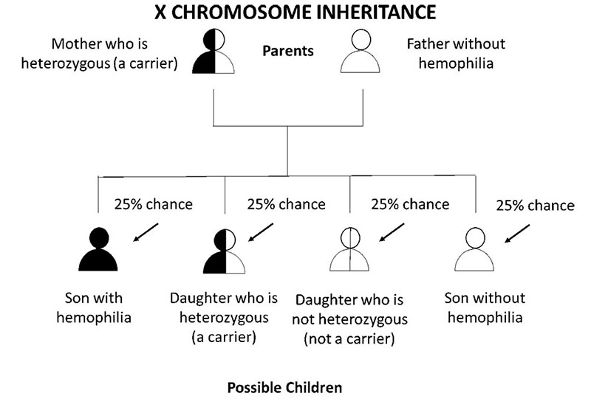
Figure 1
Inheritance diagram showing likelihood of developing haemophilia when the mother is a carrier of haemophilia.

(https://ww.cdc.gov/ncbddd/hemophilia/images/x-chromosome-inheritance-mother-carrier-800px.jpg)

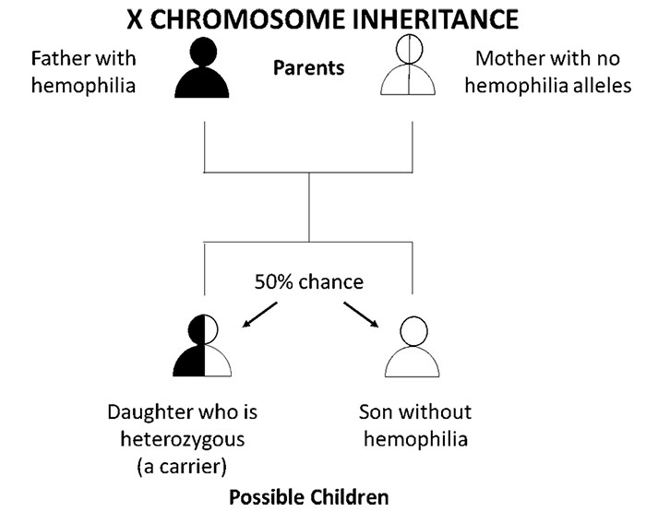
Figure 2
Inheritance diagram showing the likelihood of developing haemophilia when the father has haemophilia.

(https://www.cdc.gov/ncbddd/hemophilia/images/x-chromosome-inheritance-father-hemophilia-700px.jpg)

There is also another type of haemophilia that can occur when the patient has no family history of diseases that are related to clotting or coagulation, this is known as acquired haemophilia. For about 50% of people that are diagnosed with acquired haemophilia, no underlying cause will ever be found, however autoimmune diseases, cancer, pregnancy, and drug reactions have been associated with acquired haemophilia [6]. Acquired haemophilia is a rare disorder; the patient develops autoantibodies that will attack the clotting factors, in this case it is usually factor VIII [7][8].

What is Factor VIII and Factor IX?
Factor VIII is found in the plasma and is thought to be associated in a complex with the highest molecular weight multimers of another glycoprotein, Von Willebrand protein. When factor VIII is highly purified it can have an Mr between 200 000 and 300 000 and consists of multiple polypeptide chains [12].

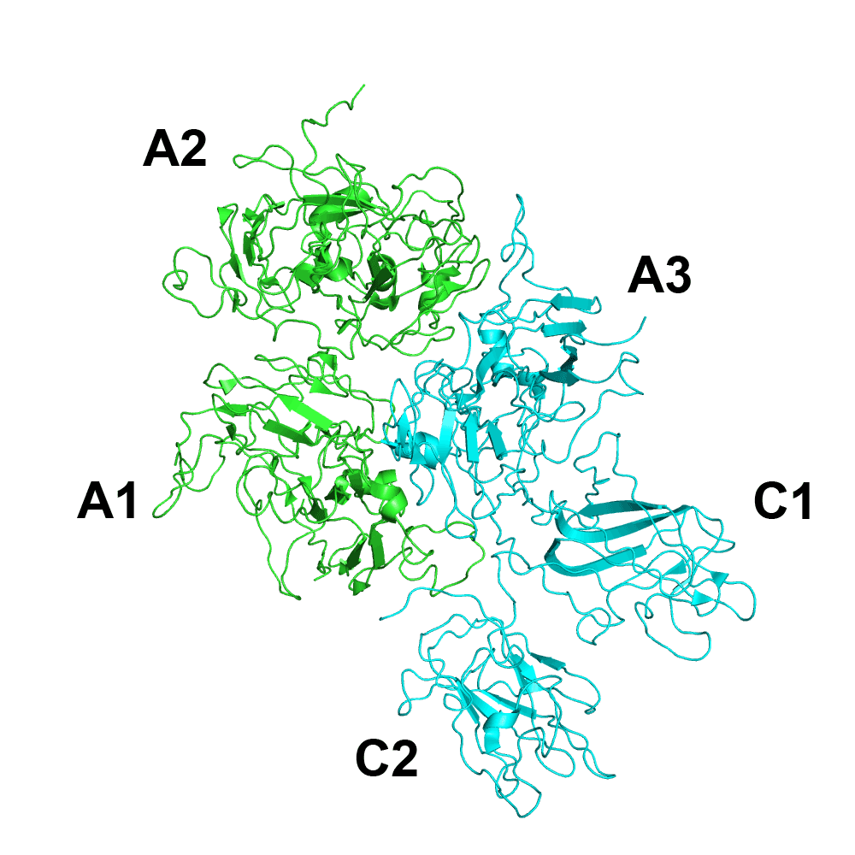
Figure 3
Factor VIII
(https://upload.wikimedia.org/wikipedia/commons/thumb/a/a3/Fviii_2R7E.png/800px-Fviii_2R7E.png)

Factor IX is a type of serine protease that is part of the coagulation system, and it belongs to the peptidase family S1 and is made of four protein domains [14]. It is also a vitamin K- dependent protein, meaning that vitamin K is necessary for the body to generate factor IX. Factor IX is produced in the liver and transported through the bloodstream [37].

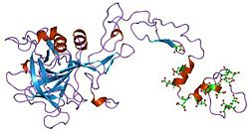
Figure 4
Factor IX
(https://upload.wikimedia.org/wikipedia/commons/thumb/c/c9/PDB_1pfx_EBI.jpg/250px-PDB_1pfx_EBI.jpg)

Case Study - Can the COVID-19 Vaccine or Infection Cause AHA?
A recent case has been recorded which has linked the Pfizer-BioNTech SARS CoV-2 mRNA vaccine to the development of acquired haemophilia A (AHA).
A 69-year-old male presented with mild bruising on his left wrist, 9 days after receiving his first dose of the COVID-19 vaccine. He had no family history of any bleeding disorders. After his second dose of the vaccine, he presented with several new bruises on his arms and legs, all of which were spontaneous, except for a bruise with swelling on his right thigh due to a minor trauma to the area. These bruises continued to expand over the next two days. He had multiple comorbidities which included, diabetes, hypertension, and an adenocarcinoma of the prostate, which is now in remission. He also had swelling on his left anterior mid-thigh with no discolouration which is suggestive of an intramuscular hematoma, as well as a large ecchymosis on his left elbow and forearm and right thigh.
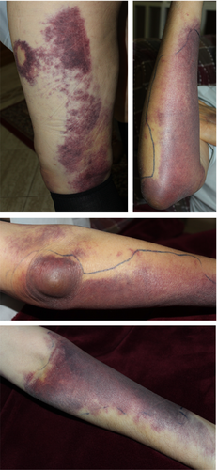

Figure 5
Bruising and ecchymosis’ on patient in case study

(jth15291-fig-0001-m.jpg (1992×4308) (wiley.com))

His blood count showed mild anaemia and platelets of 237 x 10⁹/L, which is within the normal range. His coagulation profile showed a normal prothrombin time. Apart from this case there were only two other cases of acquired haemophilia that are associated with the COVID-19 infection. One was an 83-year-old woman who showed symptoms of bruising after one week of recovering from the infection. The second case was a 66-year-old male who was diagnosed with AHA in 2011 and went into remission with treatment. He was admitted to a hospital with COVID-19 in 2019 with an ecchymosis on the trunk. Both of these cases showed low factor VIII, and factor VIII inhibitors. The first case was treated by prednisone and rituximab and in the second case immunosuppressive treatment was given in addition to antiviral medication. Both patients responded to treatment.
There were two further cases recorded when AHA was associated with vaccination (not the COVID-19 vaccine). A 72-year-old female presented with bruising 8 days after receiving a seasonal influenza vaccine. The other case was a 66-year-old female who developed ecchymoses after a H1N1 vaccination (the swine flu vaccine). Both cases showed low factor VIII and the presence of factor VIII inhibitors. Both cases were treated with steroids, but, in the first case, due to a lack of responsiveness, rituximab was added to ensure remission [8].

Symptoms of Haemophilia
Symptoms for haemophilia A and B are the same [10]. People with haemophilia may experience a range of bleeding symptoms. Symptoms that a person with haemophilia may experience are joint bleeding, soft tissue bleeding, bleeding in areas such as the brain or stomach, bleeding after a minor trauma, easily bruised, prolonged bleeding in the mouth after a cut or bite, or excessive bleeding associated with surgery or other forms of invasive procedures [11].
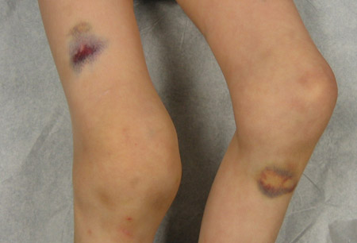
Figure 6
Bruising that can occur due to haemophilia

(https://bestpractice.bmj.com/image/468/en-gb/normal/468-1-hlight_default.jpg?status=ACTIVE)

Standard Treatments for Haemophilia
Prophylactic factor VIII has improved treatment for haemophilia A. It is used to prevent joint bleeding and stopping the deterioration of joints [32]. Recombinant factor VIII concentrate does not come from human plasma. It is genetically engineered using DNA technology. Haemophilia B is also treated using recombinant factor [33].

Ethics of Previous Treatments
During the late 1970’s and early 1980’s haemophilia was treated with donated blood and blood screening wasn’t introduced until 1992 [34][33]. Due to this, between 1970 and 1990 it is said that 5000 and some say around 30 000 people were infected with blood-borne infections from blood transfusion and an estimated 3000 people died. It happened as there was such a high demand for factor VIII in the UK, so it had to be imported from the US and a lot of the human blood plasma came from prison inmates and drug-users who sold their blood and these groups had higher proportions of blood-borne viruses and at the time HIV hadn’t been diagnosed and hepatitis still wasn’t fully understood at this point [35].
New Treatments for Haemophilia
Musculoskeletal Treatment for Haemophilia [15]:
Nearly three-quarters of all haemorrhages in haemophilia take place in the musculoskeletal system. Large joints of the lower extremity and elbows are the most common target joints. Repeated instances of haemorrhage can lead to subsequent degenerative arthritis and a limited range of motion. Haemorrhage in the muscles or joints accounts for 80% to 90% of all bleeding episodes with patients diagnosed with haemophilia. The knee joint is a frequent target due to the size of the synovial membrane and large rotational forces present. Furthermore, primarily in the long bones or pelvis, patients can develop pseudotumours which occur because of poor treatments and incompletely reabsorbed soft-tissue blood clots where bleeding is encapsulated and erodes into the bone. If pseudotumours aren’t treated they can grow very large and putting a lot of pressure on the neurovascular structures. They mimic the image of tumours and are limb-threatening and can be fatal. However, the likelihood of these developing is <2% [38].
Concentrations of factor VIII provides primary prophylaxis and replacement therapy when required
Around 15% to 20% patients will develop an inhibitor antibody that prevents the clotting factor from being able to develop blood clots and stop bleeding.
Physiotherapy and rehabilitation in patients with haemophilia are highly important in joints returning to the normal state of joint motion, to regain muscle strength, to obtain functional levels to an optimal degree, and to improve the patient’s quality of life.
Physiotherapy and rehabilitation can be divided up into sub-categories:
- Muscular Haematomas – muscle haematomas tend to occur due to overstretching muscle or by direct contusion [19].
- Hemarthrosis – these can develop within a few hours which cause inflamed, warmed joints and a limited range of movement.
- Rehabilitation after surgery.
Overall, this approach to treat haemophilia has been deemed effective by researchers as it provides long-term management of the condition and pain.

Use of Tranexamic Acid (TXA) for Short-Term Haemophilia Treatment:
TXA is approved for heavy menstrual bleeding and is also approved for short-term prevention in patients diagnosed with haemophilia, including tooth extractions with haemophiliac patients.
TXA is a synthetic reversible competitive inhibitor to the lysine receptor, which is found on plasminogen. When this receptor binds it prevents plasmin from binding and dissolving that fibrin clots [36].
AAV Gene Transfer:
An AAV (adeno-associated virus) gene transfer is an in vivo gene therapy. A modified AAV vector containing a therapeutic gene would be injected intravenously as a one-time occasion. The capsid of the AAV vector capsid helps to transport the therapeutic gene to the cell of interest for protein production.
For haemophilia treatment AAV 2/8 and AAV 5 are the most common serotypes used in gene therapy due to their specific modifications to maximise target cell tropism and transfection. The factor VIII gene has the construction and size to fit in the small space of the AAV vector [30].

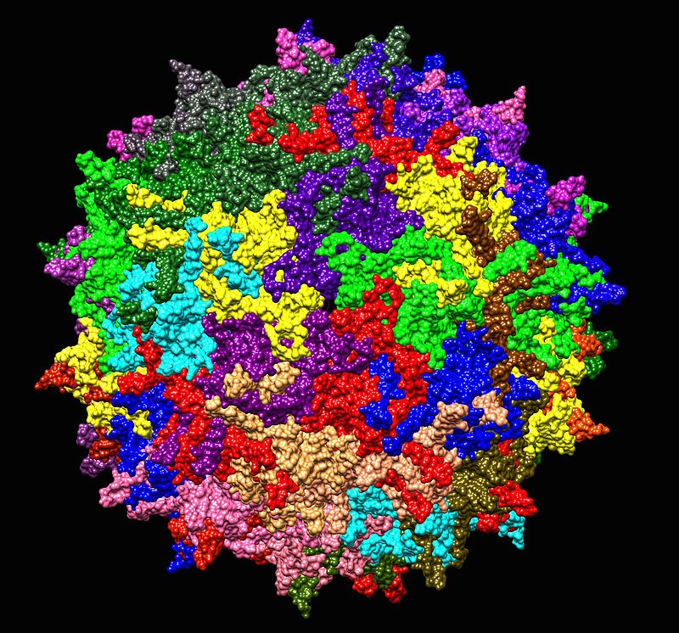
Figure 7
Adeno-Associated Virus Serotype 2.

(https://upload.wikimedia.org/wikipedia/commons/thumb/7/7f/Adeno-associated_virus_serotype_AAV2.jpg/800px-Adeno-associated_virus_serotype_AAV2.jpg)

Gene Editing:
Many approaches have been taken for gene editing, but the use of zinc finger protein nucleases (which are used as gene-targeting tools) is the most recent advancement in the treatment for haemophilia. An approach has been developed targeting an albumin locus (a liver-directed protein) in liver cells (hepatocytes) for replacement with a factor IX gene construct giving the potential for longer term factor IX expression [30].

Rebalancing therapy:
Targeting natural anticoagulant pathways can restore haemostatic equilibrium in the presence of a bleeding disorder.
Fitusiran is an RNA interference therapy which can be used to target antithrombin in the liver and interferes with the antithrombin translation by binding and interferes with translation to prevent antithrombin synthesis and stimulate haemostasis [31].

Inhibiting Protein C or S:
Activated Protein C (APC) is a natural anticoagulant that degrades factors V and VIII, so inhibiting it has been proposed to treat patients with haemophilia.
There are two different methods of protein inhibition that are currently being considered and studied. One is using HAPC1573, which is a mAb, it works by targeting APC and interfering with the inactivation of factors V and VIII and has shown not to interfere cytoprotective factors.
Studies done in vitro have shown some promising results as a shorter activated partial thromboplastin time (aPTT) in factor VIII deficient plasma.
Another study, this time in vivo, involved an induced factor VIII deficient in a Cynomolgus monkey which resulted in restoration of haemostasis as shown by bleeding time following injury.
Even though proof of concept has been demonstrated across these two studies, involving the inhibition of APC, no human clinical trials have been carried out for this type of treatment [30].

Conclusion
It has been demonstrated that new developments and trials in the treatment of haemophilia over the past few years has shown that there is hope for the future to replace the standard treatments that are available now, due to some patients developing inhibitors complementary to the recombinant factor replacements.
These new methods have been shown to provide longer term treatments, without the need for regular intravenous injections of recombinant factors.
Even though this recent research is promising it still doesn’t have the ability to replace the current methods of treatment as not many of the treatments have shown results that have lasted for a long period of time. However, the musculoskeletal treatment does seem to be the most promising in managing pain, so that patients can function with less pain than they had previously, due to the symptoms of haemophilia mainly targeting the musculoskeletal system.
References:
[1] What is Hemophilia | CDC – 27/12/21
[2] Symptoms of haemophilia - NHS - NHS (www.nhs.uk) – 28/12/21
[3] Hemophilia - Symptoms and causes - Mayo Clinic – 27/12/21
[4] How Hemophilia is Inherited | CDC – 27/12/21
[5] Inheritance of Hemophilia | NHS (nepalhemophilia.org.np) – 27/12/21
[6] HAE_AHA_01.pdf (stgeorges.nhs.uk) – 27/12/21
[7] Acquired Hemophilia - NORD (National Organization for Rare Disorders) (rarediseases.org) – 27/12/21
[8] Radwi M, Farsi S. A case report of acquired hemophilia following COVID-19 vaccine. J Thromb Haemost. 2021 Jun;19(6):1515-1518. doi: 10.1111/jth.15291. Epub 2021 May 10. PMID: 33783953; PMCID: PMC8250362. – 28/12/21
[9] Alkaline phosphatase: Liver Function Test - Viral Hepatitis and Liver Disease (va.gov) – 28/12/21
[10] Hemophilia | Texas Oncology – 28/12/21
[11] Signs and Symptoms of Hemophilia | Bruising and Bleeding (ihtc.org) – 28/12/21
[12] Chavin SI. Factor VIII: structure and function in blood clotting. Am J Hematol. 1984 Apr;16(3):297-306. doi: 10.1002/ajh.2830160312. PMID: 6424437. – 29/12/21
[13] Structural Biochemistry/Enzyme/Serine Proteases - Wikibooks, open books for an open world – 29/12/21
[14] Factor IX - Wikipedia – 30/12/21
[15] Atilla B, Güney-Deniz H. Musculoskeletal treatment in haemophilia. EFORT Open Rev. 2019 Jun 3;4(6):230-239. doi: 10.1302/2058-5241.4.180068. PMID: 31210965; PMCID: PMC6549116. – 30/12/21
[16] https://www.ncbi.nlm.nih.gov/books/NBK525999/ - 04/01/21
[17] Atilla B, Güney-Deniz H. Musculoskeletal treatment in haemophilia. EFORT Open Rev. 2019 Jun 3;4(6):230-239. doi: 10.1302/2058-5241.4.180068. PMID: 31210965; PMCID: PMC6549116.
[18] https://www.ncbi.nlm.nih.gov/pubmedhealth/PMHT0022821/#:~:text=A%20layer%20of%20connective%20tissue%20that%20lines%20the,makes%20synovial%20fluid%2C%20which%20has%20a%20lubricating%20function. – 04/01/22
[19] Muscle Hematoma - an overview | ScienceDirect Topics – 04/01/22
[20] Nathwani AC. Gene therapy for hemophilia. Hematology Am Soc Hematol Educ Program. 2019 Dec 6;2019(1):1-8. doi: 10.1182/hematology.2019000007. PMID: 31808868; PMCID: PMC6913446. – 04/01/22
[21] Veronese FM, Mero A. The impact of PEGylation on biological therapies. BioDrugs. 2008;22(5):315-29. doi: 10.2165/00063030-200822050-00004. PMID: 18778113.
[22] https://www.sciencedirect.com/topics/neuroscience/pharmacokinetics - 05/04/22
[23] Von Willebrand Factor - an overview | ScienceDirect Topics – 05/01/22
[24] Pseudotumor | definition of pseudotumor by Medical dictionary (thefreedictionary.com) – 05/01/22
[25] Serotype Definition & Meaning - Merriam-Webster – 05/01/22
[26] Plasminogen - an overview | ScienceDirect Topics – 06/01/22
[27] Plasmin - an overview | ScienceDirect Topics – 06/01/22
[28] Chauncey JM, Wieters JS. Tranexamic Acid. 2021 Jul 28. In: StatPearls [Internet]. Treasure Island (FL): StatPearls Publishing; 2021 Jan–. PMID: 30422504. – 06/01/22
[29] Weyand AC, Pipe SW. New therapies for hemophilia. Blood. 2019 Jan 31;133(5):389-398. doi: 10.1182/blood-2018-08-872291. Epub 2018 Dec 17. PMID: 30559264. – 06/01/22
[30] 2021 clinical trials update: Innovations in hemophilia therapy (wiley.com) – 06/01/22
[31] Tomeo F, Mariz S, Brunetta AL, Stoyanova-Beninska V, Penttila K, Magrelli A. Haemophilia, state of the art and new therapeutic opportunities, a regulatory perspective. Br J Clin Pharmacol. 2021 Nov;87(11):4183-4196. doi: 10.1111/bcp.14838. Epub 2021 Apr 12. PMID: 33772837; PMCID: PMC8596702. – 06/01/22
[32] Aledort L, Mannucci PM, Schramm W, Tarantino M. Factor VIII replacement is still the standard of care in haemophilia A. Blood Transfus. 2019 Nov;17(6):479-486. doi: 10.2450/2019.0211-19. Epub 2019 Dec 11. PMID: 31846611; PMCID: PMC6917528. – 08/01/22
[33] Treatment of Hemophilia | CDC – 08/01/22
[34] Haemophilia and HIV | Terrence Higgins Trust (tht.org.uk) – 08/01/22
[35] What is the contaminated blood inquiry? - BBC News – 08/01/22
[36] Ockerman A, Vanassche T, Garip M, Vandenbriele C, Engelen MM, Martens J, Politis C, Jacobs R, Verhamme P. Tranexamic acid for the prevention and treatment of bleeding in surgery, trauma and bleeding disorders: a narrative review. Thromb J. 2021 Aug 11;19(1):54. doi: 10.1186/s12959-021-00303-9. PMID: 34380507; PMCID: PMC8356407.
[37] Antigen, Abbreviated: Factor IX – Innovative Research (innov-research.com) – 23/01/22
[38] https://radiopaedia.org/articles/haemophilic-pseudotumour?lang=gb#:~:text=Haemophilic%20pseudotumour%20is%20a%20rare%20complication%20of%20haemophilia,It%20is%20reported%20in%201-2%25%20of%20haemophiliacs%20patients. – 31/01/22
Amy,
This is a very well written and researched piece of work. You have a concise writing style and the accuracy of your written English is excellent. I really like how you based your work on “real” science, but kept it accessible to a reader who may not have a high level understanding around Biology – this give your writing “weight” but keeps it approached to a wide audience. You have structured and presented the piece logically, using informative and relevant images, so it is easy to follow your discussion – I like your use of subheadings signpost to the reader the aim of each section of your writing.
To improve your work to an even higher standard, I would do the following:
- Your work is very well researched and based on a wide range of sources, which is superb. Your references are fine for a school project, but at University you will be expected to follow a more standardised referencing style. The link below gives a good run through on how to reference an academic paper.
https://www2.le.ac.uk/offices/ld/resources/writing/writing-resources/ref-bib.
Programmes such as Endnote help you track the sources you have used and give the citation in the correct style based on the discipline you are writing within.
- Think critically about the validity of the sources you use; acknowledge this is your writing if your sources aren’t from academic bodies of work, (granted that you will not have current access to these sources as you are not a member of a university).
- To further develop this piece of work I suggest you make a slide show to accompany your essay and present it to MedSoc.
Amy, I hope you enjoyed writing this, as I have enjoyed reading this and I am very impressed by your efforts in producing such a high quality piece of work.
Miss Hirst

